Sports Day 2021
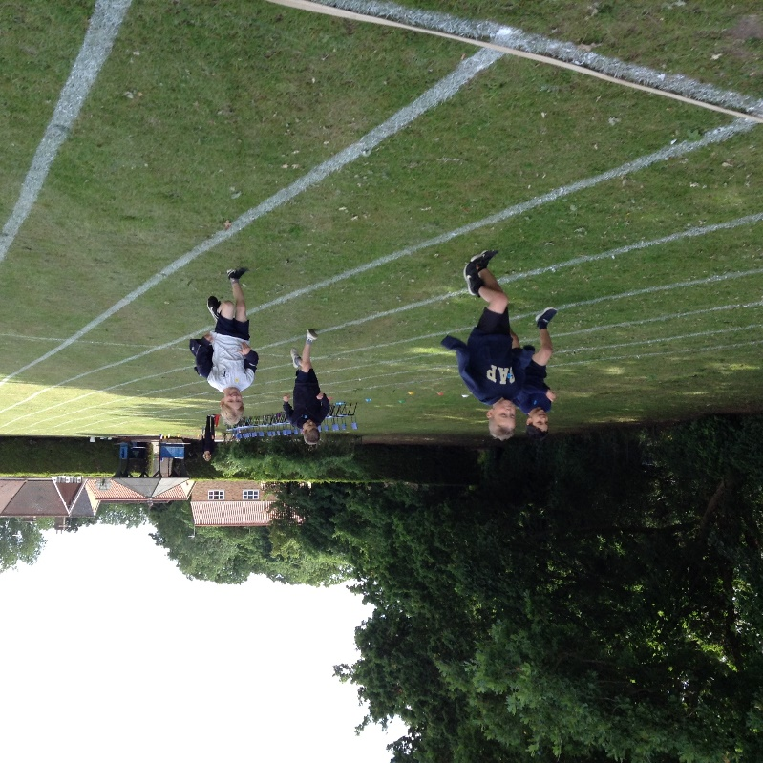
We were thrilled to be able to hold our first Sports Day for two years. Although we had to make some adjustments to our ordinary activities due to pandemic restrictions, the event went very well. The Year 6 children were very efficient young leaders, helping to organise and run events - they did a marvellous job.
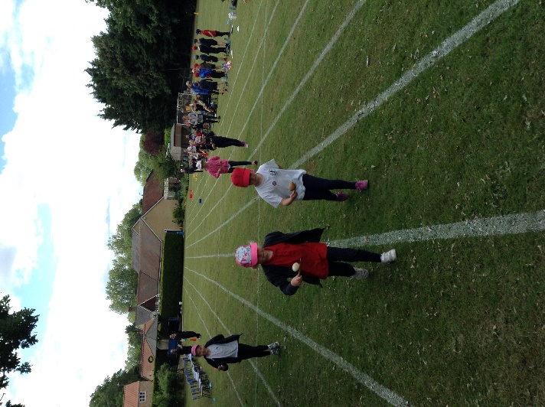
We missed having parents being able to attend so are very hopeful to be able to invite them next year.
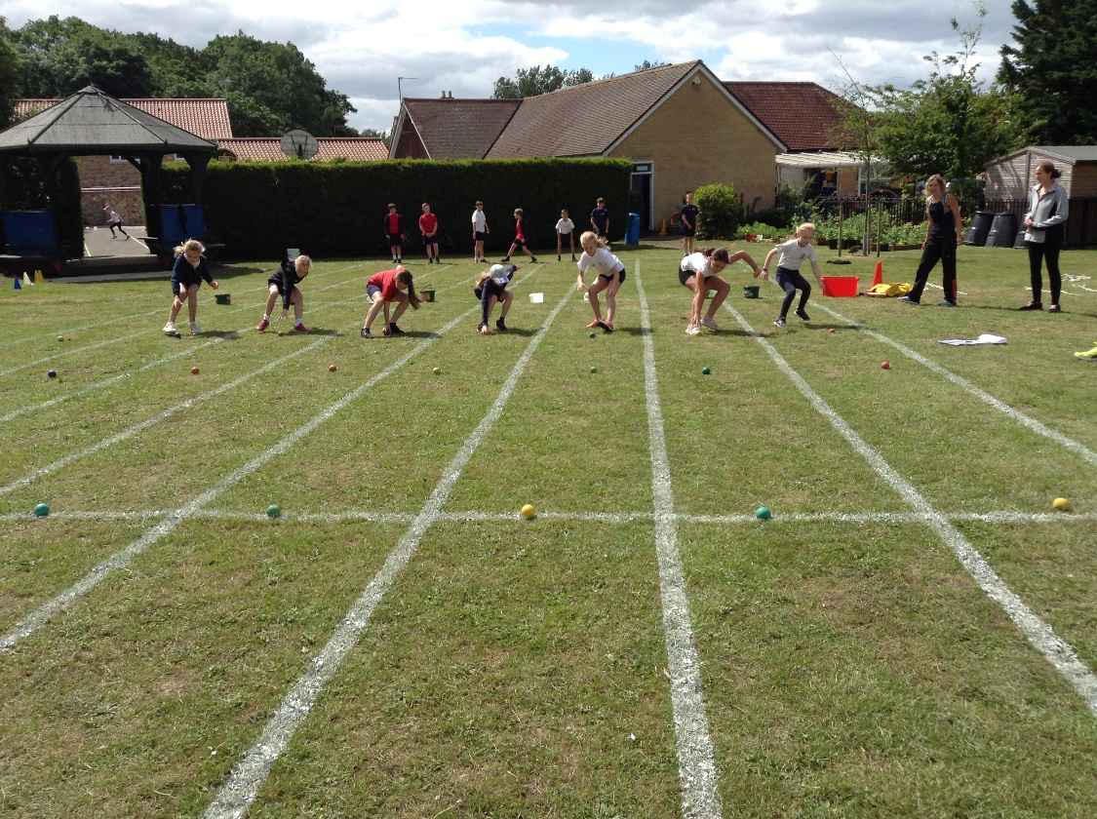
I would like to offer my sincere thanks to all of the staff and adult helpers who helped to make the day such a success.
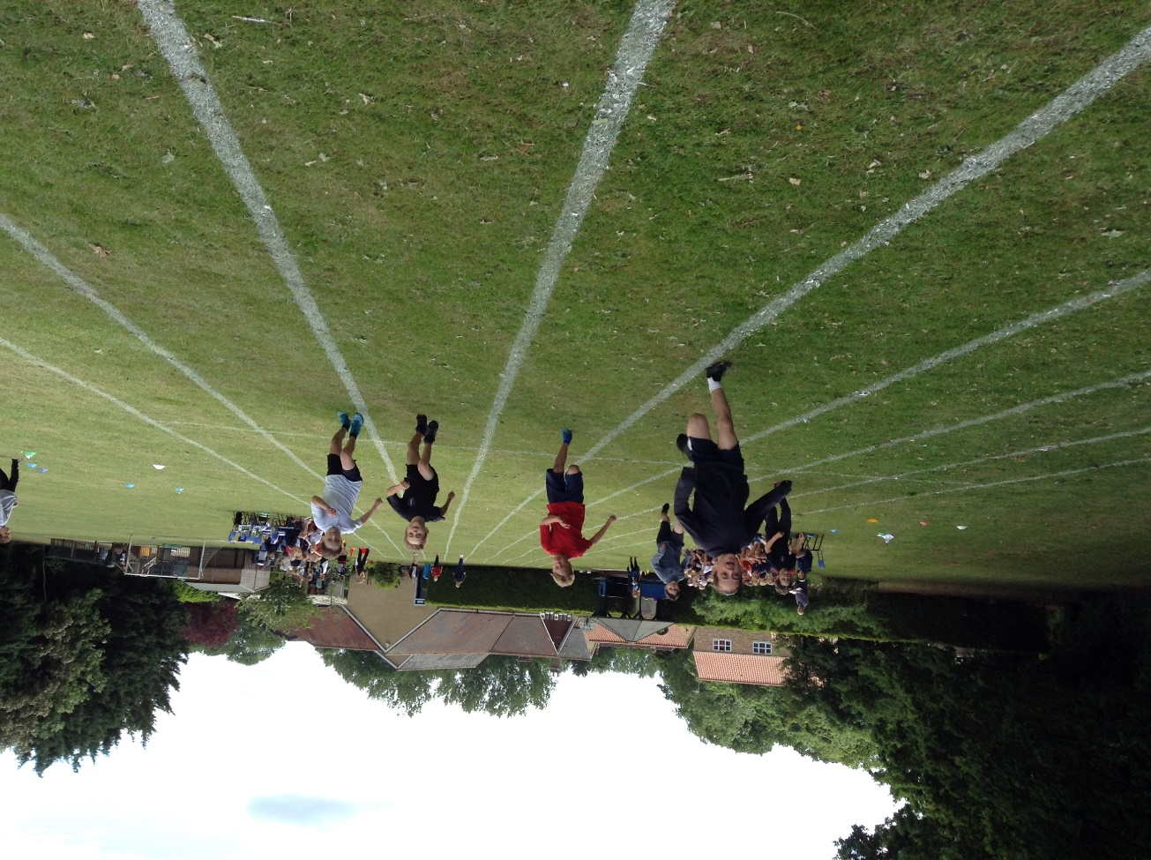
The White team were the overall winners but to us all children across the school are winners for the excellent sportsmanship that they demonstrated, their enthusiasm and their encouragement of each other.
