Class 3 2022 The Elf Party

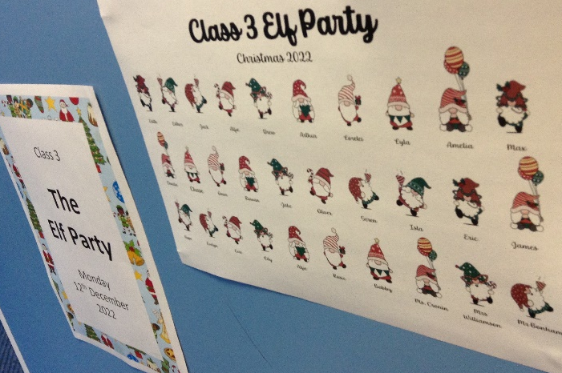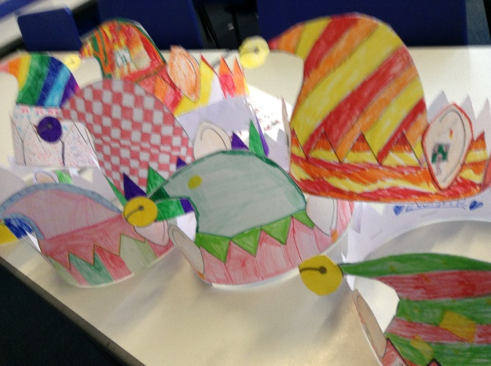

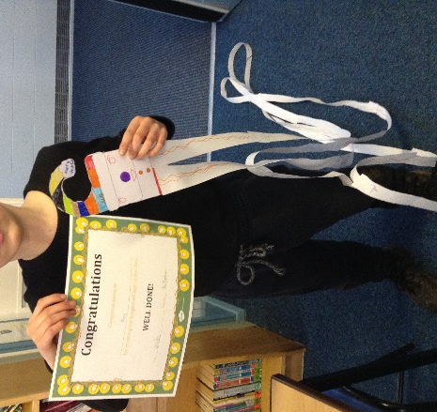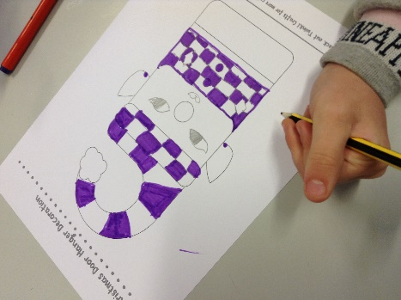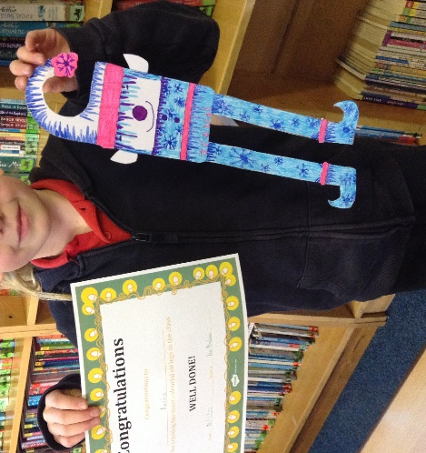

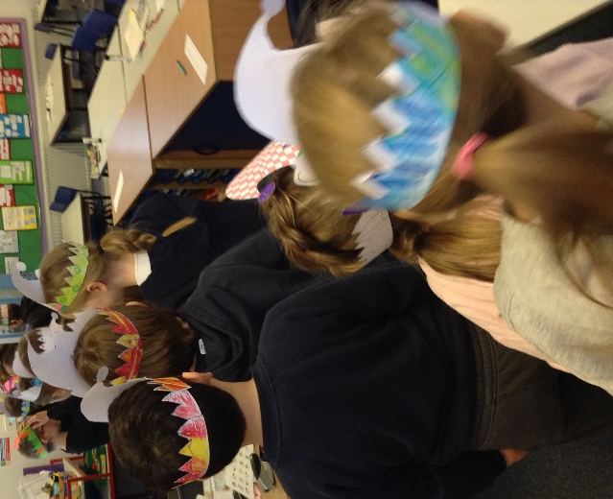

On Monday 12yh December 2022, Class 3 had their Christmas Party. It had an Elf Theme. Every child made an Elf Hat and took part in Pass the Parcel. Everybody had a copy of all the Elves in the class to take home. Rosie won the Pass the Parcel game and took home her own gecko toy! The children made their own Elf Door hangers. There was also an Elf Longest Leg Challenge and a most colourful Elf legs competition. Max’s Elf had the longest legs and the children voted that Amelia’s Elf had the most colourful legs. A great time was had by all.

