Anti-bullying week November 2022
This week marks the Anti-Bullying Alliance anti-bullying week which aims to raise awareness of bullying, what can be done to help to prevent bullying, how to identify if someone is being bullied and what help and support is available to those suffering.
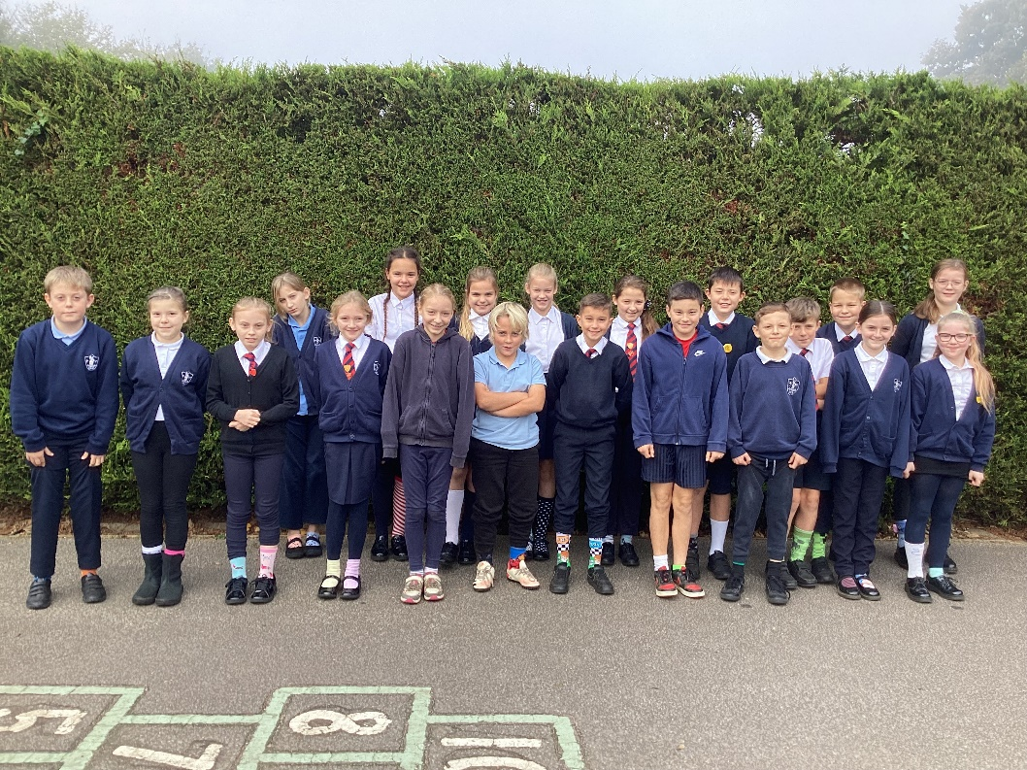

We began with Odd Socks Day on Monday. The odd socks are a way of expressing and celebrating our differences.
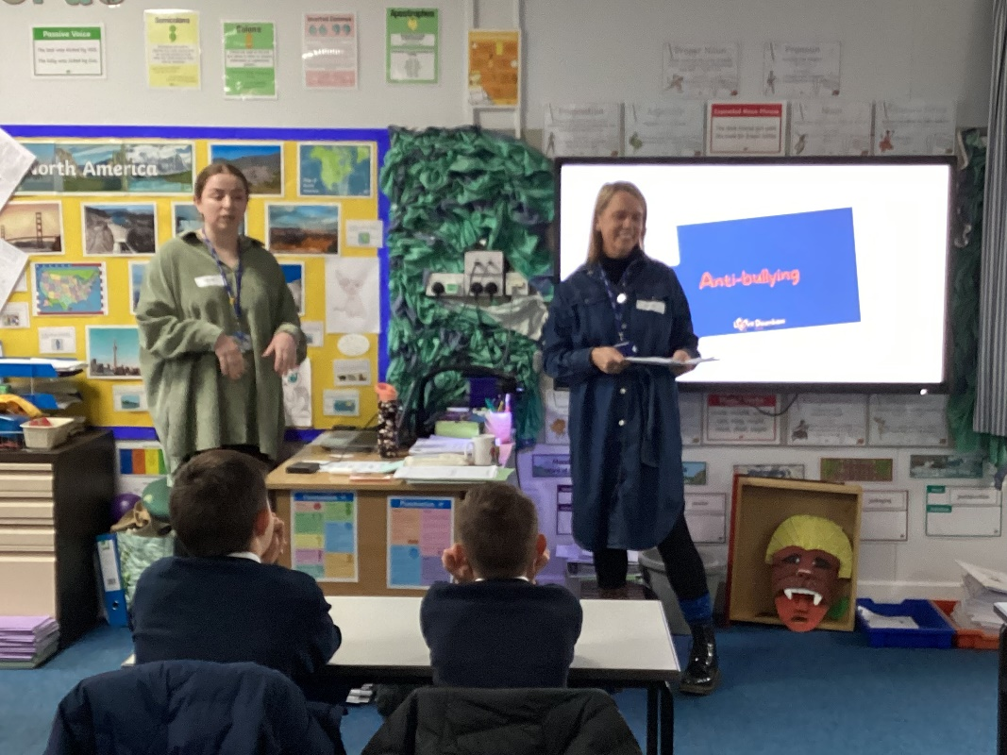

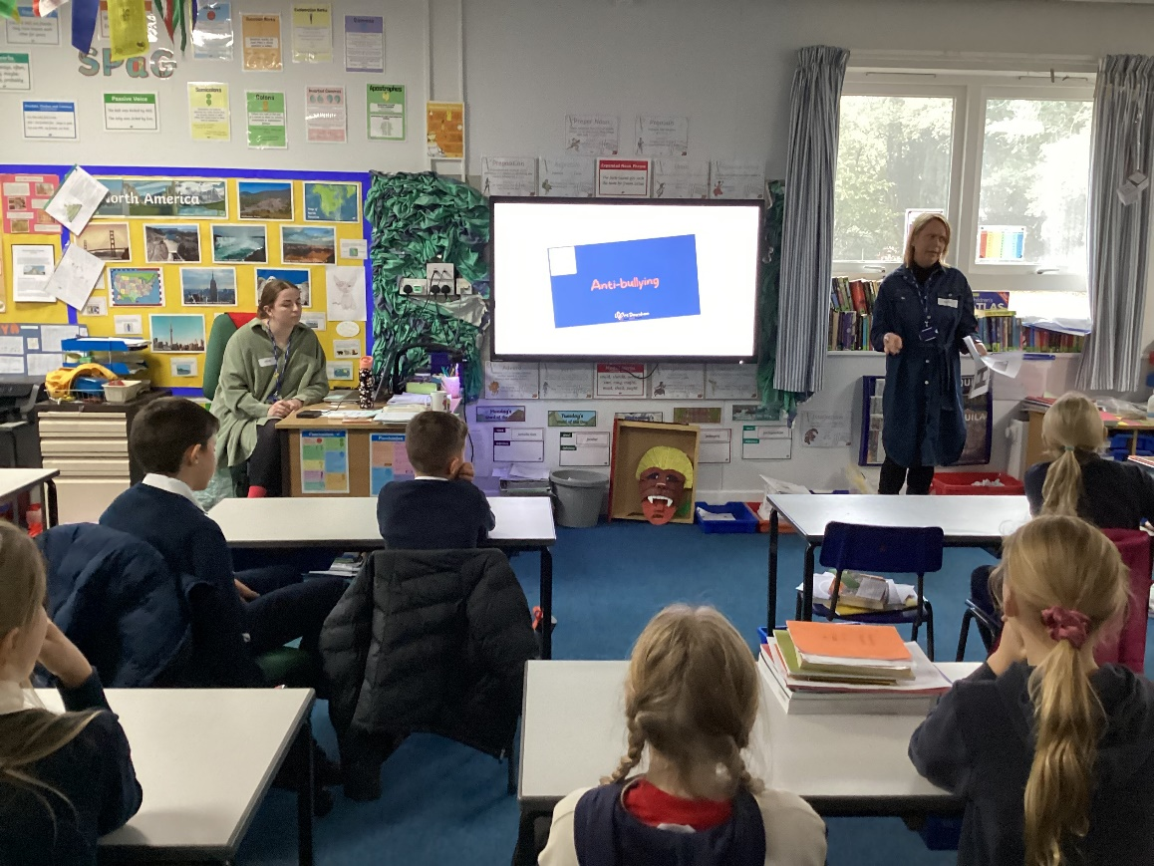

We were also joined by Louise and Lucy from the Downham Market charity ‘The Swan Youth Project’. They came to run anti- bullying workshops across KS2. They also explained about what facilities they offer, including a youth club which takes place on Thursdays. Their aim is to support the wellbeing of local young people and their families. Information about the project can be found on our school website.

