Christmas Party!
Whilst years 1 – 6 were out of the school to enjoy this year’s pantomime, Class 1 had their Christmas party!
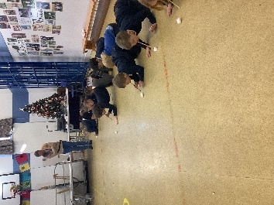
Before we started the party, we needed to get into the festive spirit and so we all made a Christmas party hat ready to wear.
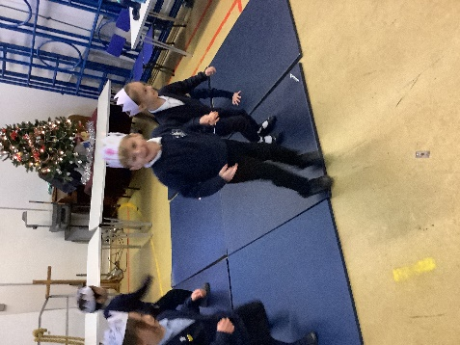
The class played many games including musical statues, pass the parcel and stick the nose on Rudolph. There was some spectacular dancing and singing of Christmas songs and everyone won a prize in the day, thank you to the Friends of Denver for their kind donations!
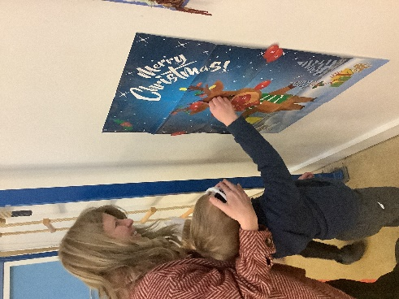
The morning was topped off a party lunch supplied by Mrs Fenn in the hall. We were even treated to having our lunch with the Christmas Elves and Twiggle the Turtle!

