A new place to stay
On Friday afternoons, our gardening group enjoy a variety of outdoor activities with Mrs Collins.
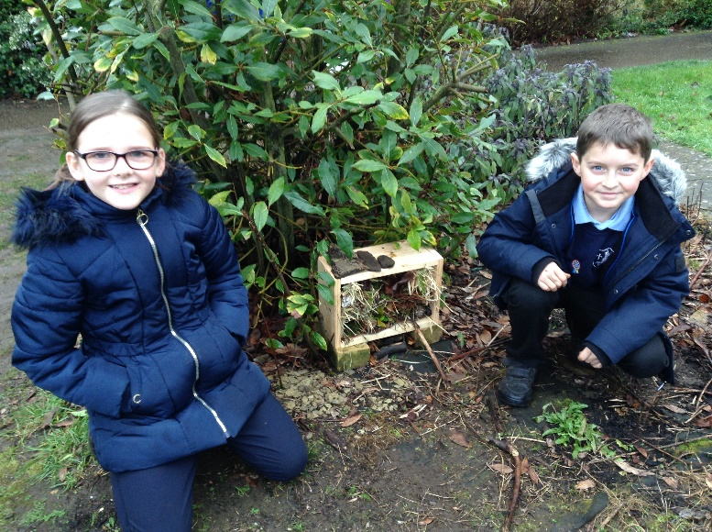
This week the children are very proud of the bug hotel that they have made – a new home for all of the little creatures in our grounds. We shall keep a regular watch to see what it attracts…
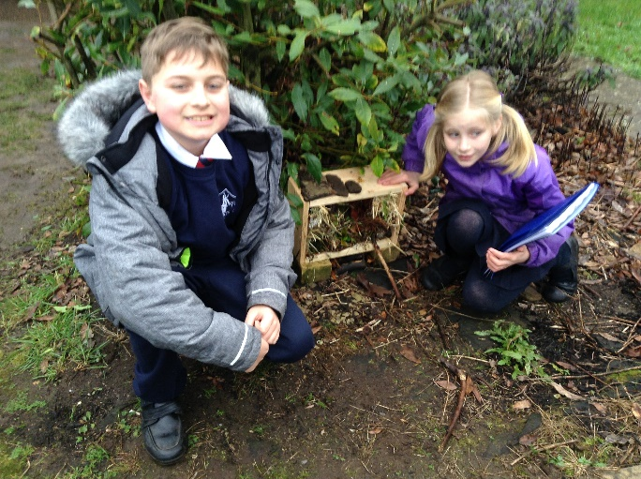
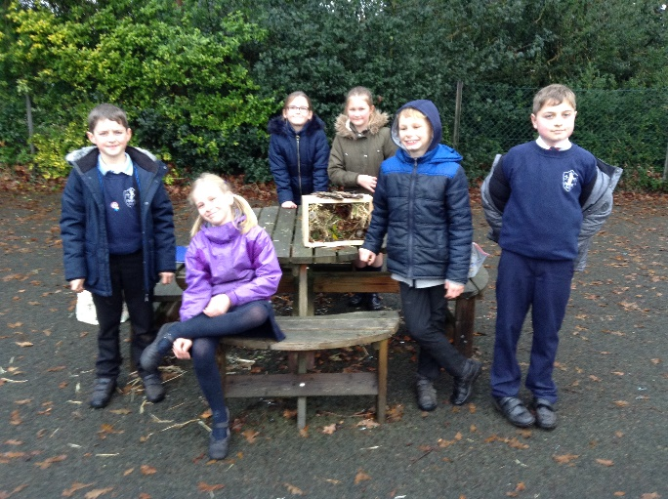
11.12.20

