Class 4 Christmas Party
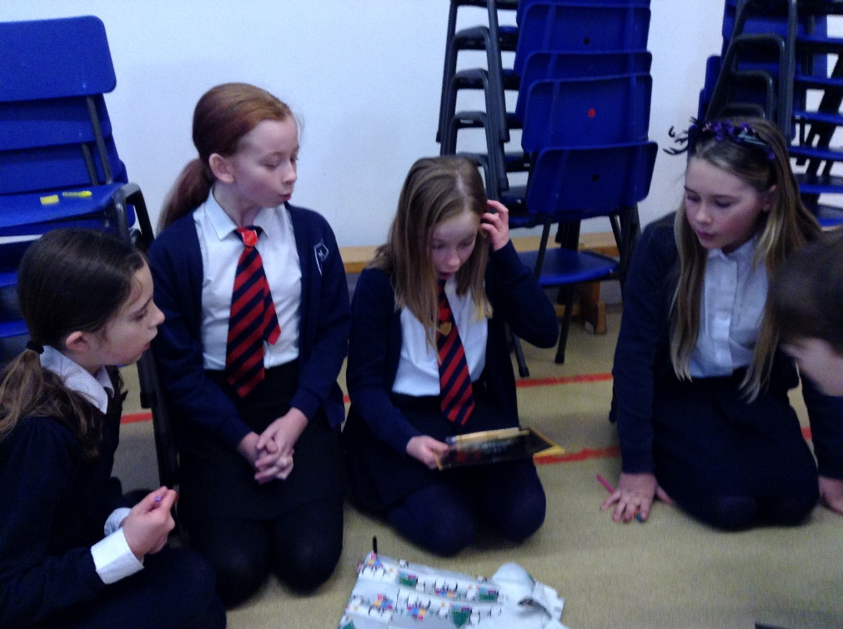
Today was our chance to have our Christmas party. Throughout the afternoon we played a variety of games including Pass the Parcel, Corners, Musical Chairs, Musical Spots, Musical Statues, Pin the tail on Rudolph and Pass the Balloon.
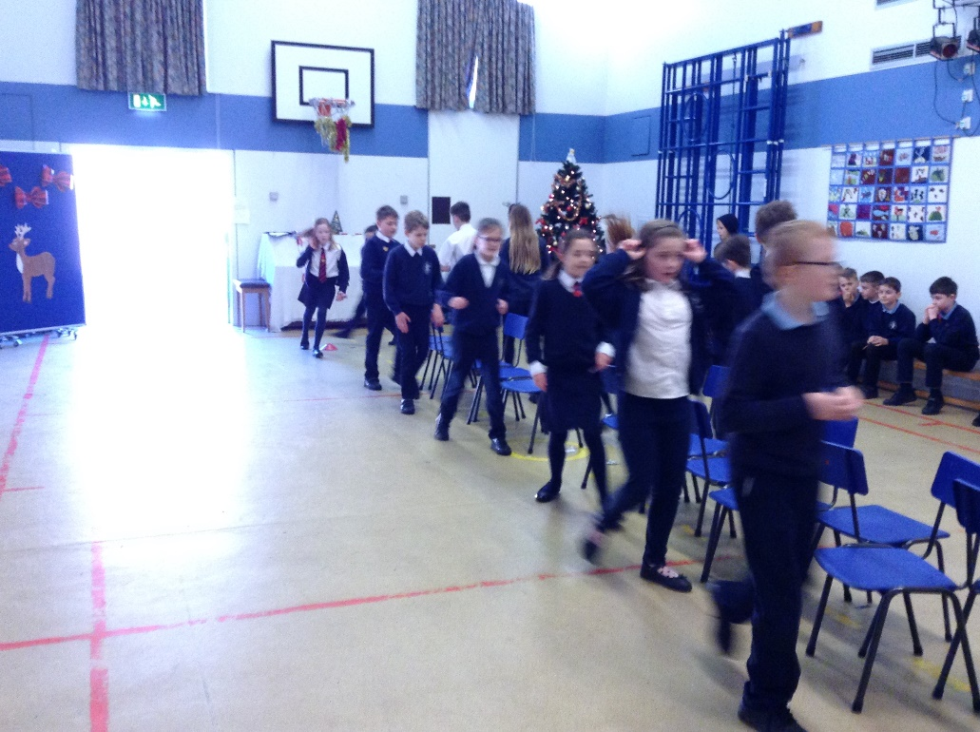

It was a great way to round off the term and to enjoy some valuable social time together.

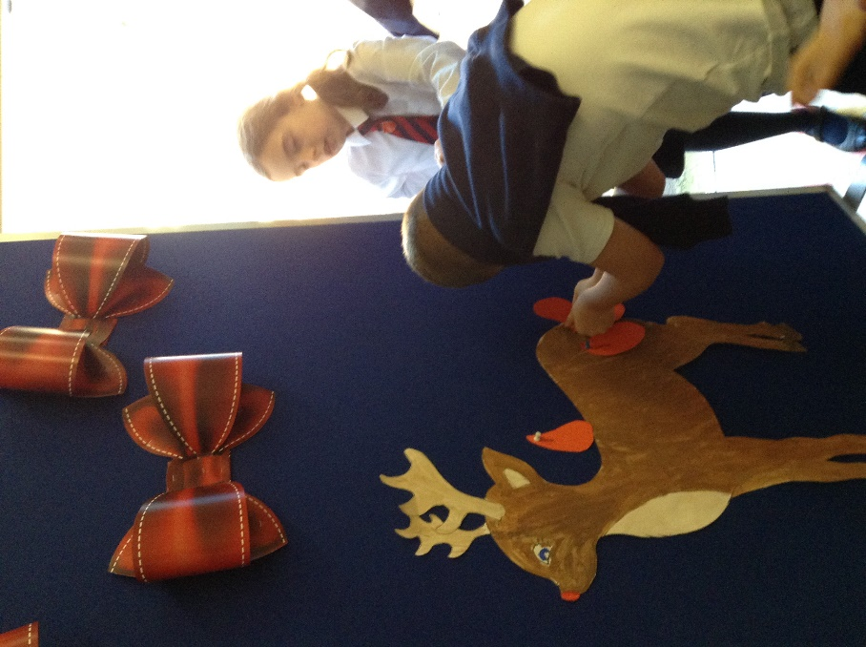
We are extremely grateful to the Friends of Denver School who donated the prizes and prepared our parcel for the game.
