On Friday 8th 2022 June Class 1 and Class 2 went on a trip to Welney Wetland Centre .
We went into the hides and looked for Godwits which are an endangered wildfowl. We have become guardians for a godwit called Jeffrey. We didn’t see one, but we did see some mute swans.
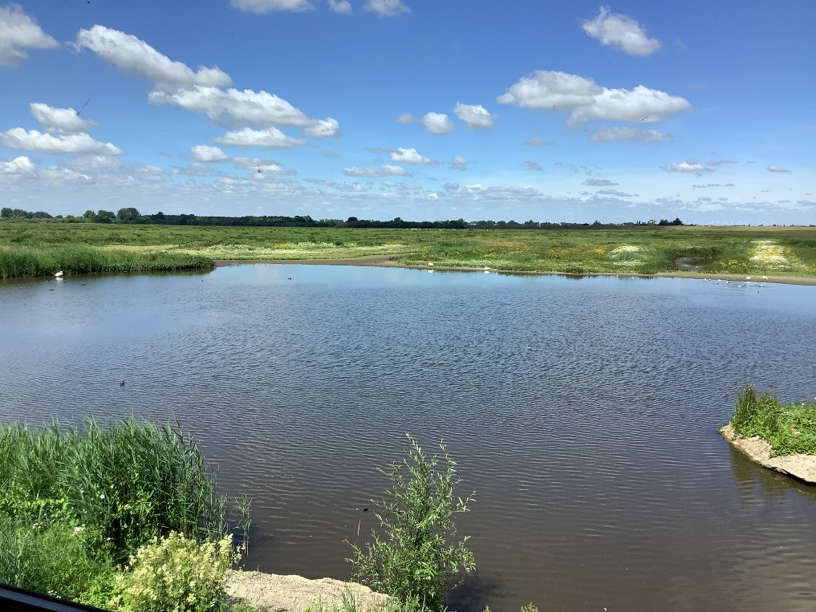

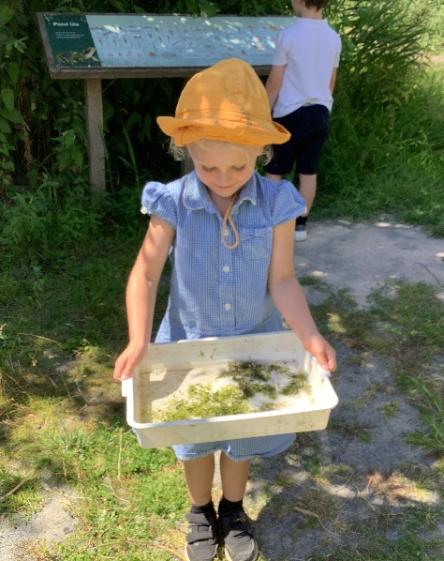
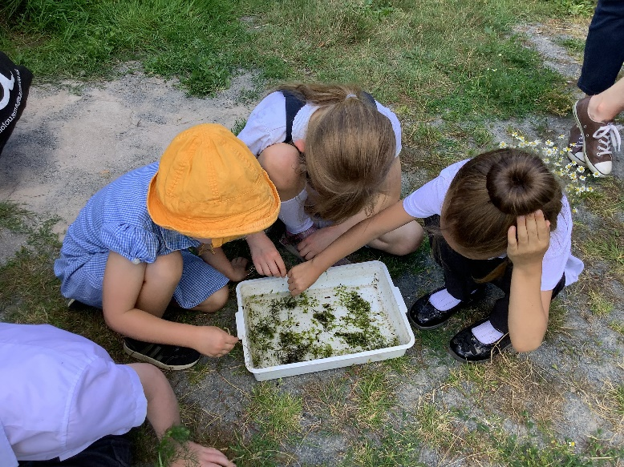
We also went pond-dipping and found all sorts of interesting creatures like leeches and blood worms.
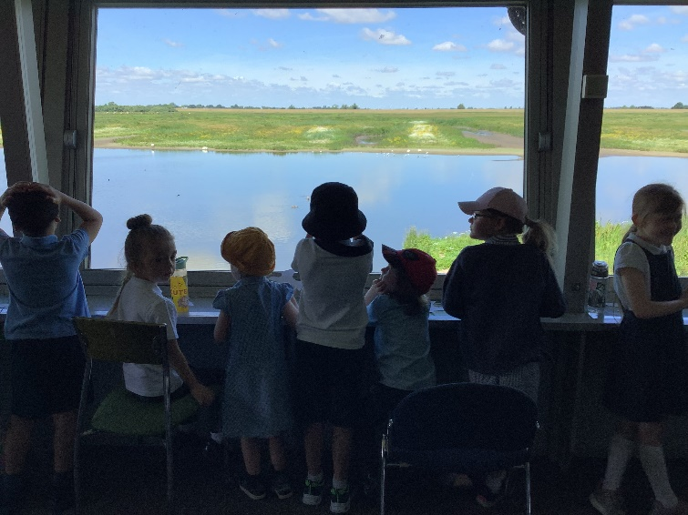

We went to the dragonfly ponds, but unfortunately we couldn’t find any.

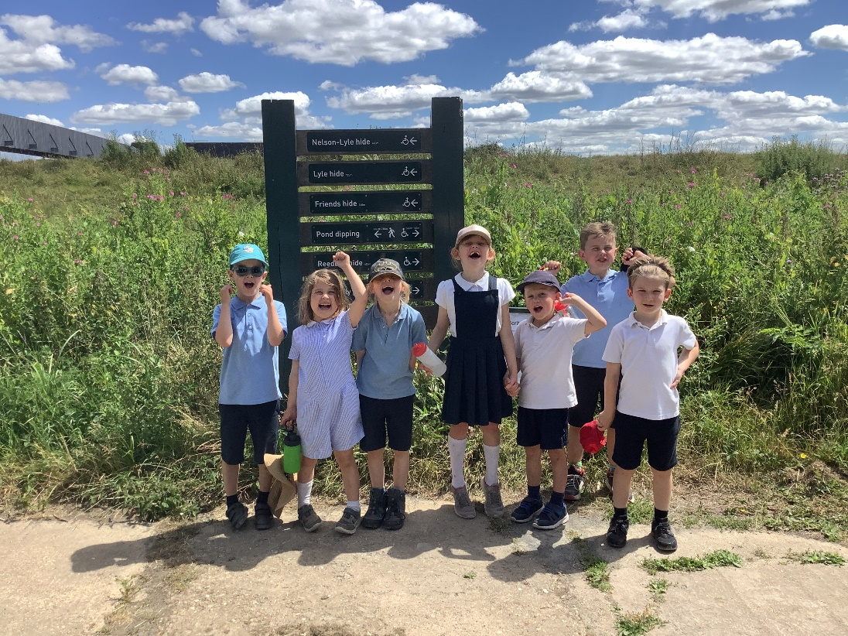
It was a very hot day and we really enjoyed learning about wetlands.

