Downham Market Cluster Football Tournament
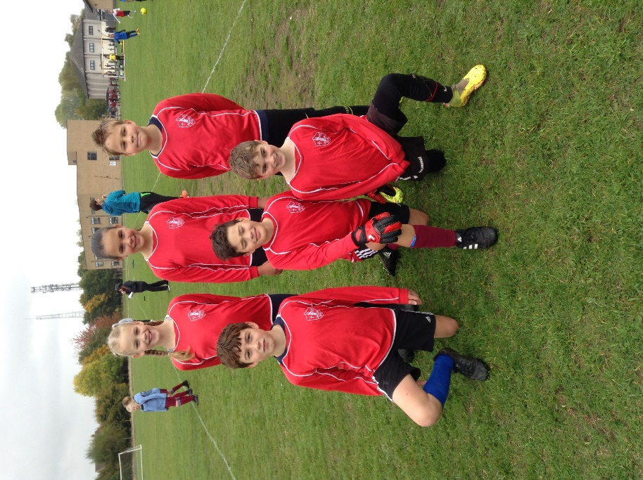
Two teams of 6, Denver Dynamos (in red) and Denver Jets (in blue), travelled to Hillcrest Primary School on Friday 14th October to play in a tournament against other schools in the cluster.
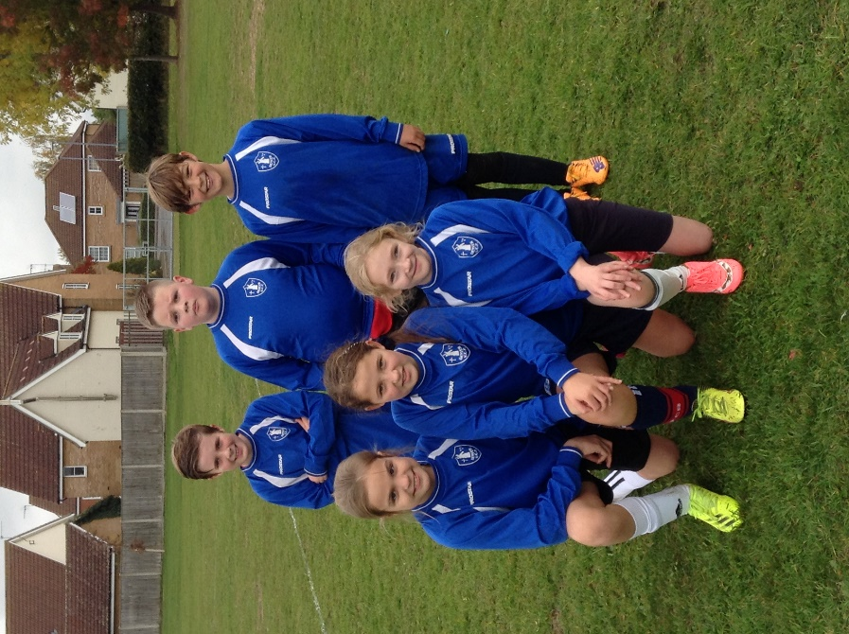
They each played all of the other teams, including each other. Both teams played brilliantly and the Dynamos returned as the champions! What an excellent result against the might of larger schools such as Hillcrest and Nelson! Our teams were also strongly represented by girls, more so than the other teams that were entered. They earned recognition for their skills and Hillcrest are keen for us to commence some opportunities for their girls and ours to play and practise together.
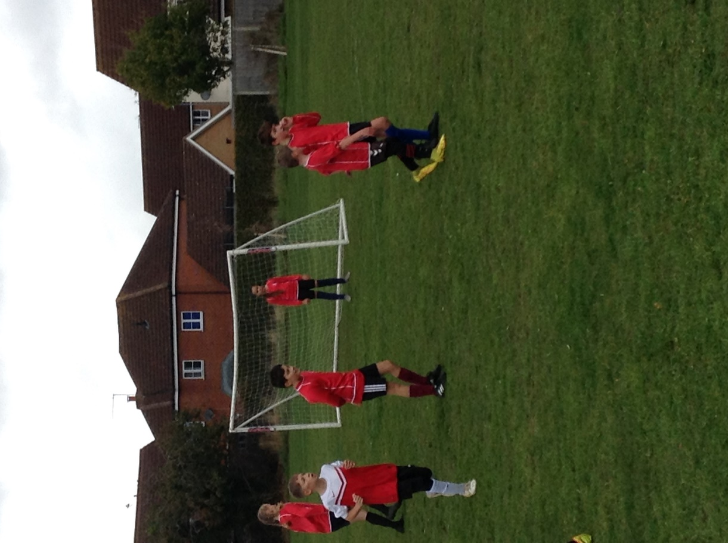

At each cluster event, Tracy Bower, the School Games Organiser for the area, awards special recognition to particular children who show evidence of the School Games Values. Well done to Sonny and William who received two of the three accolades awarded today.

Mrs Collins and Miss Loveridge, who took the children, were full of praise for how well the children played, behaved and supported each other.
