Practical science experience afternoon
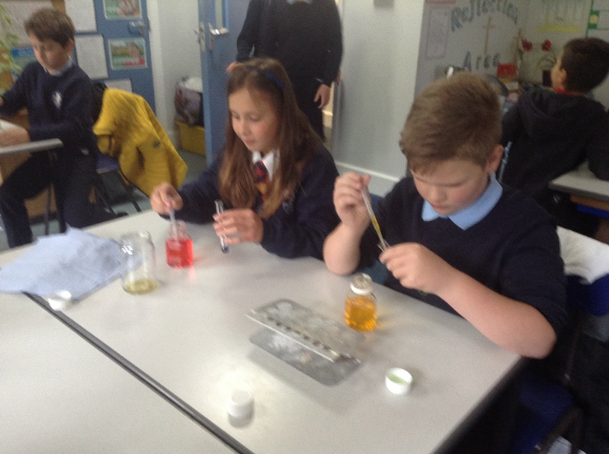
During the afternoon of Tuesday 5th October, Class 4 children were joined by science specialist, Mrs White, from the University Academy of Long Sutton. The session was to allow us to develop our scientific enquiry and practical science skills.
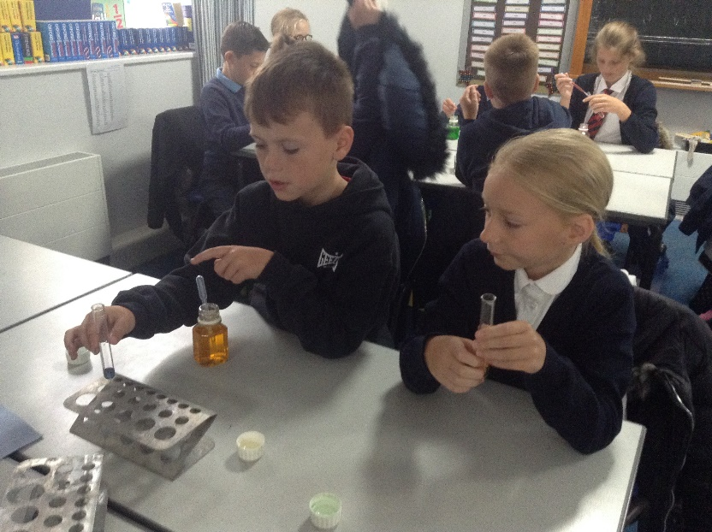
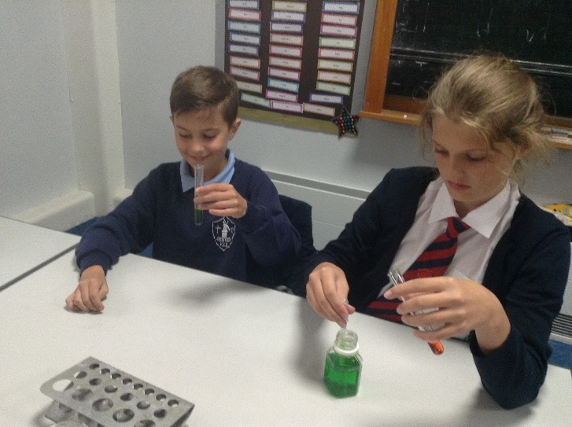
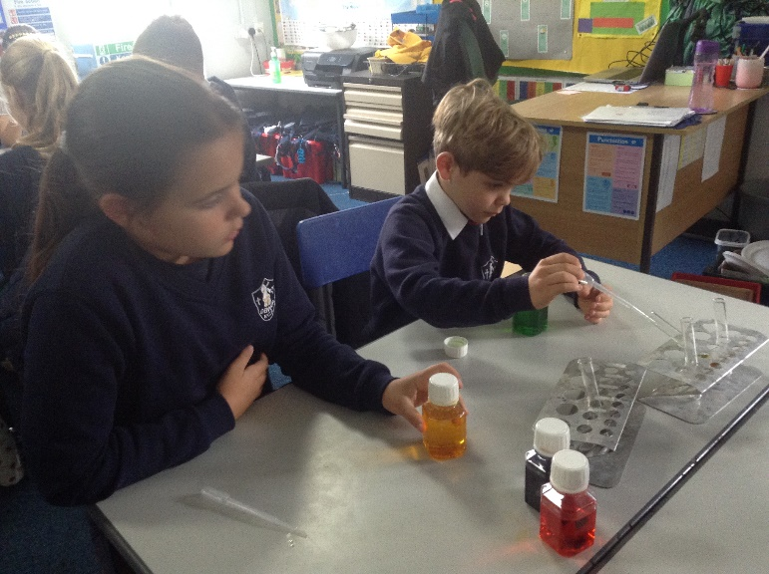
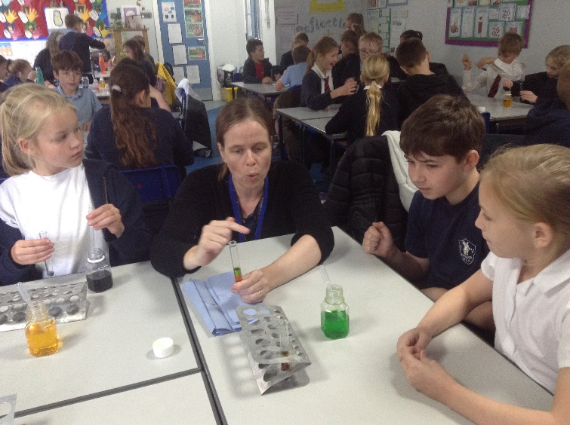
The first activity was to explore the density of liquids. Containers with different coloured water had been filled with varying amounts of sugar. The task was to work out which colour had been filled with the most sugar by using a pipette to gently squeeze liquid into a test tube. The colour with the highest density of sugar would stay at the bottom while the other colours would remain on top. If the liquids mixed rather than created a rainbow effect, we had to try again.
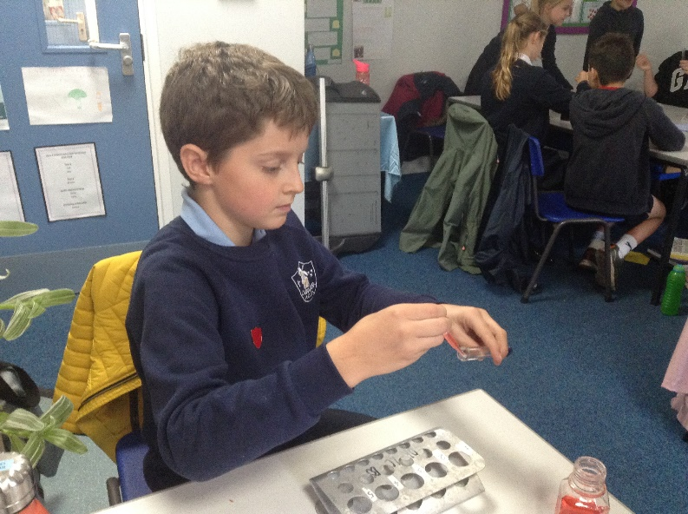
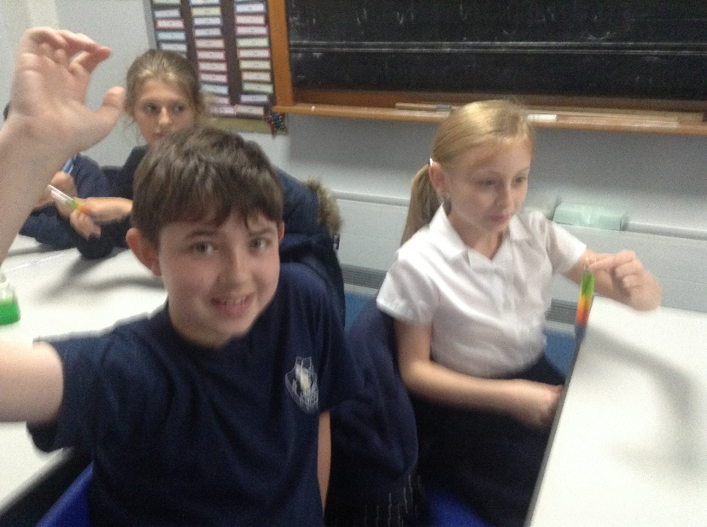
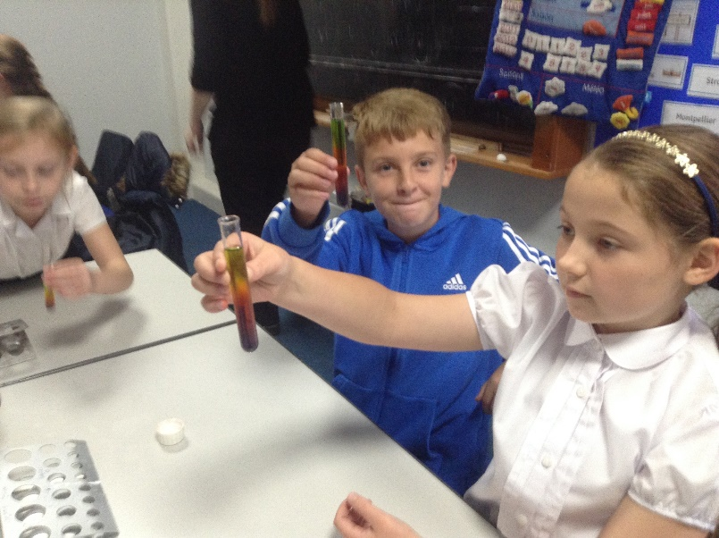
We then used special microscopes to look at different plant and animal cells (including human blood cells) and make careful scientific drawings. We learnt that these should never be done with rulers or pairs of compasses.
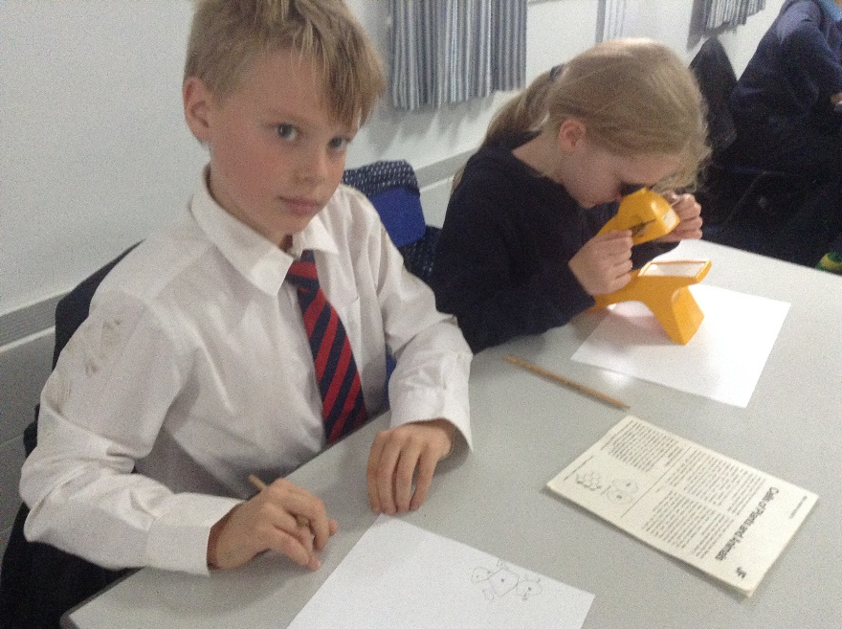

Later in the afternoon, we investigated static electricity. Firstly, we had to make a small paper snake. With a piece of cloth and a rubbery ruler, we had to rub hard (create friction) to make enough static electricity so that the snake would be attracted to the ruler and lift off the table without being touched.
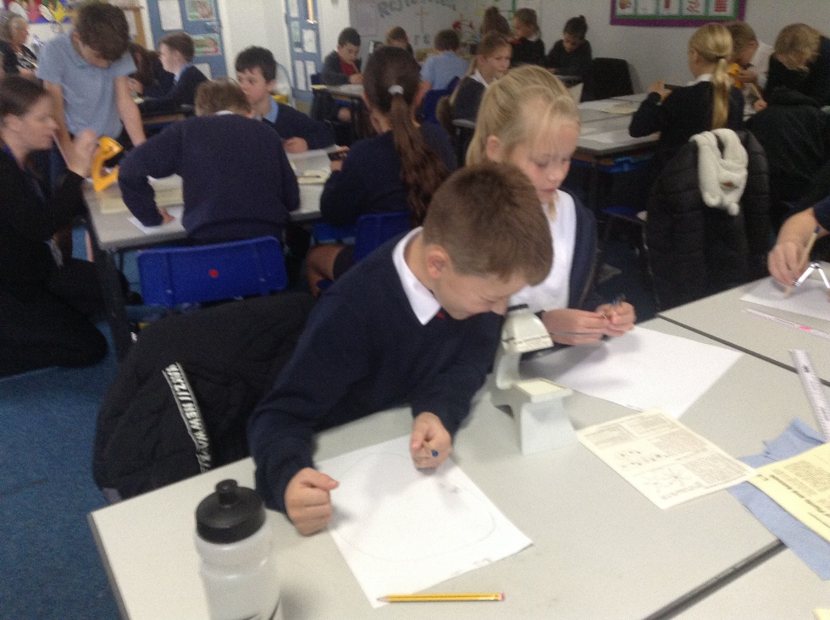
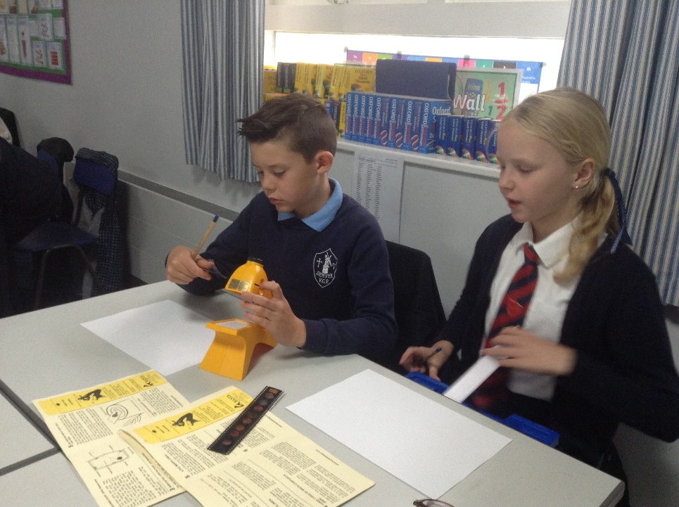

Finally we used friction with balloons to create enough static electricity for the balloons to create some crazy hairstyles and to make the balloons seem to stick to the wall.

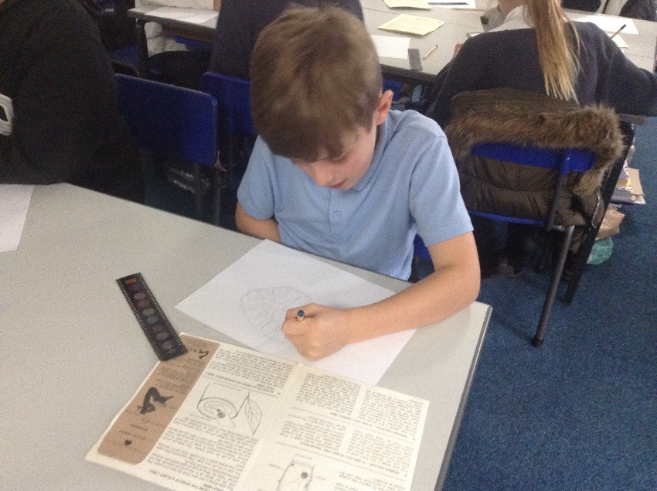
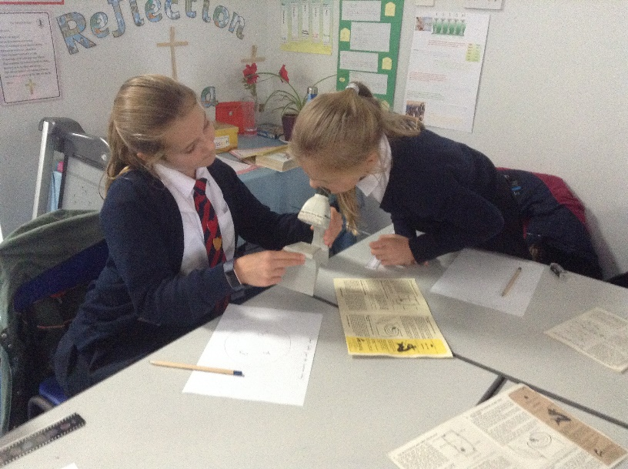
It was a very busy and entertaining afternoon. We are very grateful to Mrs White and her organisation for providing such a valuable and memorable learning experience.
