Tennis Coaching

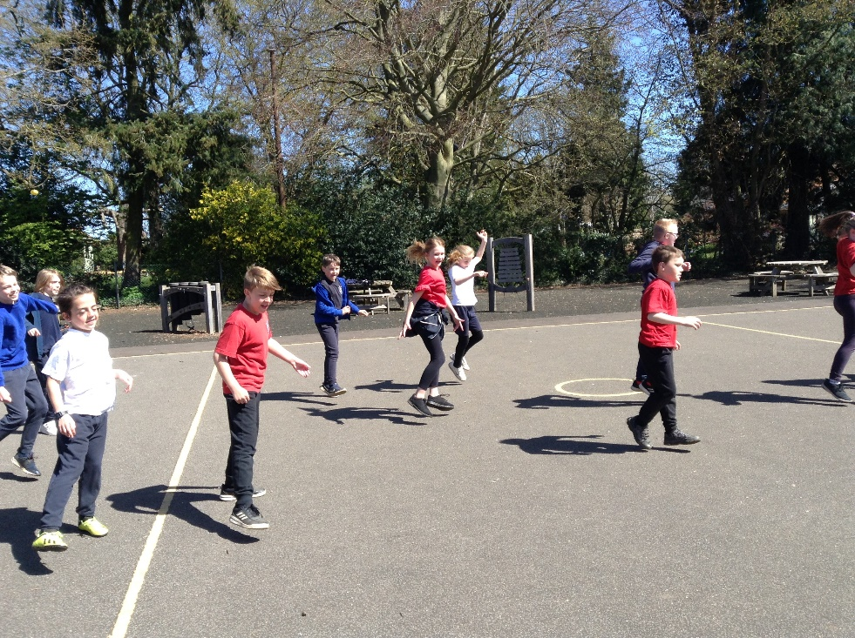
This week Class 4 began the first of ten tennis coaching sessions with professional tennis coach, Jeremy. We thoroughly enjoyed it and here are some pictures from our first session. Each week we will be developing skills until the final two sessions where we shall get to play singles and doubles tournaments.
