Christingles
Today we celebrated the coming of Christmas by making Christingles.
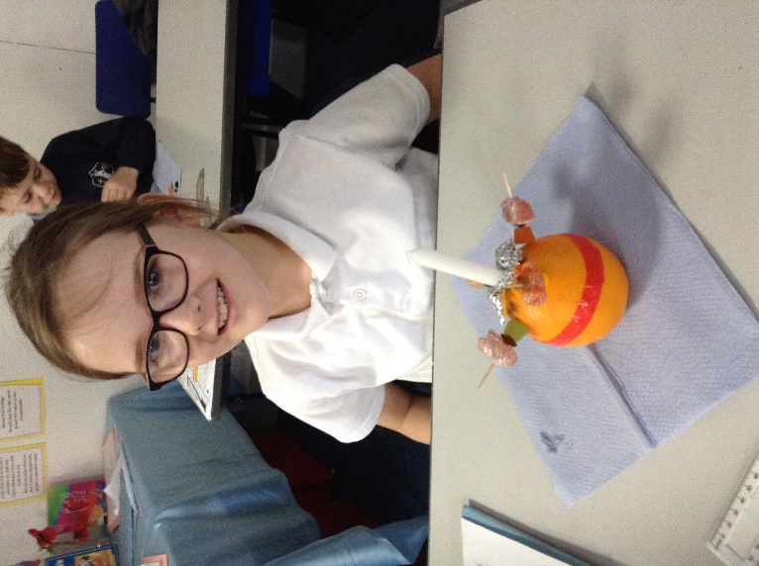
We learnt about what each part of the Christingle represents and had a special assembly with a surprise guest, Rev. Judith Grundy, (formerly of St. Mary’s, Denver) who we hadn’t seen for more than a year since her retirement.
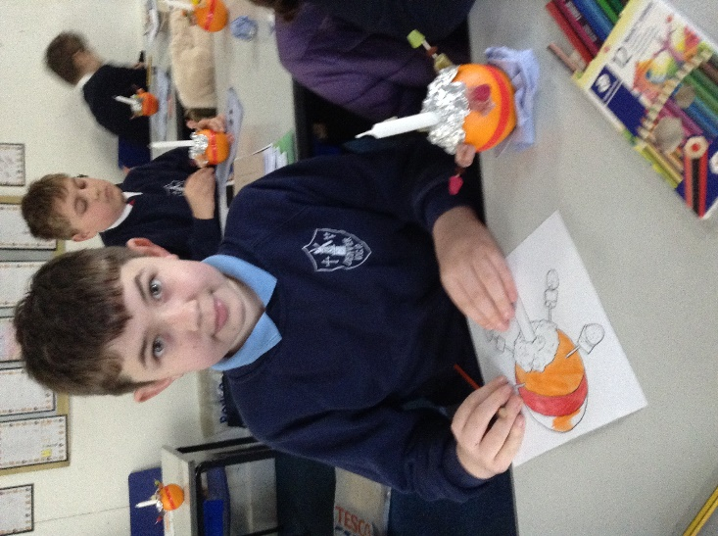
In the afternoon, we attended a virtual service from Ely Cathedral with Bishop Stephen leading the service.

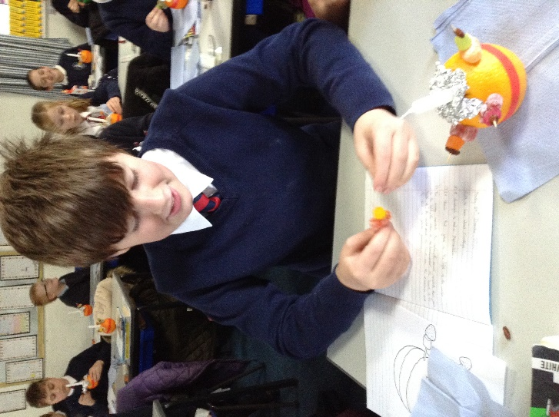

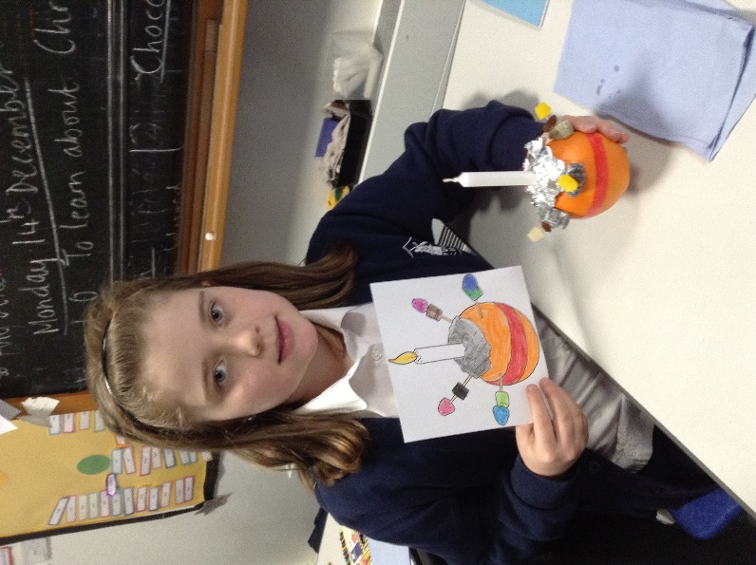

14.12.20

