New menu tasting

Classes 1 and 2 were given the opportunity to try some of the possible new lunch options for the school’s new menu after half term.
Class 1 had recently learnt about the 5 senses when thinking about going on an autumn walk around the school so were very good at using their sense of taste to judge the new foods.
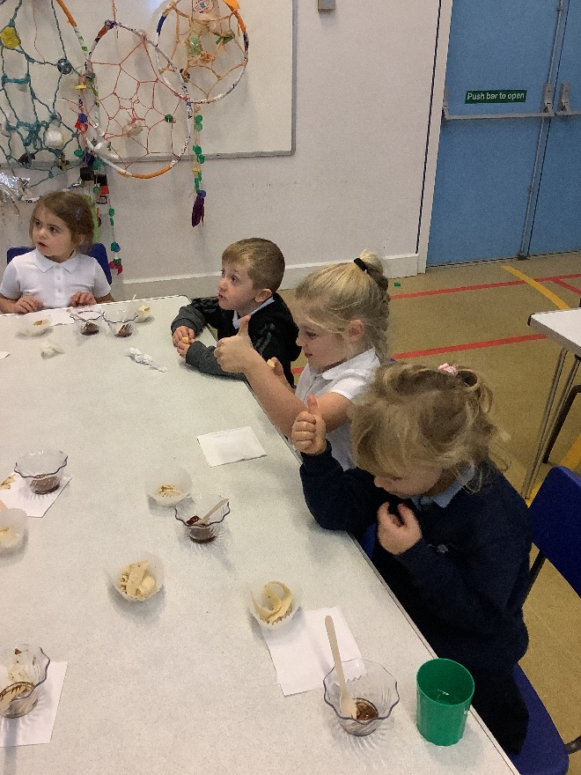
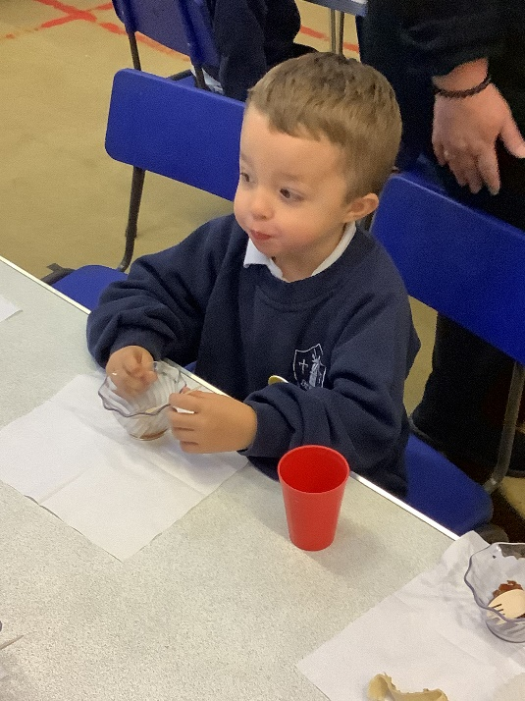
Class 1 has some very good food critics as we could identify different senses like sweet and sour and we used these to decide whether the new food got a thumbs up or down.

