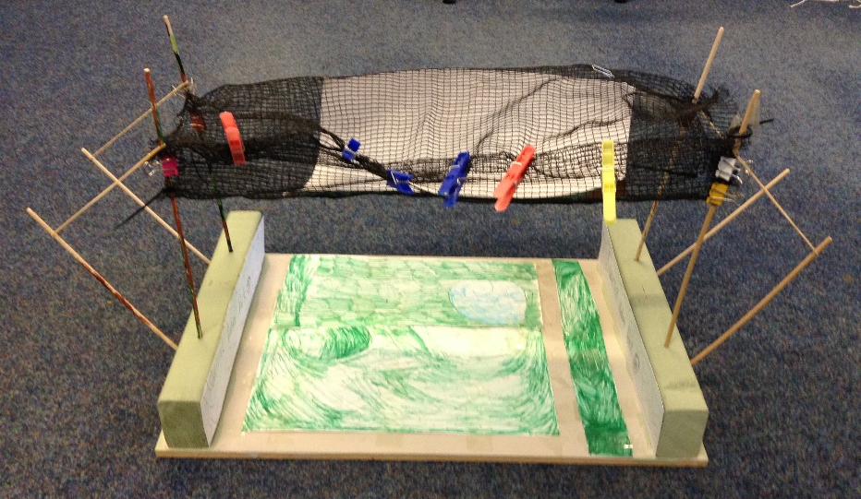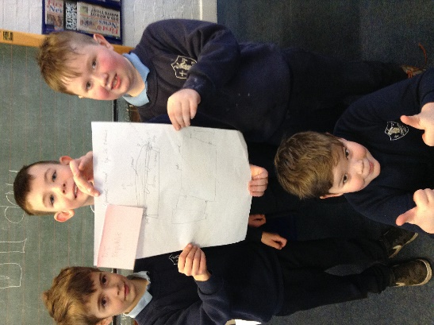

Class 3 Design & Technology Day
On Friday 27th January Class 3 had a visit from Downham Market Rotary Club. They helped set up and run a Junior Technology Tournament. The challenge was to build an Animal Crossing across the ‘Denver Village Nature Reserve’. There was a brief to be followed and the design had to be made as a scale model and then tested. The teams were Nashers, Team England, The Best Frogs, The Galaxy Rabbits and the Star Group, The winning team were the Galaxy Rabbits who were awarded medals and the rest got certificates to celebrate their fantastic ideas and enthusiasm. The day went well and the children made the following comments about the experience.
We created a bridge for animals to cross so they don’t get run over. We have tested it with a weight and it works. Amelia, Galaxy Rabbits
We made a model of a bridge to help animals so they don’t get run over. Lorelei, Best Frogs
We used a net to make the tube but we used paper inside so that the squirrels do not get their feet stuck in the holes. Eric, Nashers.
Our design is fantastic because it uses supports and is ec0-friendly Edith, Team England
We created a bridge to save the squirrels. We used card, string and netting. We are going to add flowers. Max, Star Group
We are trying to make it strong enough to survive the hairdryer, it is called Squirrel Road. Charlie, DT Republic

