Denver Primary Sports Day 2022
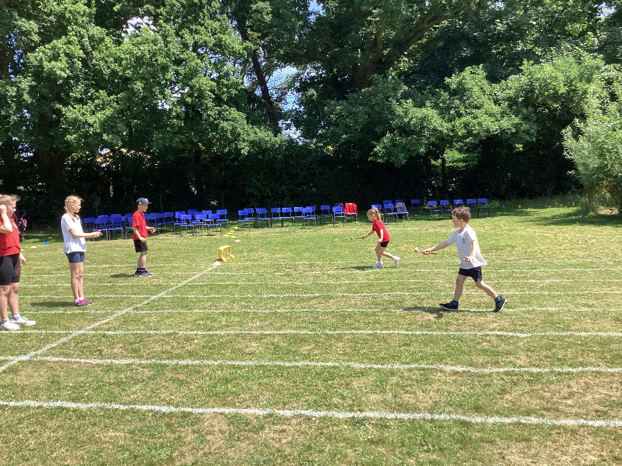
What a fantastic day we had! The sun shone and we were so pleased to be able to welcome our families back to spectate for the first time in 3 years!
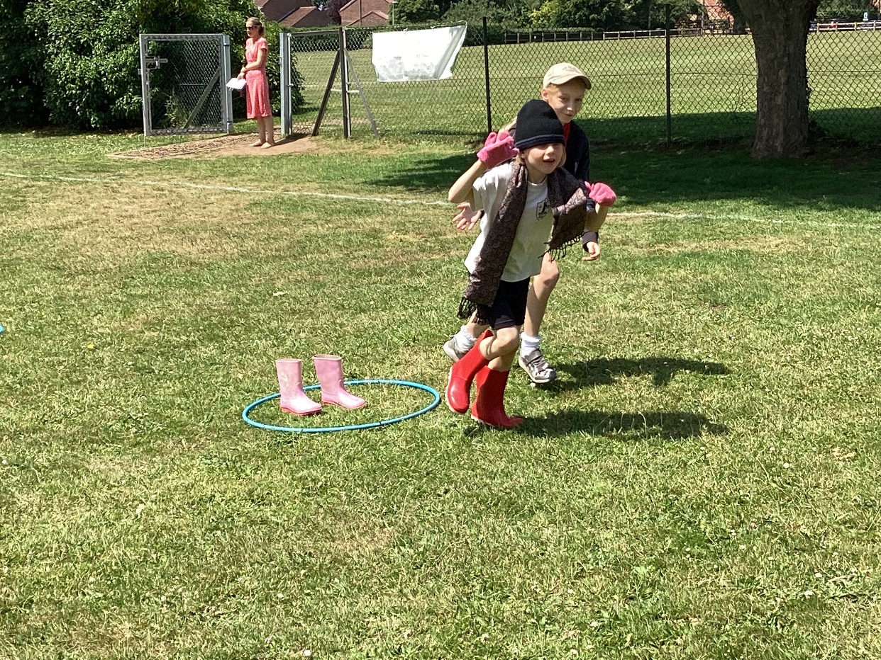

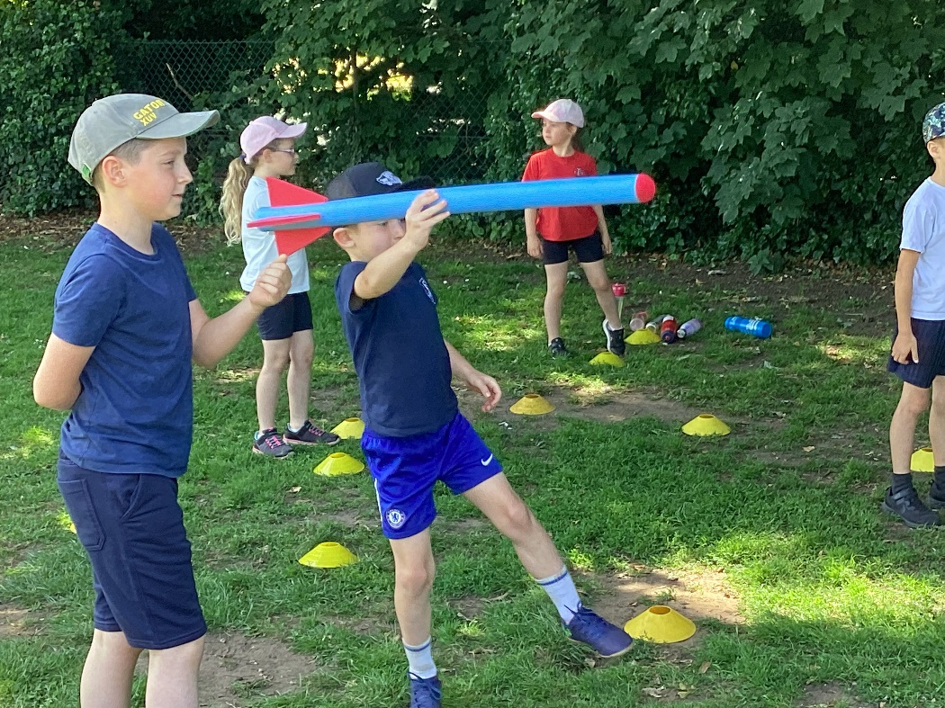
The afternoon began with the KS1 inclusive carousel of activities. This allowed the children to experience a range of non-competitive events that explored fundamental movement skills. The activities included Tri-golf, the water race, the dressing-up race and the foam javelin. They also participated in these track events: egg and spoon, quoits, skipping and running. The Class 4 children were fantastic leaders, running each event and keeping the scores.
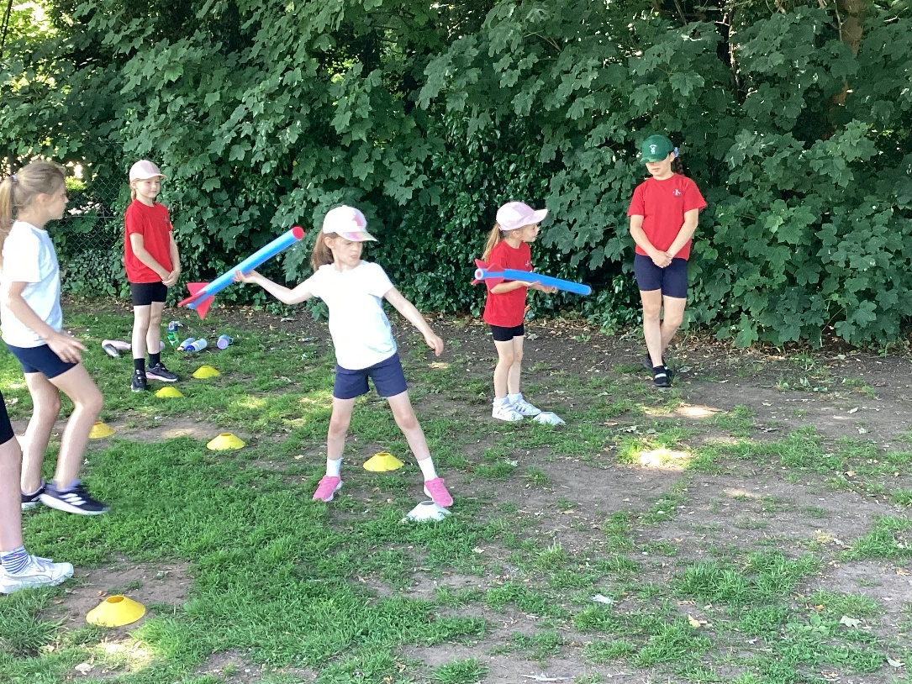

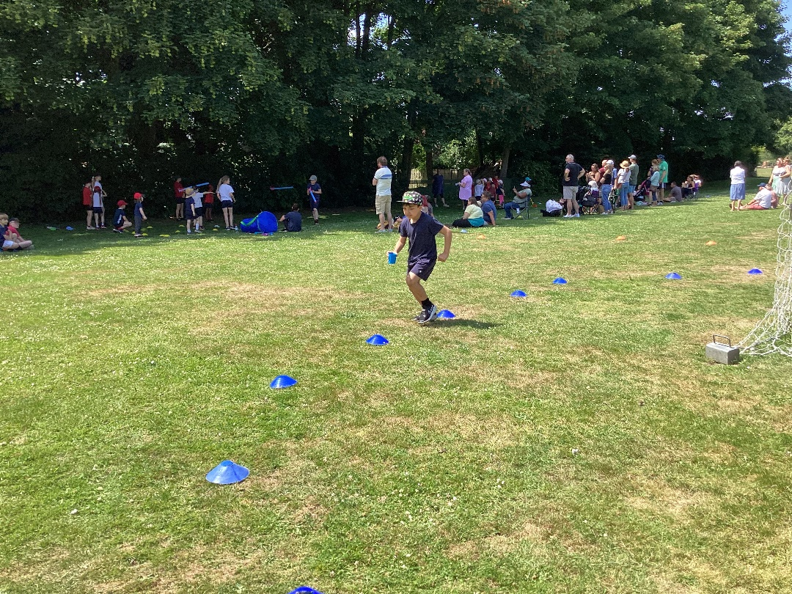
Immediately after was the KS2 traditional sports day. The children did a sprint, a skipping race, hurdles, the ball and bucket race, the egg and spoon and a house team relay. Then the winners of the throw and jump competitions that had been held in PE lessons were involved in a final face off to earn points for their team. Again, the children in Class 4 did a fantastic job of ensuring that everything ran very smoothly and that people were encouraged and supported.
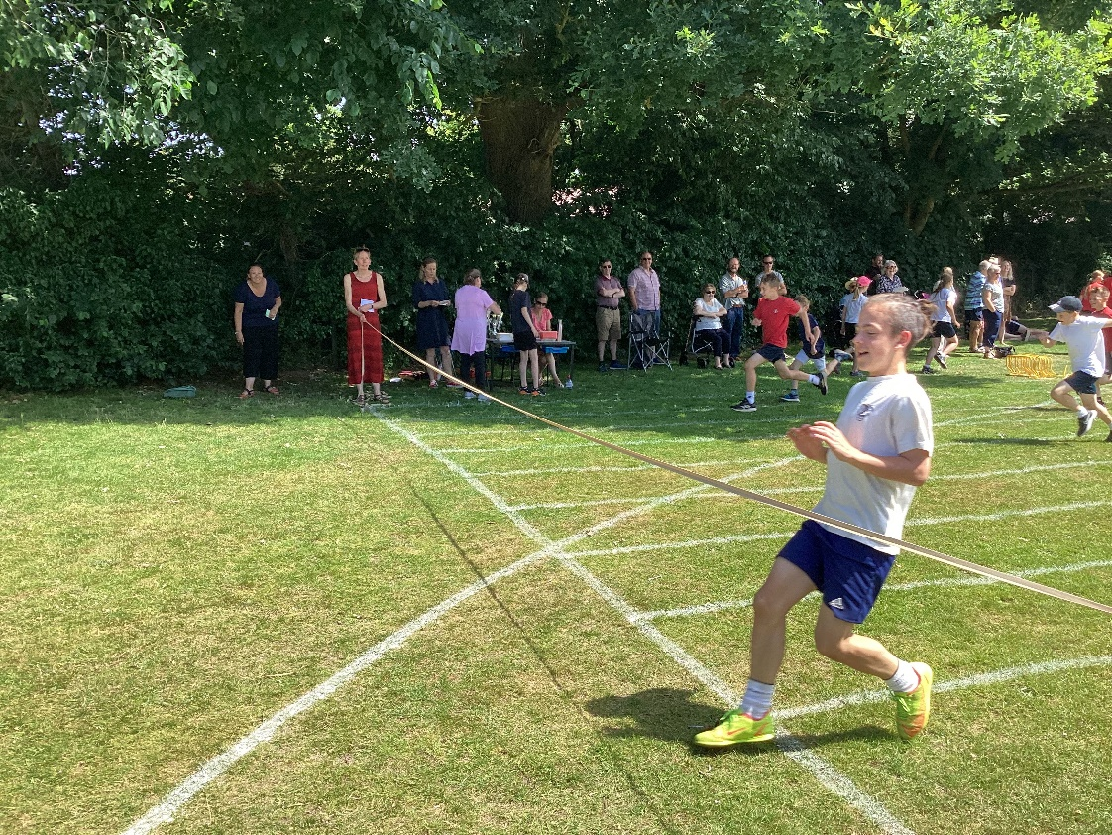
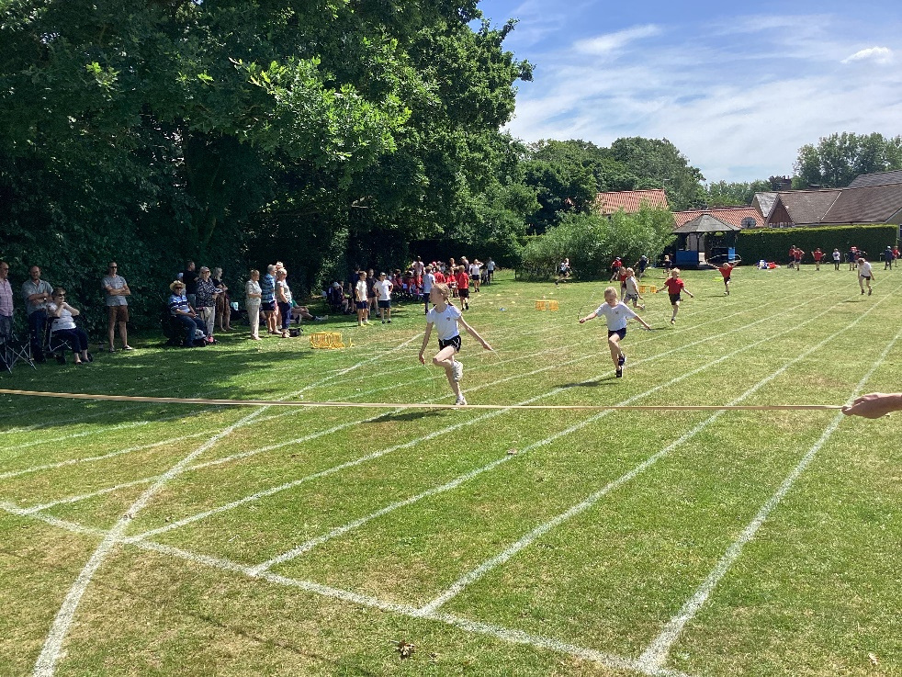
Children across both key stages earned points for their house teams. The overall winners were once again the White team with a very impressive 199 points. Well done to everyone regardless of team for your sportsmanship and for being willing to have a try.
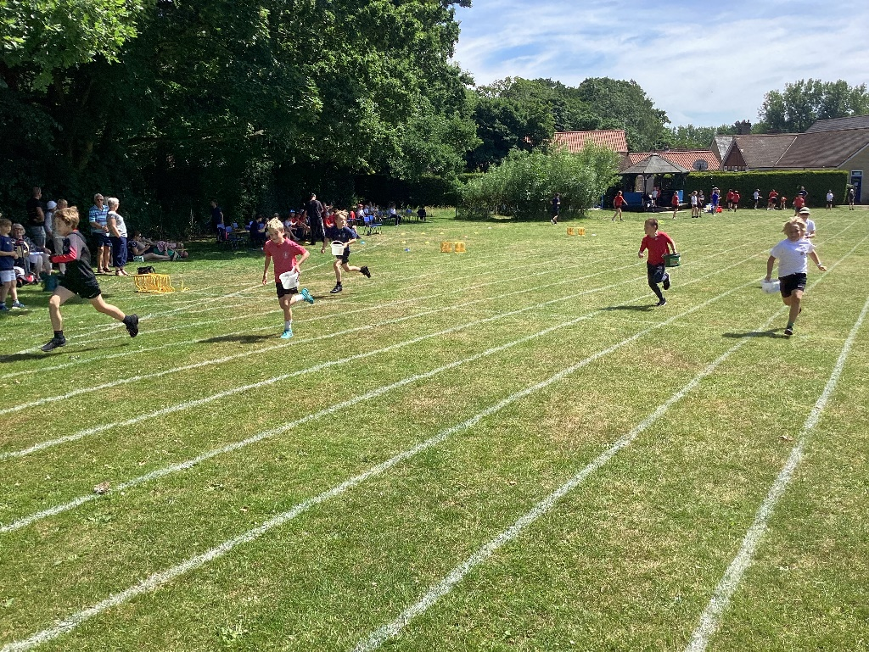

We are immensely grateful to Miss Cronin for organising the event, the staff and parent volunteers and the excellent young leaders of Class 4.

