Quad Kids Area Tournament
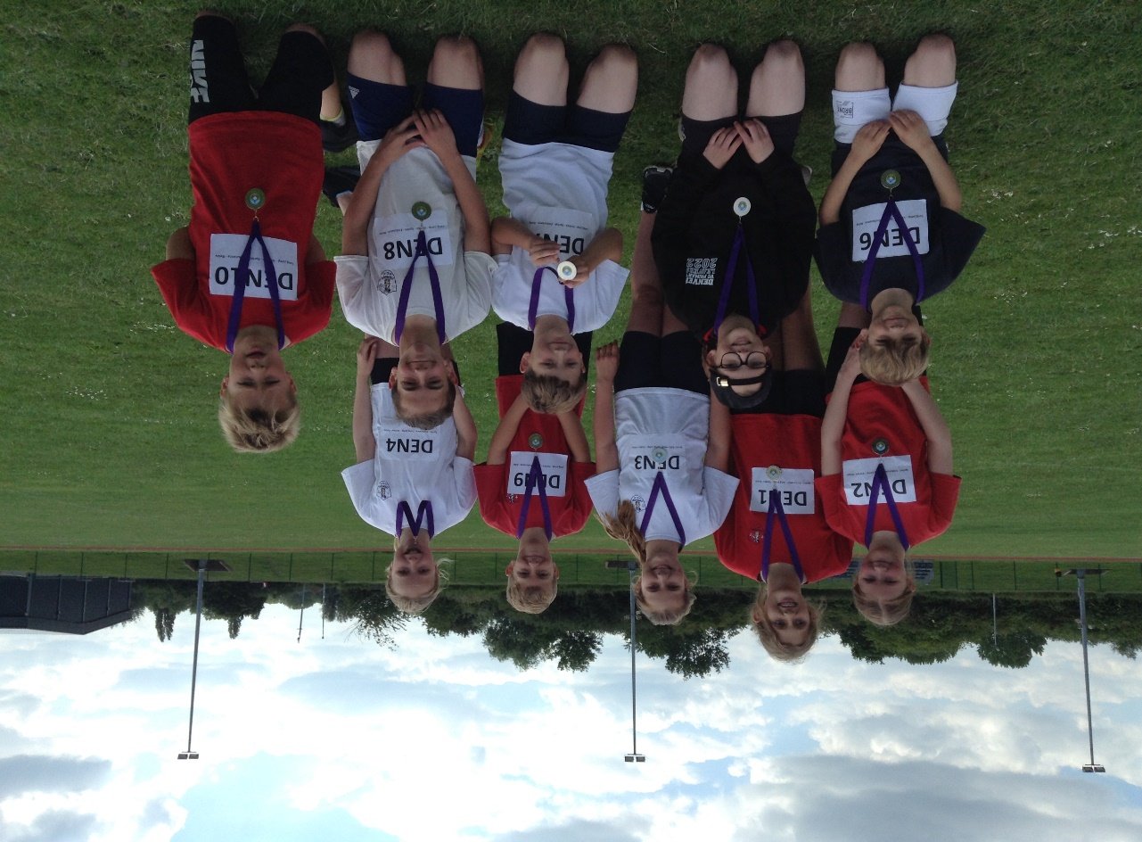
On 14th June, a team of 10 Year 6 children travelled to Lynnsport to compete against other schools in the West Norfolk area. The event was called Quad Kids and focussed on 4 fundamental athletics skills: endurance, sprint, jumping and throwing.
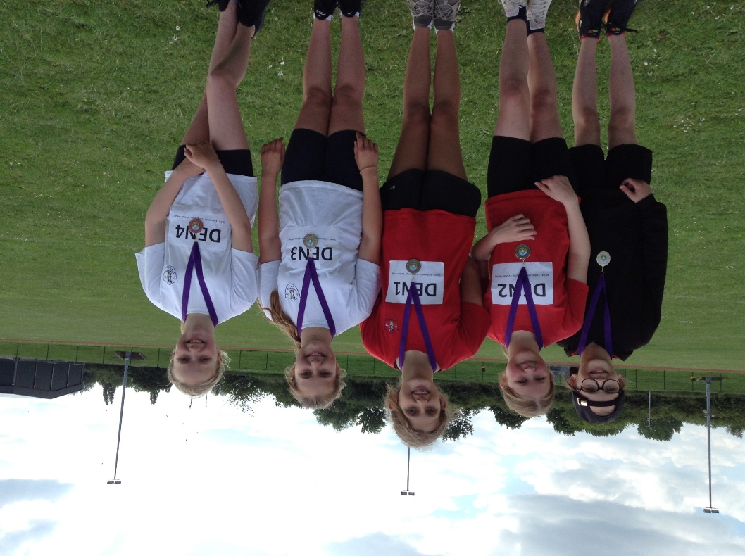

This was the first time that we had entered the event: the last two were cancelled due to Covid-19.
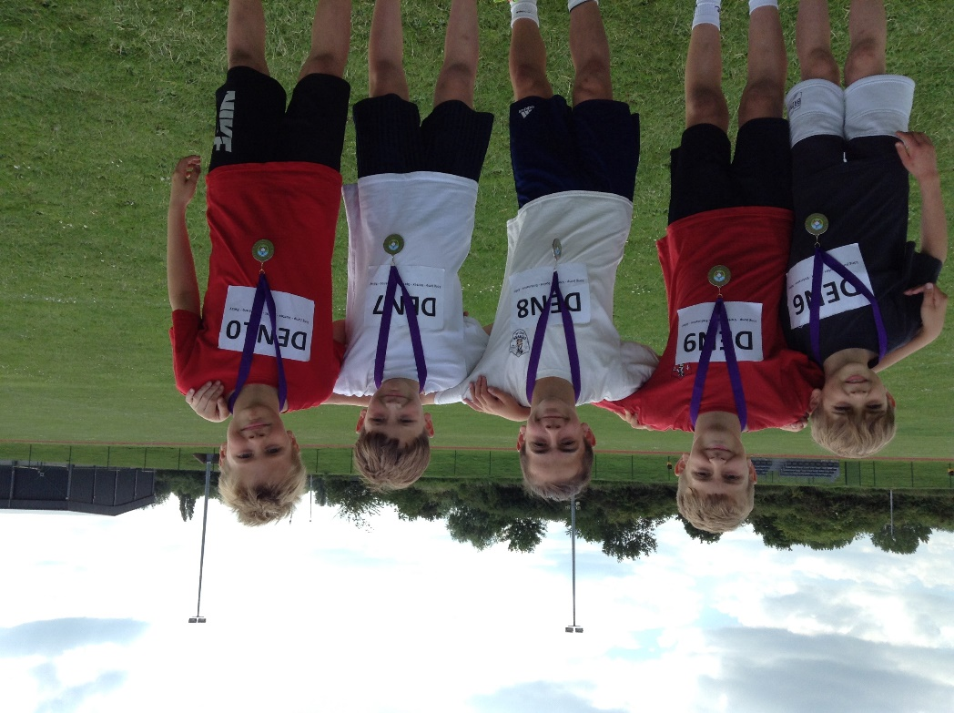
The team comprised of five boys and five girls. Each had to take part in all four disciplines and then a team relay. Scores were pooled to create a final team score.

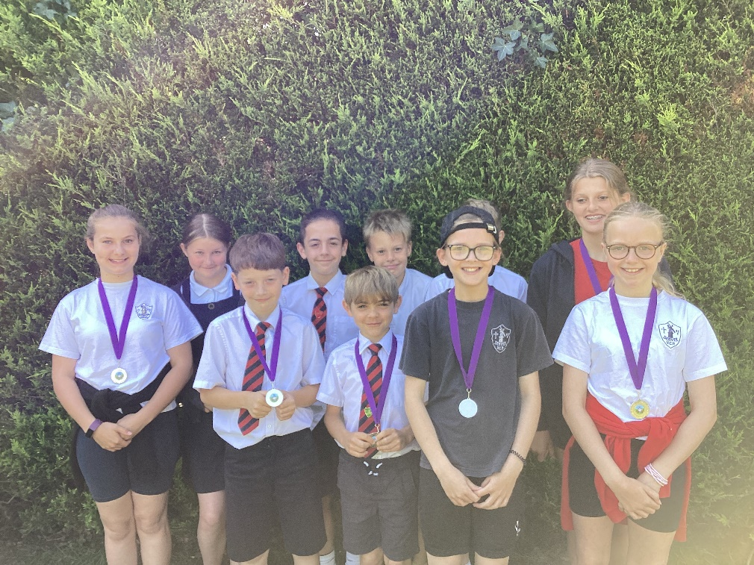

The team performed incredibly well, especially in the endurance run which is testimony to the impact of the Golden Mile.

They finished in second place and are rightly very proud of their medals. Once again they showed excellent behaviour and sportsmanship throughout the tournament.
Thank you also to Miss Waters and Mrs Williamson for taking them.

