Sponsored Walk 2022
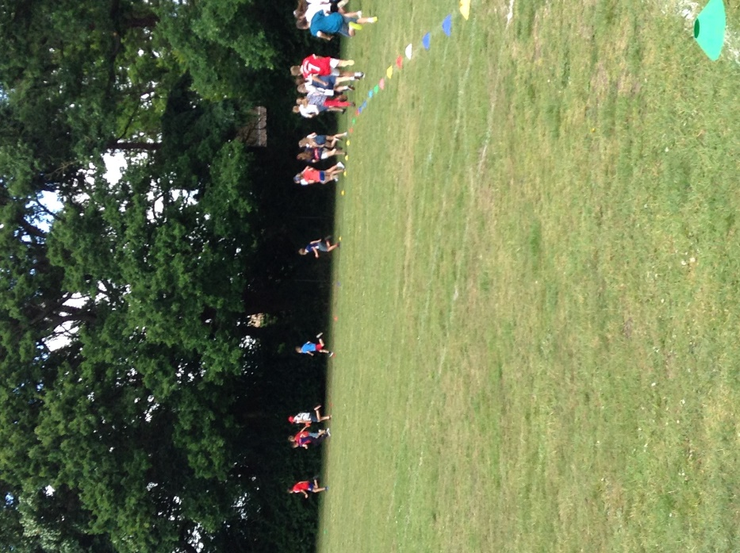
May 27th not only marked our Platinum Jubilee celebrations but was also a return to a fully mixed sponsored walk for the first time since 2019.
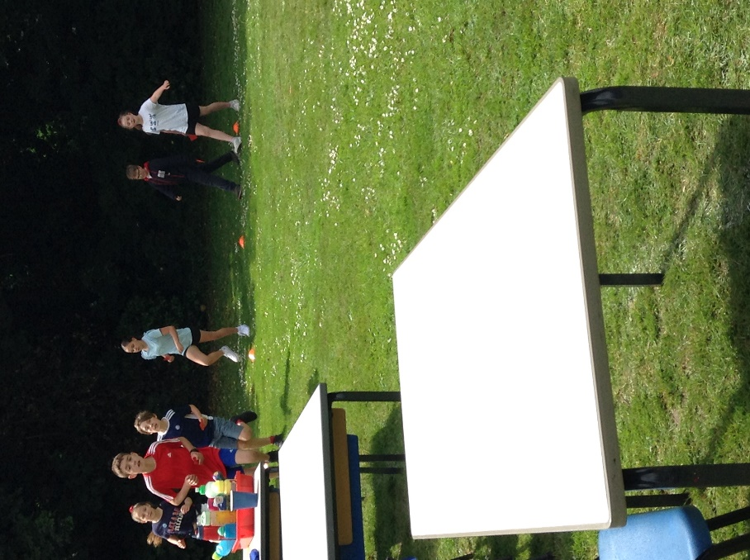
All classes watched by parents, families and carers gathered on the field to complete as many laps of our Golden Mile track as they could in approximately one hour.
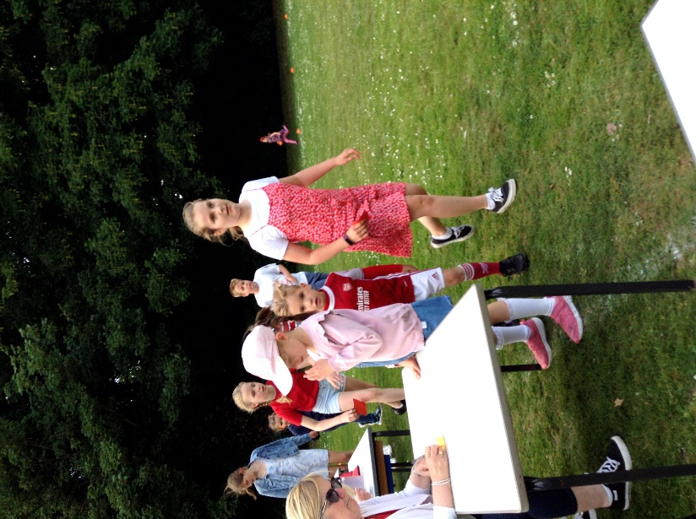
The weather was perfect. It was lovely to see our pupils helping their pre-school siblings around some of whom will be joining us in Reception this September giving them a positive first experience of the school.
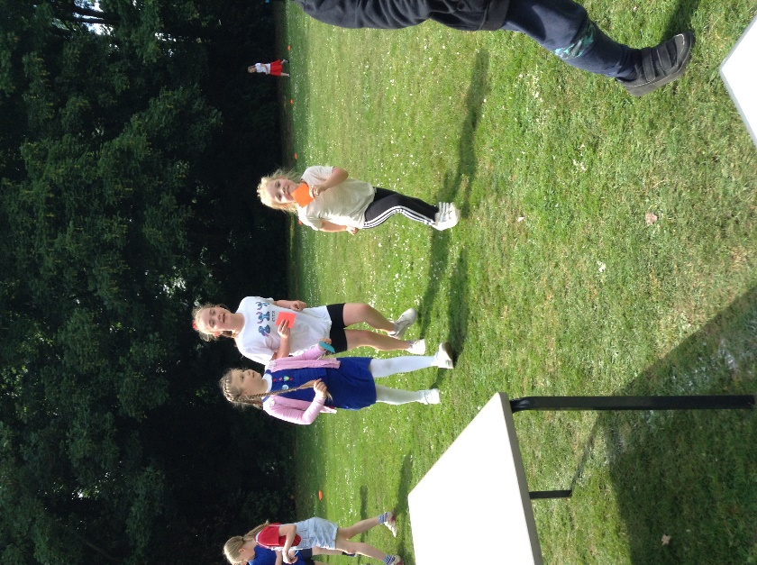
Funds raised by this event will go to the Friends of Denver School. The Friends committee provides a wealth of support to our curriculum my enriching resources and funding school visits. We appreciate their hard work and dedication.


