Class 4 Platinum Jubilee Celebrations
We arrived dressed in red, white and blue.
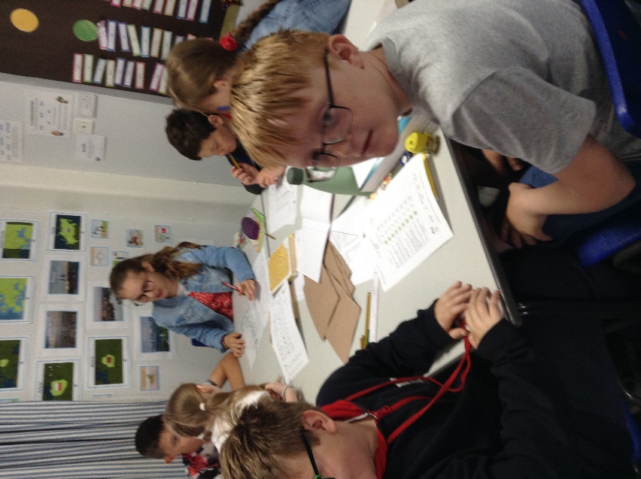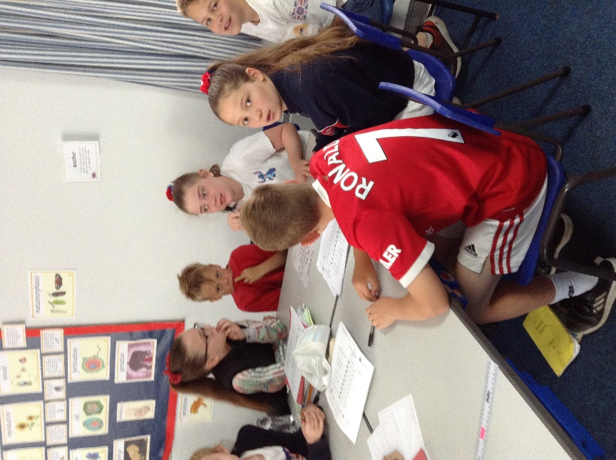
The final day of the current half-term (27th May) was a real treat. We began our celebrations in class with team quizzes about HM Queen Elizabeth II.
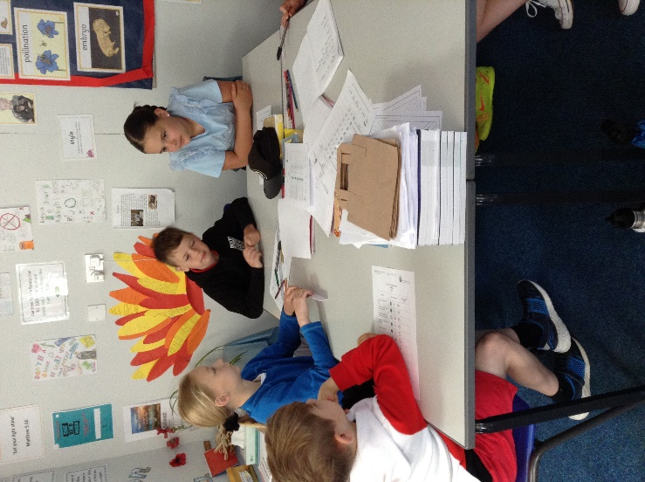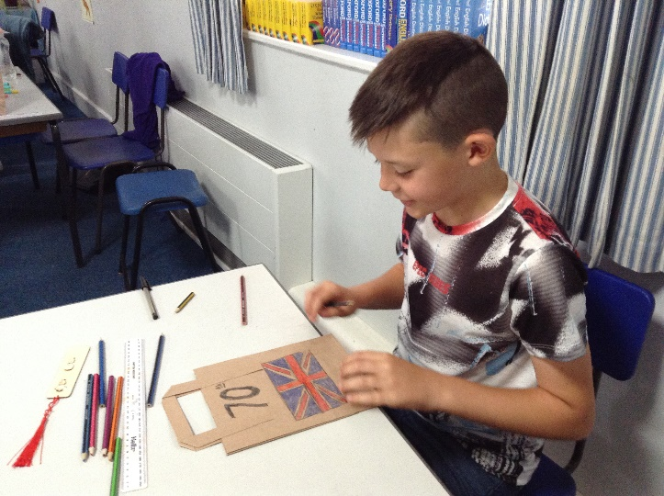

This was followed by a number of activities throughout the morning to prepare us for the street party lunch and celebrations that began from noon onwards. We made royal-themed bookmarks as a memento, decorated our lunch bags and made decorations (bunting and flags) for the party.
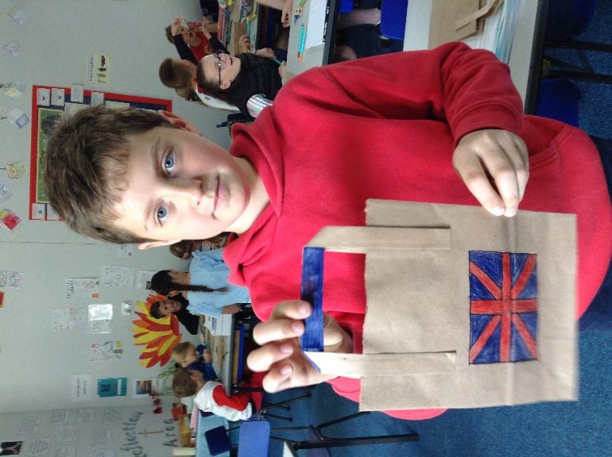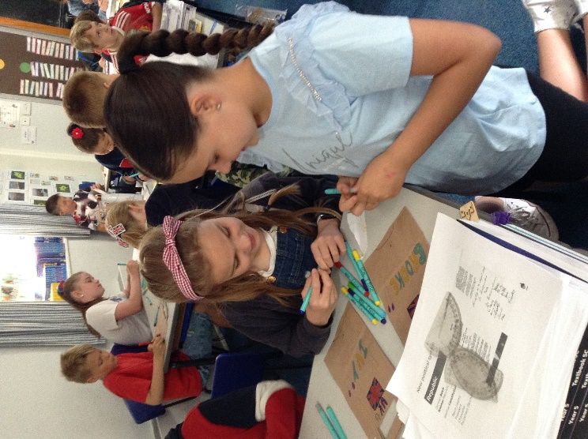

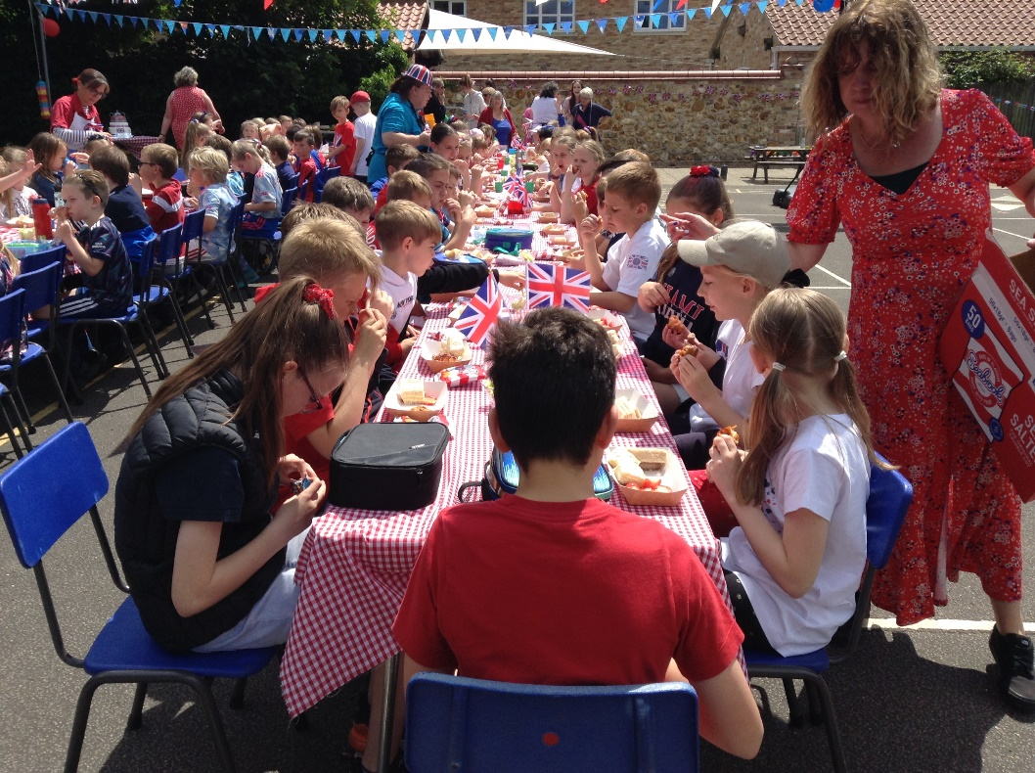
At lunchtime, we all congregated on a beautifully decorated playground for a fantastic lunch prepared by our superb kitchen staff and Mrs Legge who returned to help out. Though a little windy, the sun shone for us.
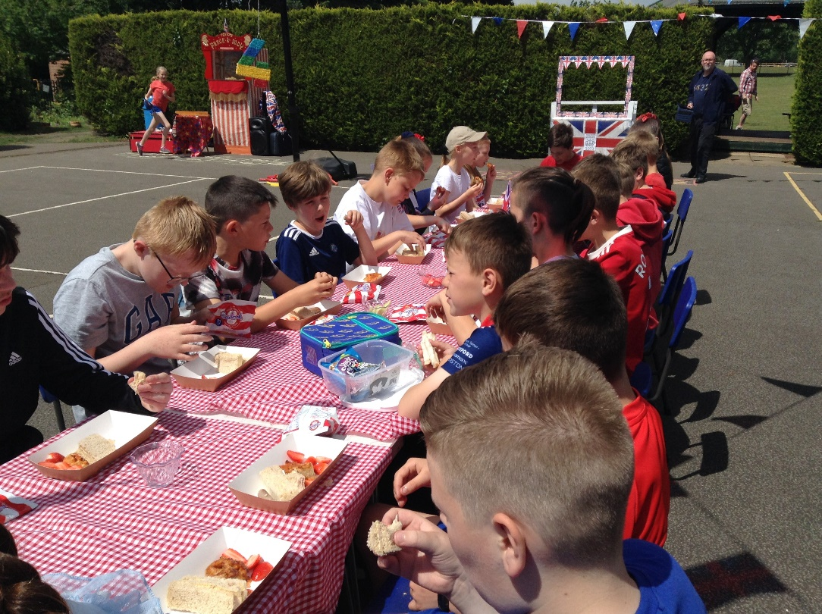
During lunch we were treated to entertainment from a former Britain’s Got Talent contestant who unicycled and juggled around us.
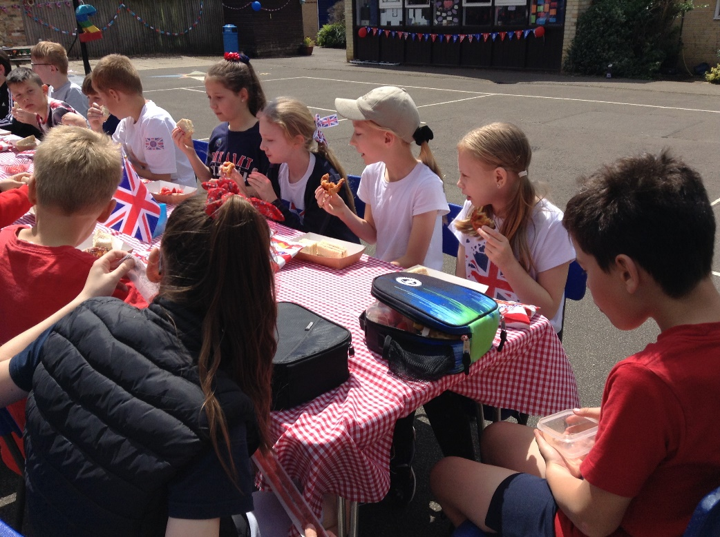
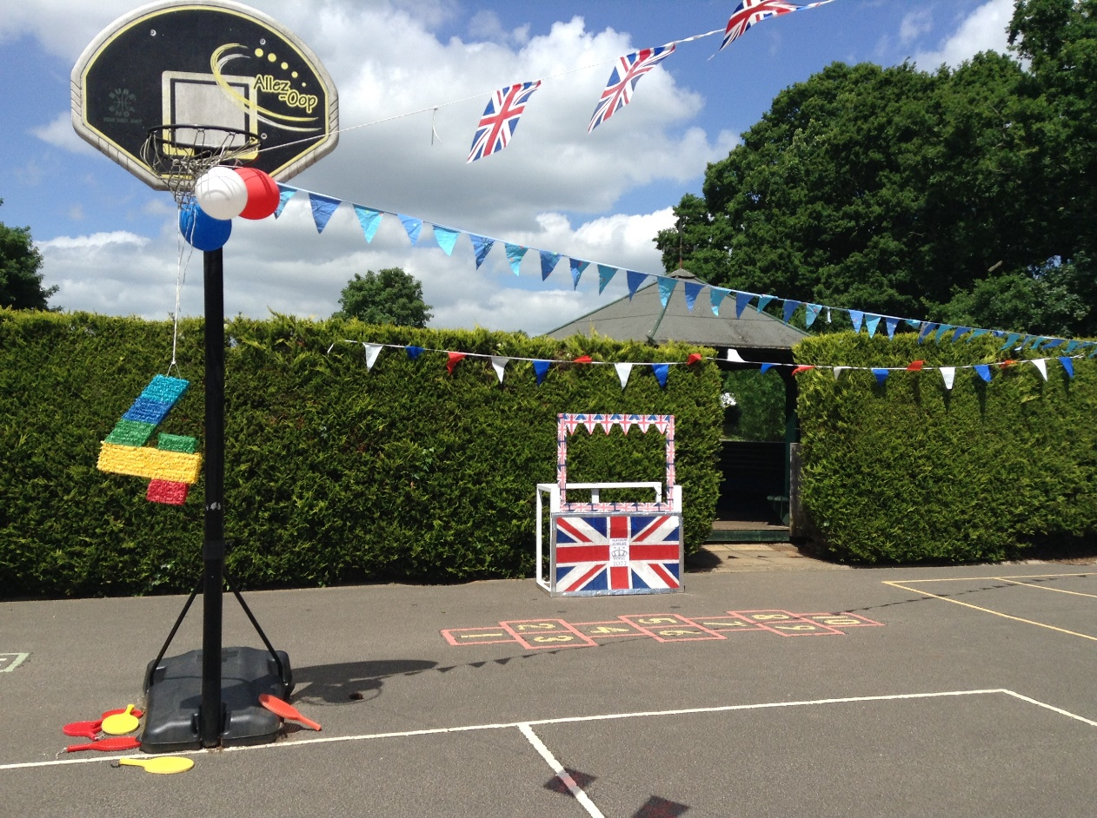
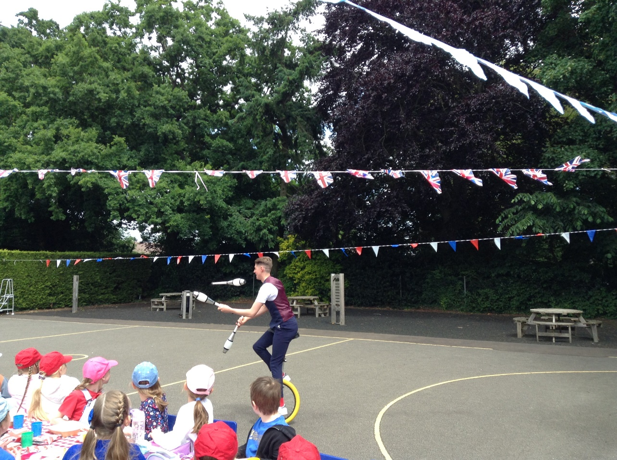

But the fun and treats didn’t stop there: having already received commemorative coins from the mayor of King’s Lynn, the children were presented with special souvenir mugs from the Denver Parish Council. Parents, families and carers had also joined us by this time too. It was fantastic to see so many and to be able to welcome people onto the site.
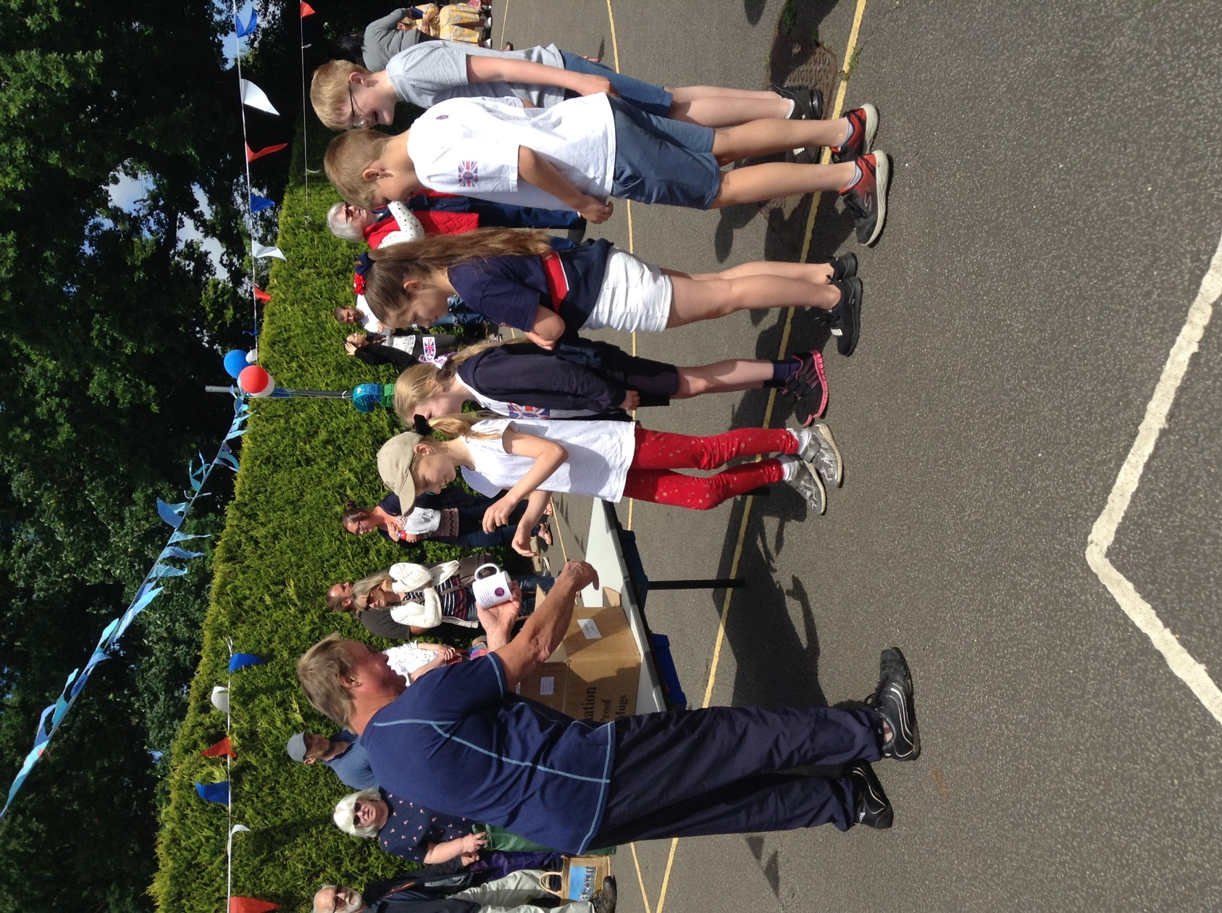
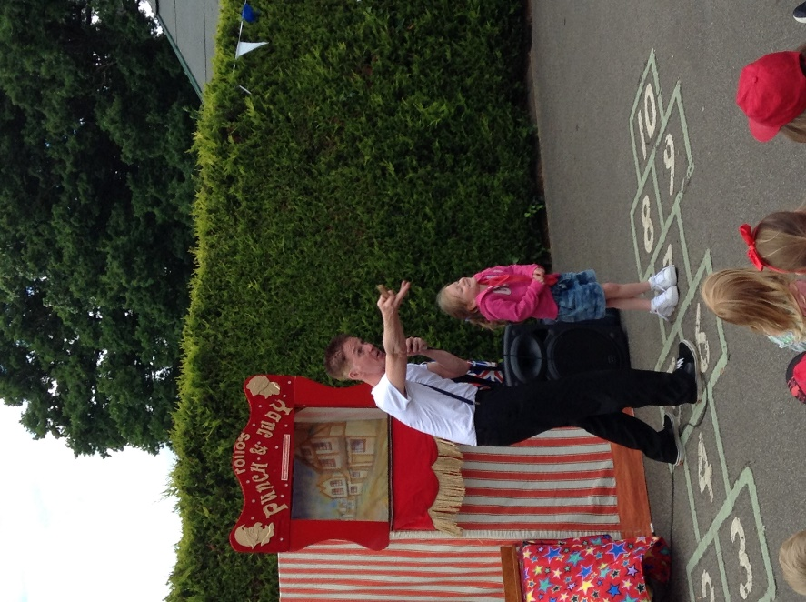
The next treat was a children’s entertainer and Punch and Judy show. Then each class smashed their piñata to get the sweets – Edward gave ours the decisive wallop!
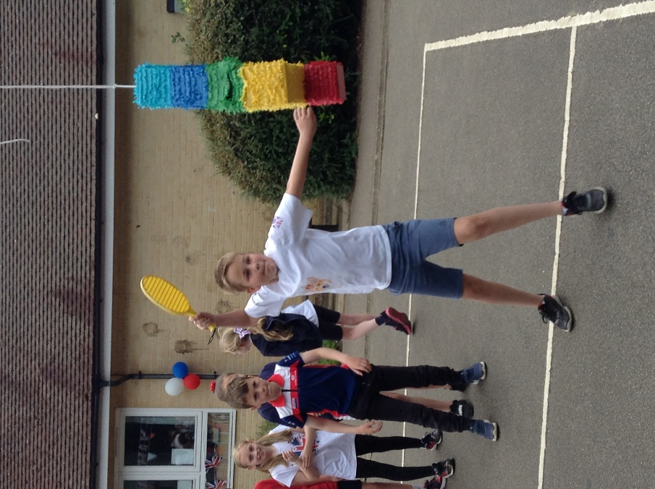

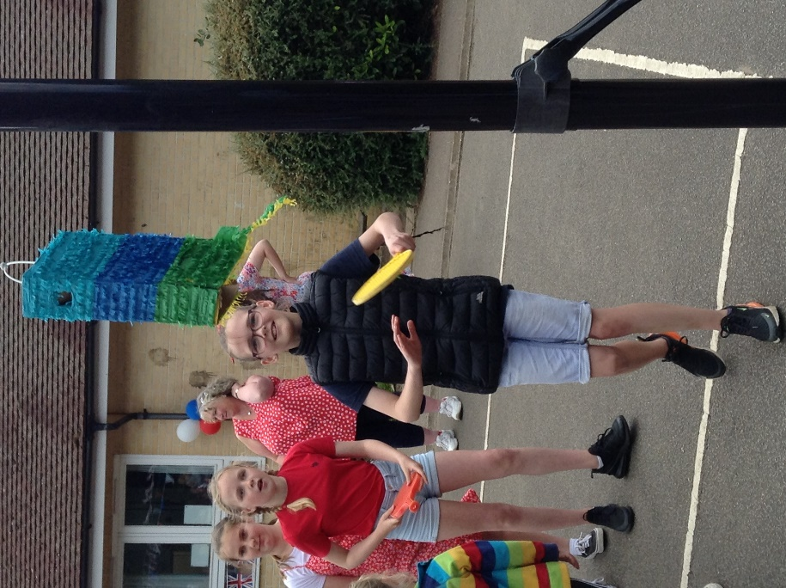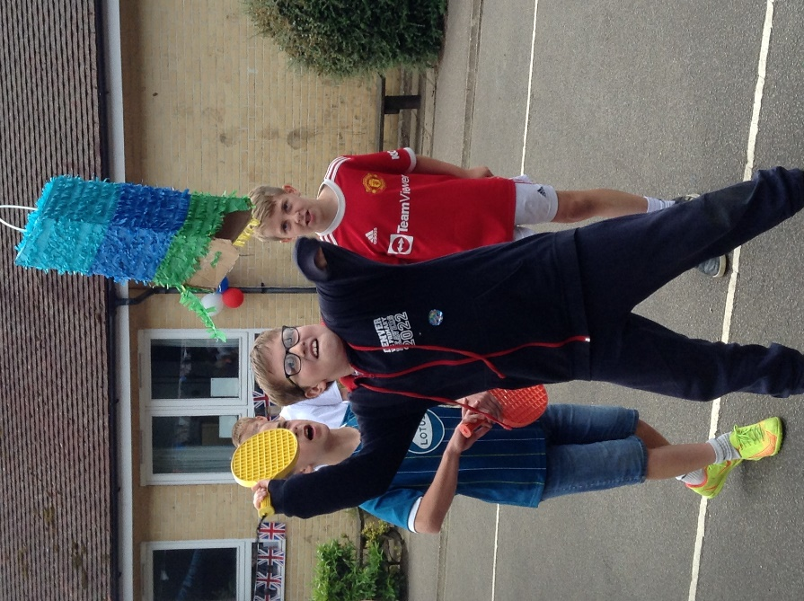

Ice-creams and cakes were flowing as the children left the school.
We are immensely grateful to everyone involved in today’s special and memorable events. Particular mentions go to the Friends of Denver School, our parents, our governors, our staff and the amazing Mrs Jones and Mrs Dawson. We are very fortunate to have had these opportunities to celebrate Her Majesty.

