Kwik Cricket Tournament 2022

The members of our cricket club attended the Downham Market Cluster Kwik Cricket tournament on Thursday 26th May at the Memorial Field in the town centre.
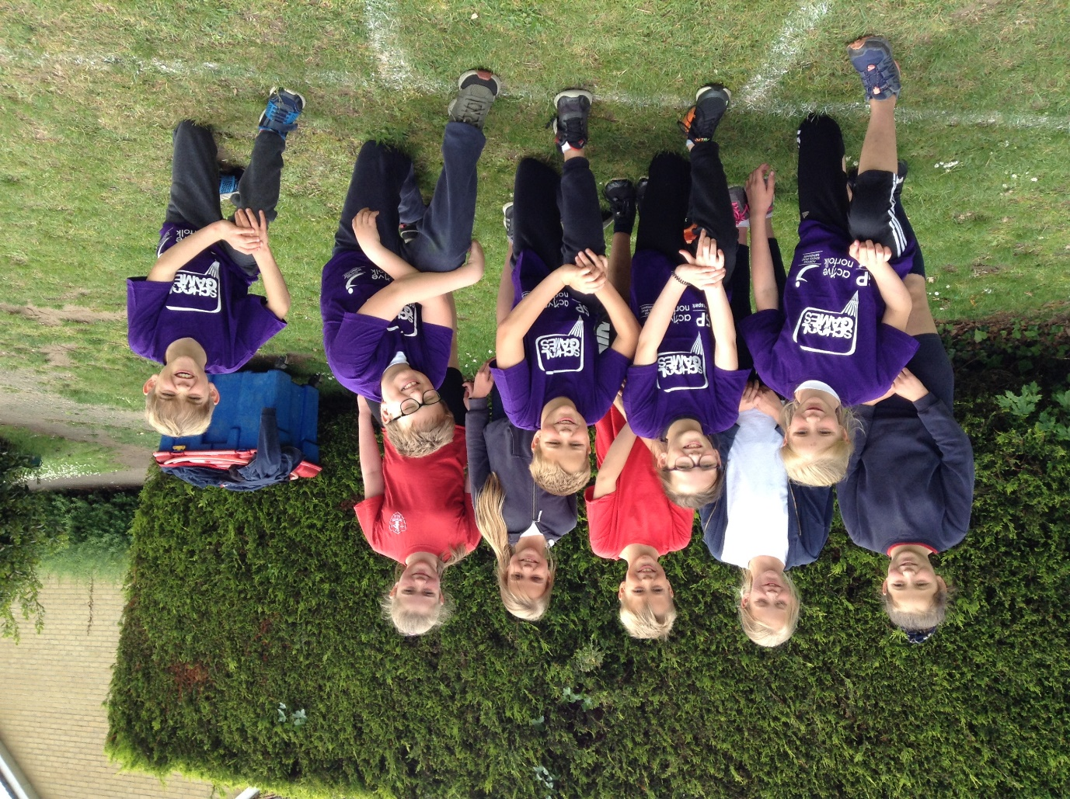

Although they didn’t finish in the top two to be able to progress to the area finals, five of the children were singled out for their talents and earned School Games T-shirts. Summer was deemed the most improved of all the players, Jacob was recognised for good sportsmanship, Thomas claimed the best catch in the competition, Kaylee was the most successful fielder and Edward won his T-shirt for hitting the most sixes and for his excellent bowling. An impressive range of sporting and social skills to be celebrated. Well done to all of the team. We are proud of you!

