Cluster Football Festival for Girls

On Monday 25th April, 2 teams of 6 girls travelled to Downham Market Academy for a football festival.
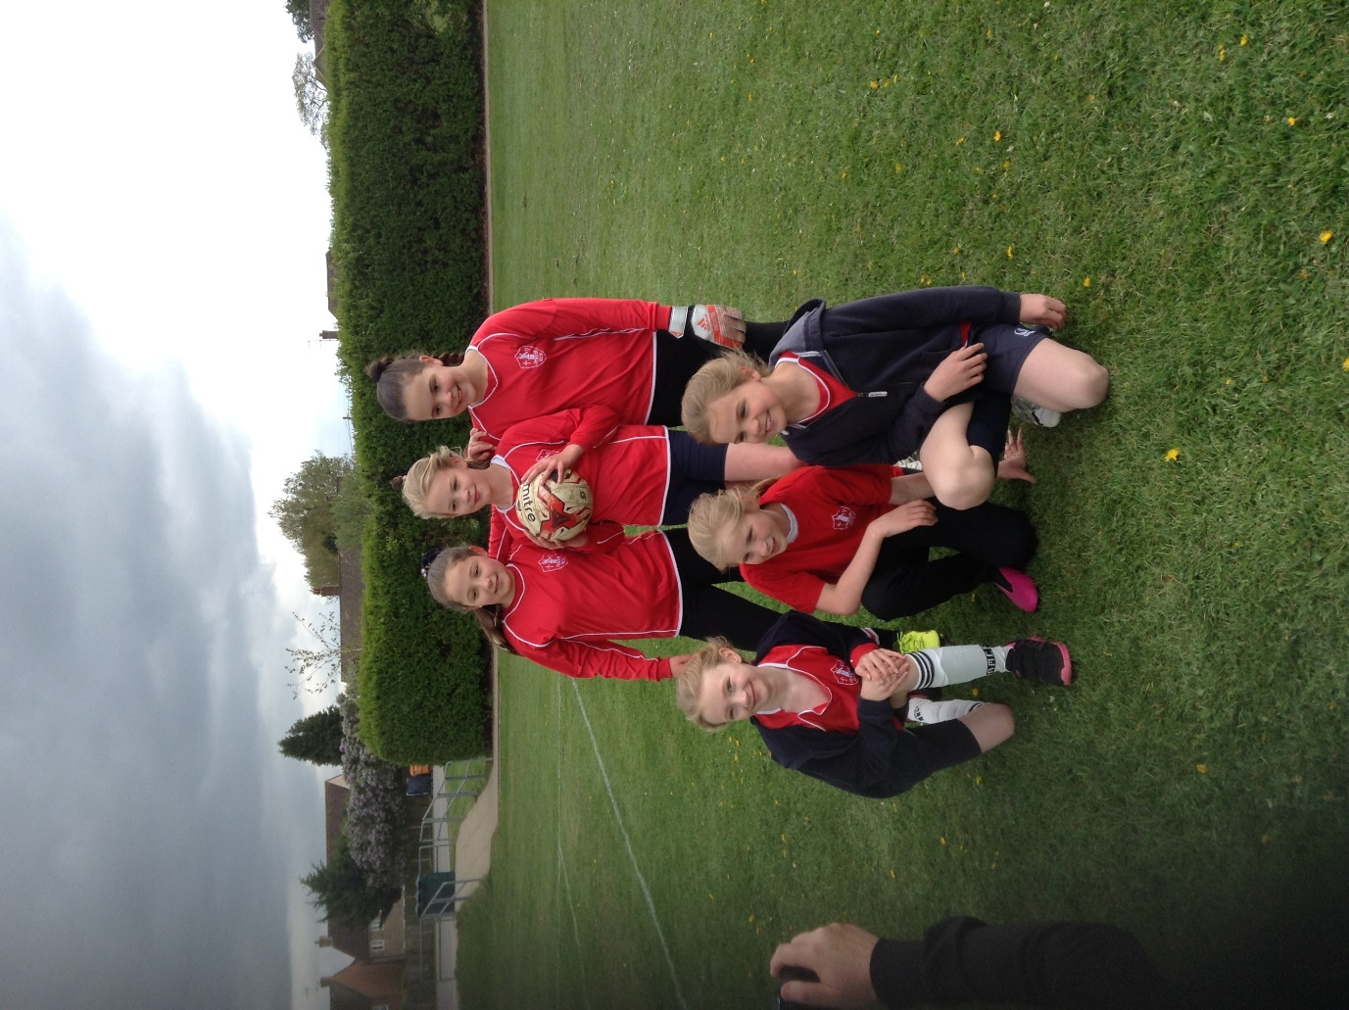

The girls were a credit to the school for their teamwork, behaviour, enthusiasm and effort. They supported each other and were recognised by the sports coaches for their talents.

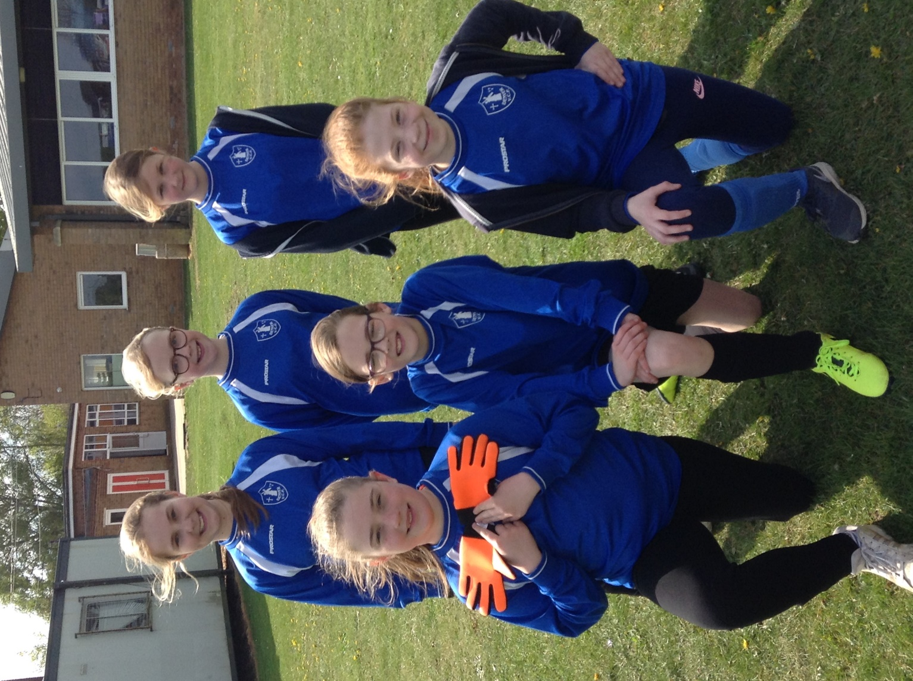

As this was a ‘development’ rather than ‘competitive’ festival no formal places were given. However, the girls performed really well winning or drawing the vast majority of their matches and scoring plenty of goals.

A very big thank you to Mrs Collins and Mrs Williamson for taking them to DMA.

