KS1 multi-skills intra-festival

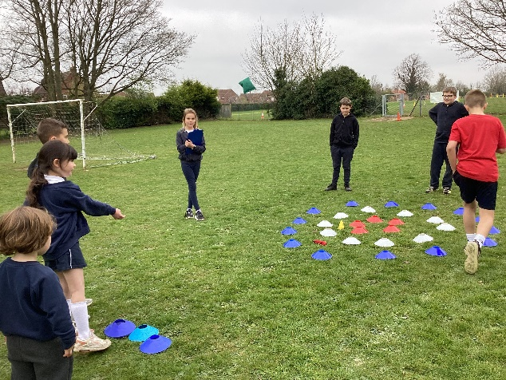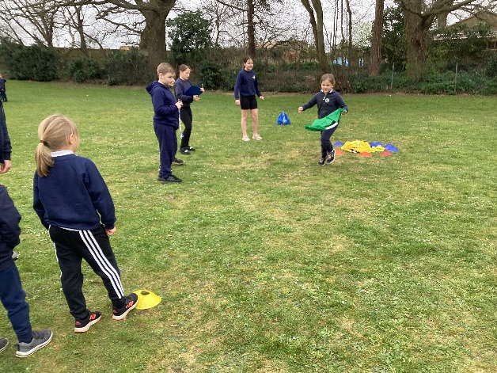
On Tuesday 29th March children in Class 4 used their ‘Young Leader’ skills to deliver a very successful multi-skills festival to all of KS1 and Reception children.
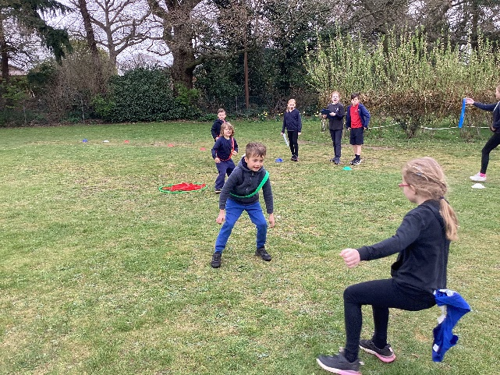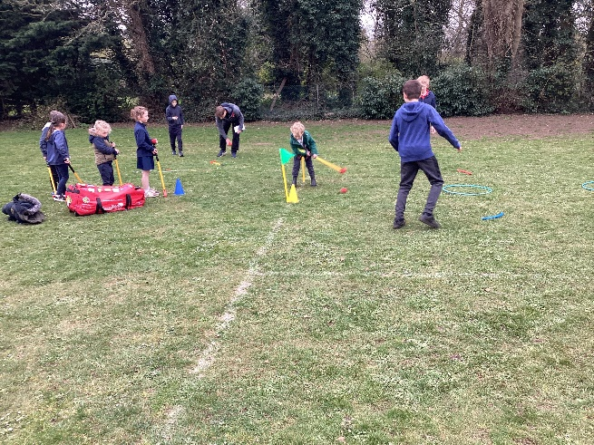
The children worked in groups to plan, design and organise an activity and decide on how they would communicate the game to the younger children and how they would score the event.
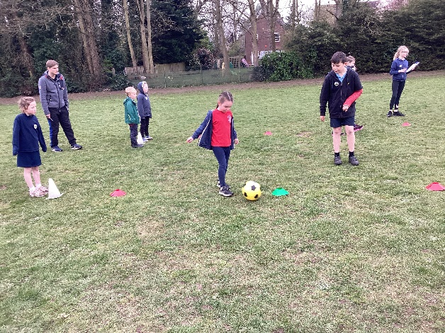
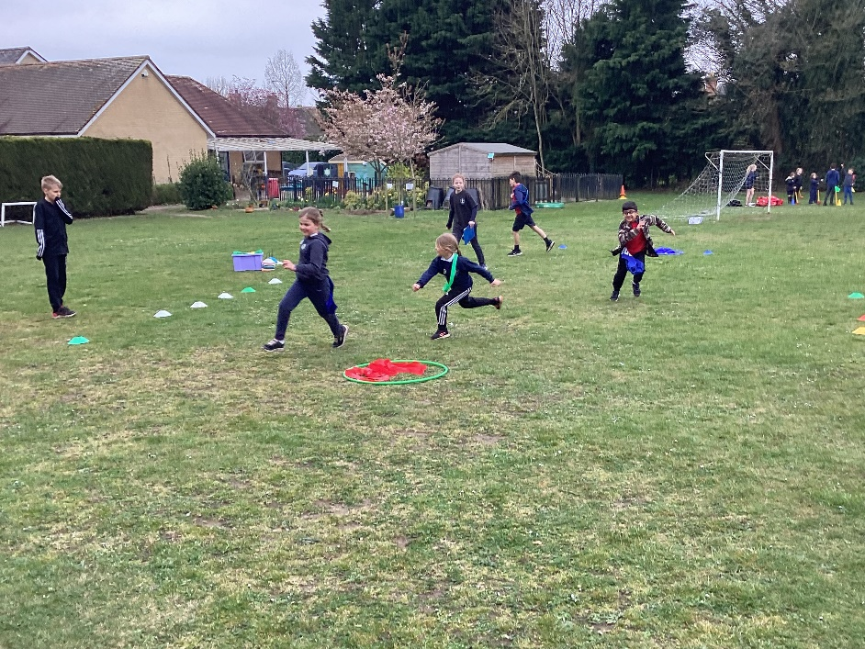

The aims of the festival were many and were achieved: increasing activity levels in all children, improving communication and interaction, promoting positive teamwork, fostering an interest in new physical activities and supporting each other.
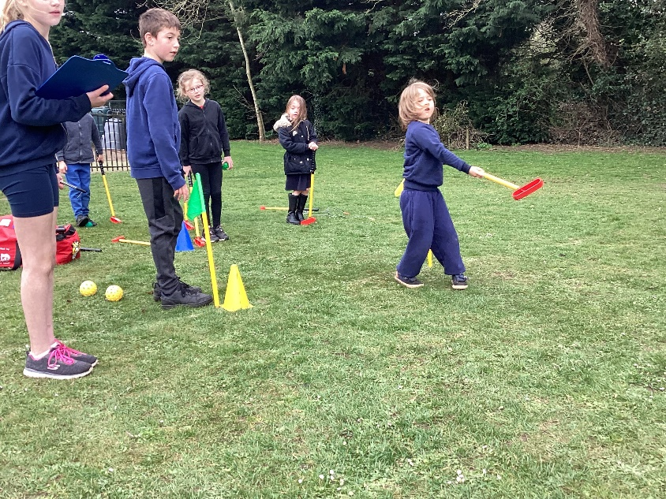

The younger children were enthusiastic, well-behaved and beamed happily as they improved at each of the activities (these included using agility, pace and stamina to throw, dribble, kick and strike).
The older children did a great job of running the event smoothly, showing patience and compassion for the younger children. We are very proud of all of them.


