Downham Market Cluster Football Tournament
After two years of being impacted by Covid restrictions, the cluster football tournament finally resumed much to the delight of the children.
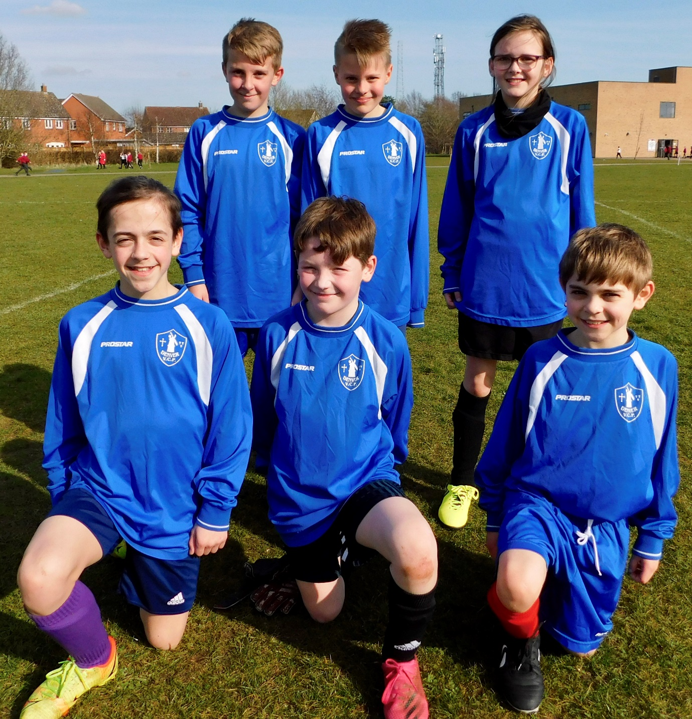

Despite a rise in cases locally, we were really pleased to be able to enter two teams to the tournament which was a School Games ‘Compete’ level competition.

The competition took place at Hillcrest Primary on Tuesday 15th March 2022 and the weather was perfect.

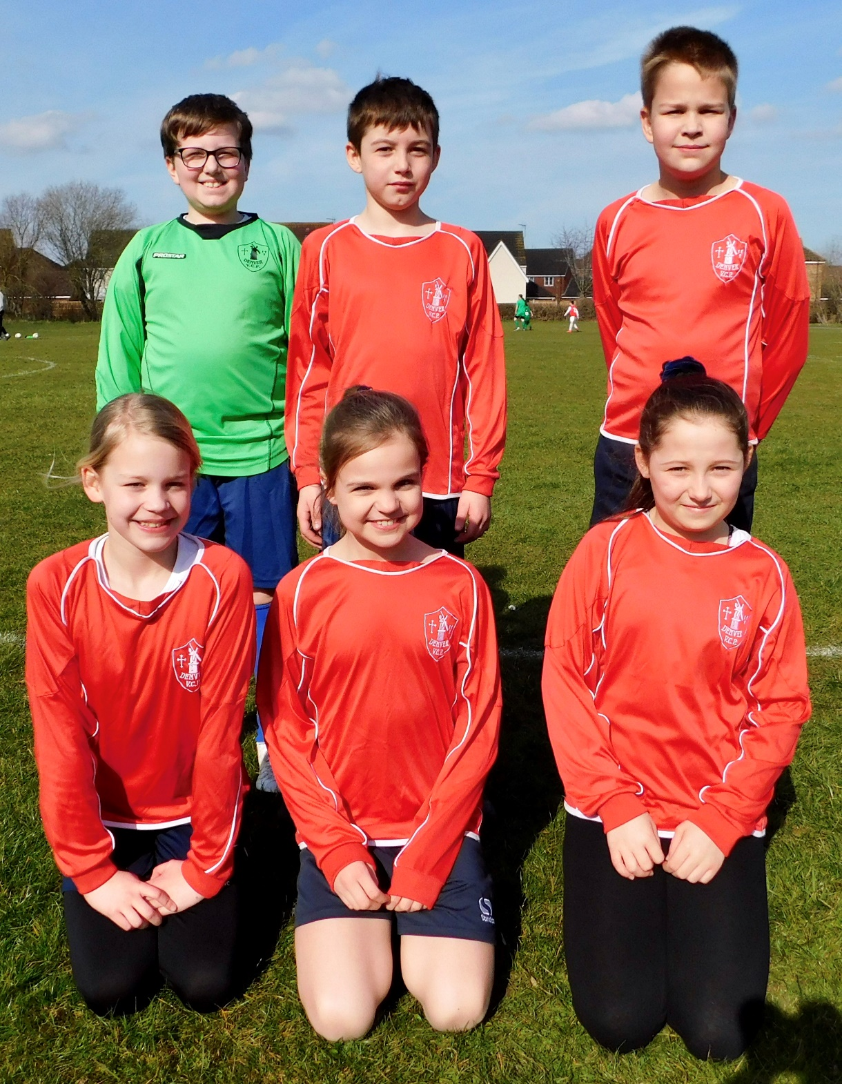
We are really proud of both teams for showing excellent sportsmanship, teamwork and resilience. Everyone gave their best effort and were a delight to take. They showed the very best of our school. Mrs Bower was especially pleased with Charlie, singling him out for a special award for showing the School Games values.
The icing on the cake was that our Year 6 team came away as victors of the tournament, winning all of their matches and coming back to school with their medals. Very impressive! All competitors will receive a certificate which will be given out in Friday’s assembly.

We are also very grateful to Miss Waters and Mrs Collins for taking the children.

