World Book Day March 3rd 2022
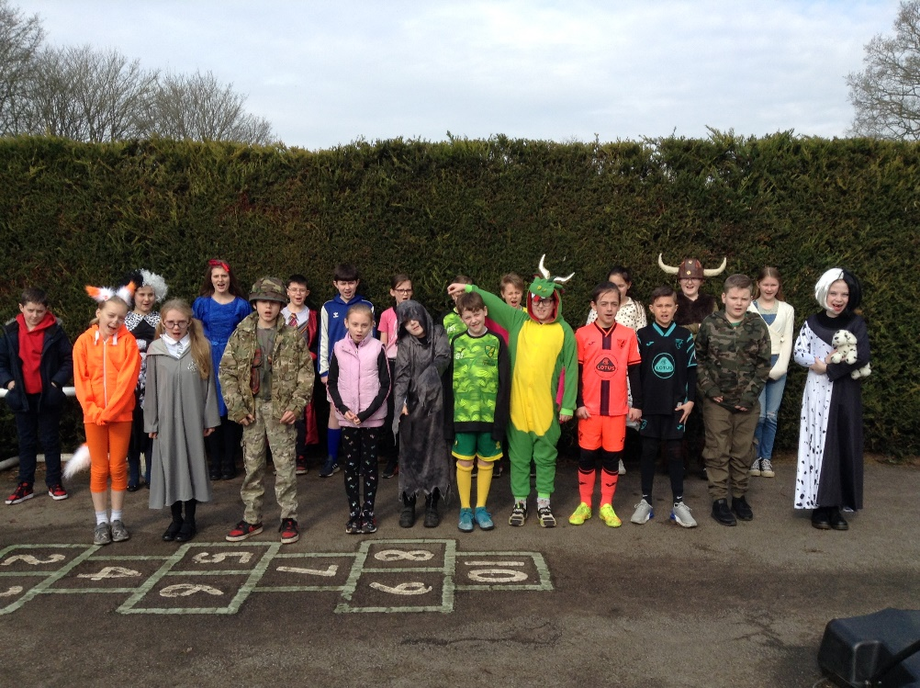
To celebrate the 25th birthday of World Book Day, we all dressed as our favourite storybook characters.
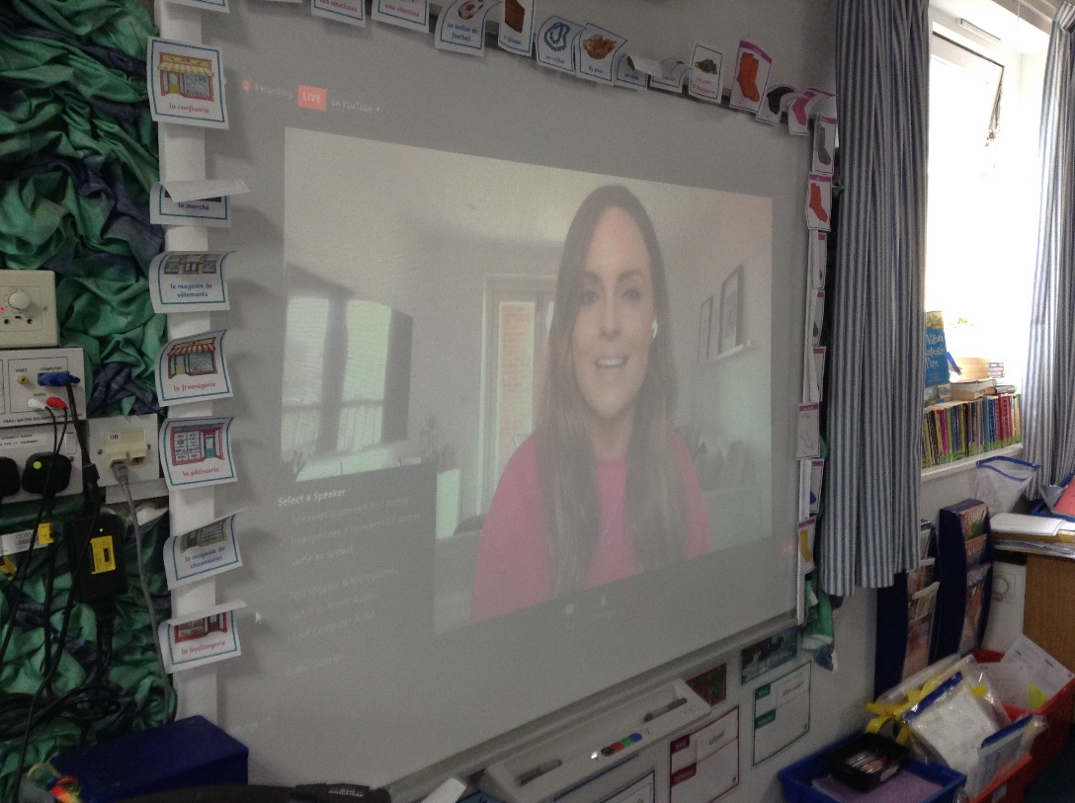

Throughout the morning we did a range of activities instead of our normal lessons. We made bookmarks and book spines about our favourite books for the school library.

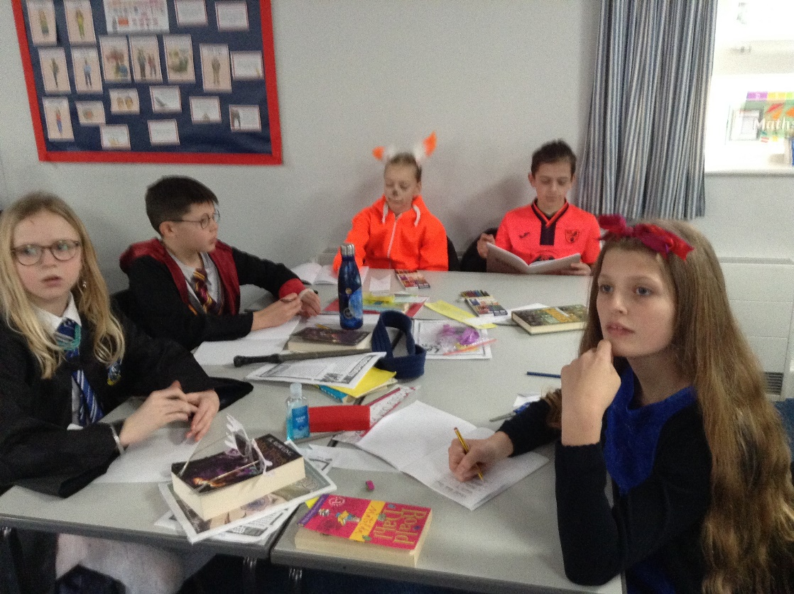
We joined the Premier League Primary Stars for a World Book Day and football quiz with many other schools throughout the country.
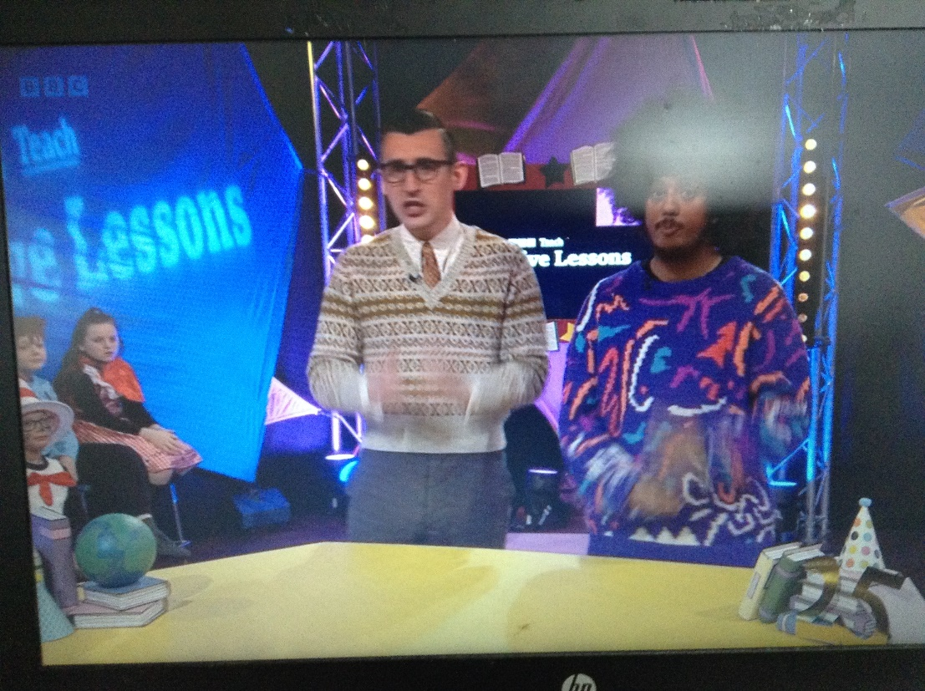

The BBC ran an online live lesson at 11am. We joined in with this and the two follow-up activities: writing the structure of our favourite book and then designing an advert encouraging others to read our favourite books.
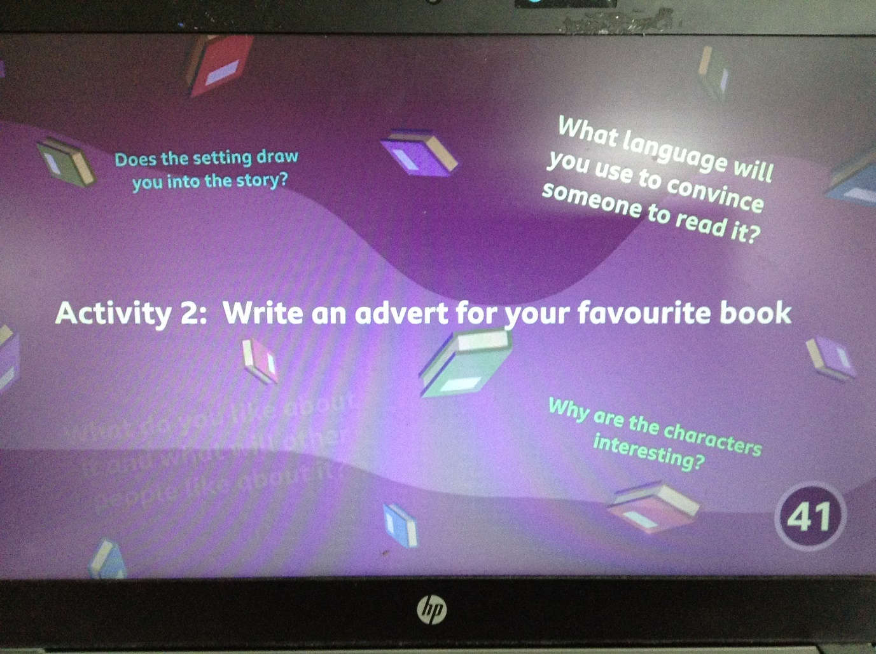
We were also treated to biscuits from the kitchen. Delicious!

Finally, we joined Class 1 to share reading with them.


