Fitness Tracker Training
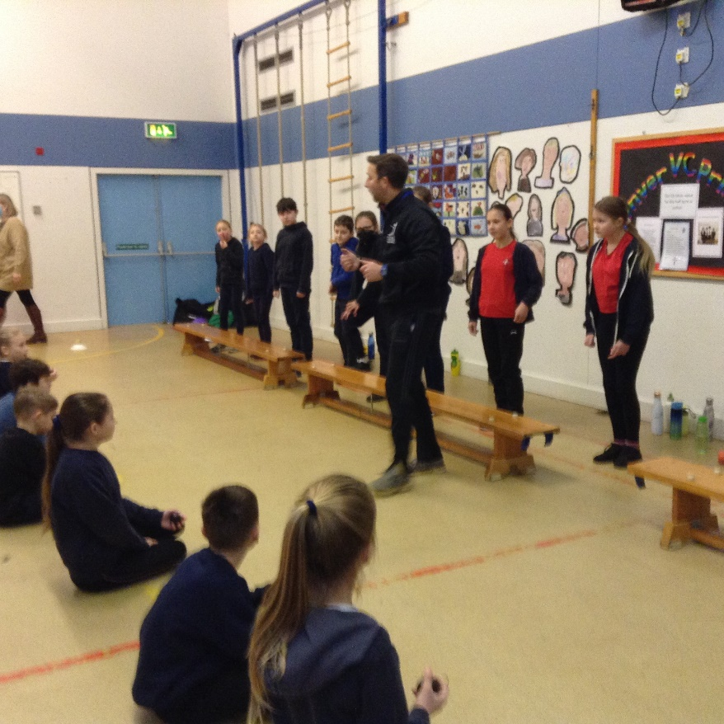
On Thursday 20th January, Classes 3 and 4 were joined by Gary Hawkins from KES Academy to begin Fitness Tracker challenges. Today they measured their own abilities in throwing, jumping, agility and flexibility. Gary will return for an endurance challenge very soon.
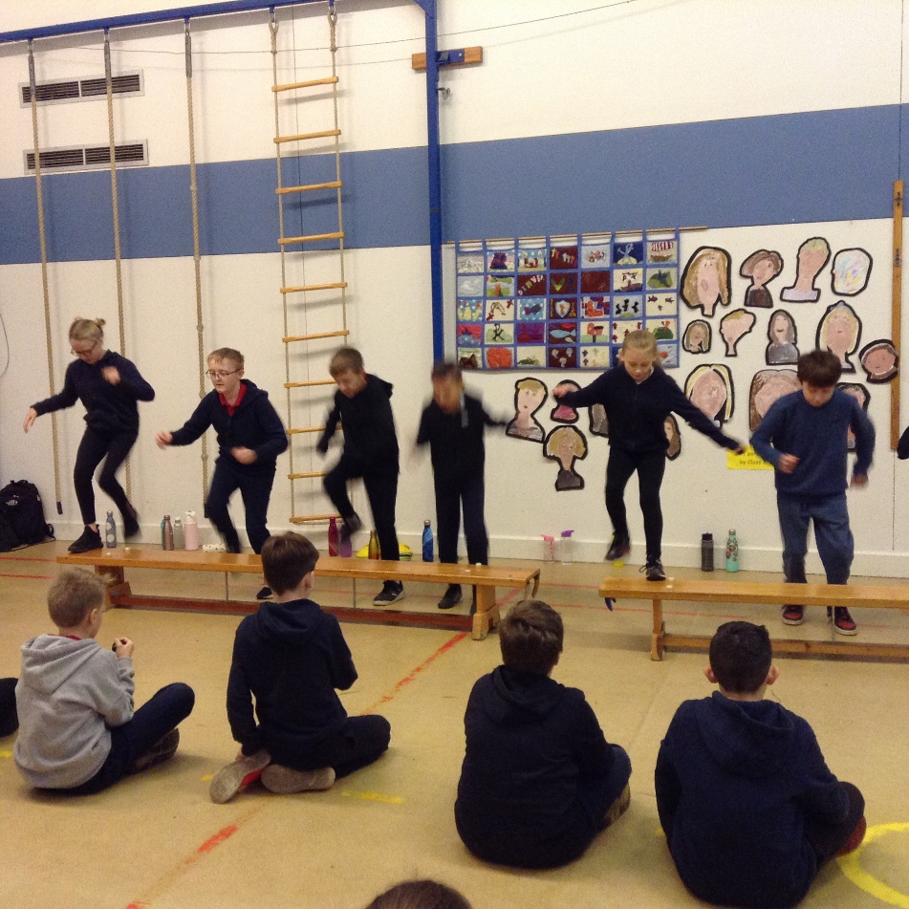
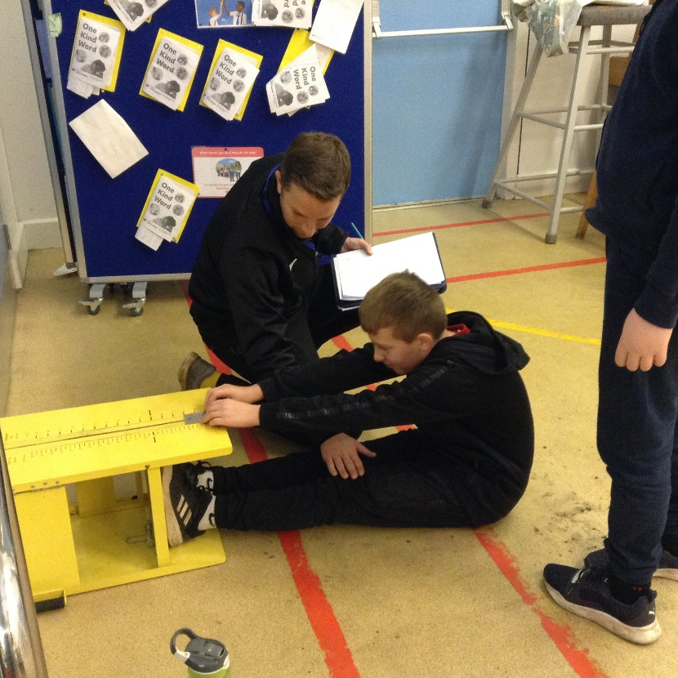
Following on from Gary’s visit we will be given some training tasks to do that will support us in beating our own personal bests. He will then return later in the year to retake the challenges to see how much we have improved in each of the areas.


