Rotary Club Junior Technology Tournament comes to Class 4
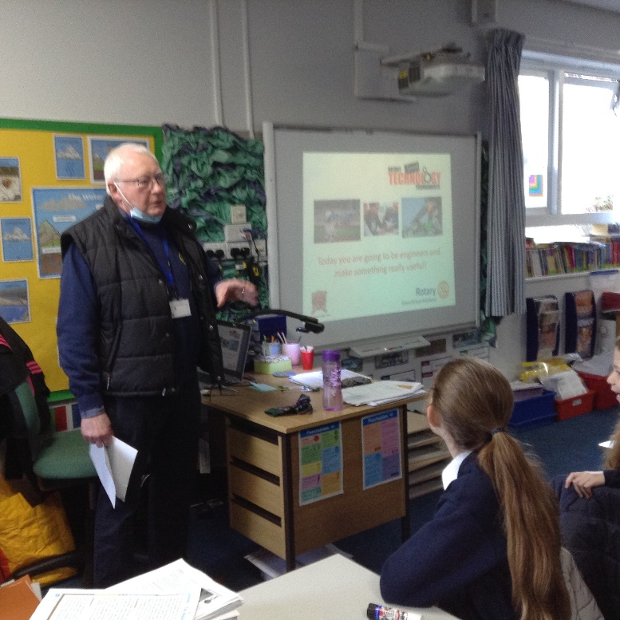
On Tuesday 18th January 2022, Children in years 5 and 6 at Denver V C Primary were joined by Alan and Howard of Downham Market Rotary Club for an inspiring day exploring science, technology, engineering and mathematical skills. Rotary technology tournaments are one day events where schools are invited to undertake an unseen challenge with an aim of fostering an interest in these subjects that might lead to students considering future careers in engineering.
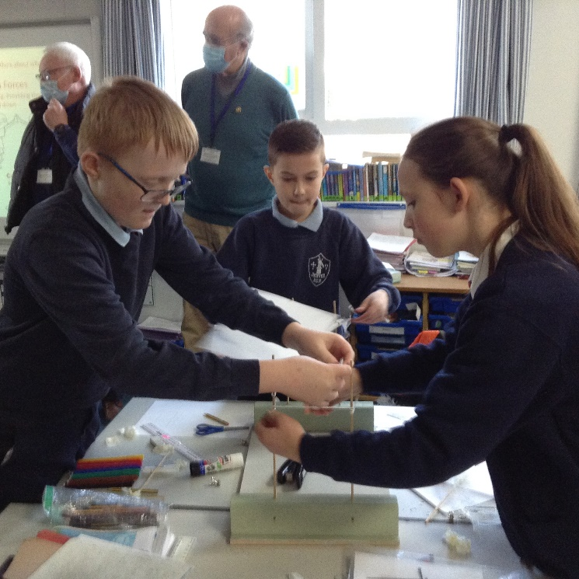
They were assigned the role of civil engineers for the day. The task involved designing and making a scale model of an animal crossing for a nature reserve with specified criteria. The task compliments the requirements of the National Curriculum, supports the government’s STEM initiative and is recognised as a qualification by the Crest Awards Scheme. Denver school was delighted to be able to enrich the school’s curriculum in offering a broad and exciting range of learning opportunities for the children. The tournaments also develop important planning, time management, communication and team building skills which were evident amongst the children throughout the competition.
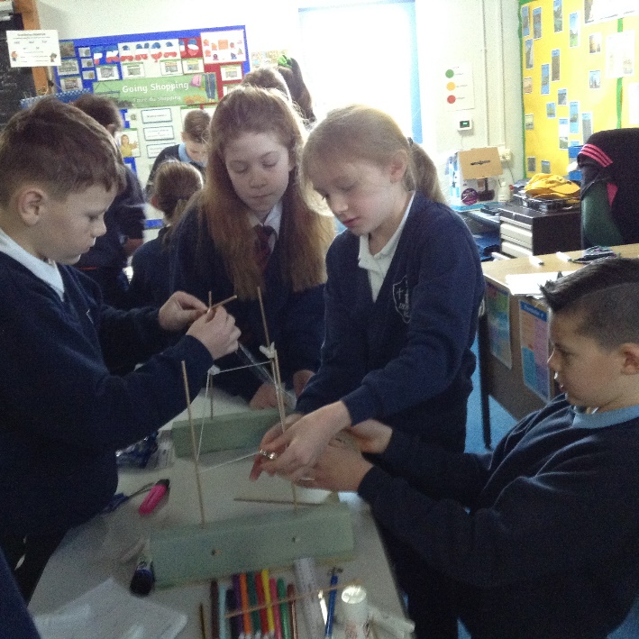
Joining in the fun were school governors Carole Reich and Amanda Dawson who took part in the testing of the final products and judging the competition. Final products were measured to ensure they met the specifications of the brief and they were tested for their strength and weather resistance.
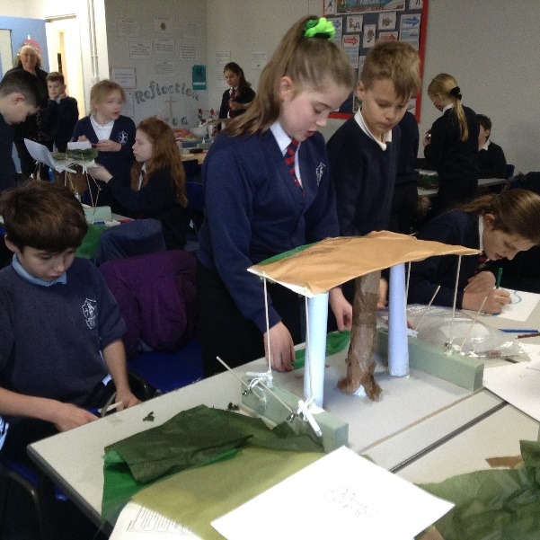
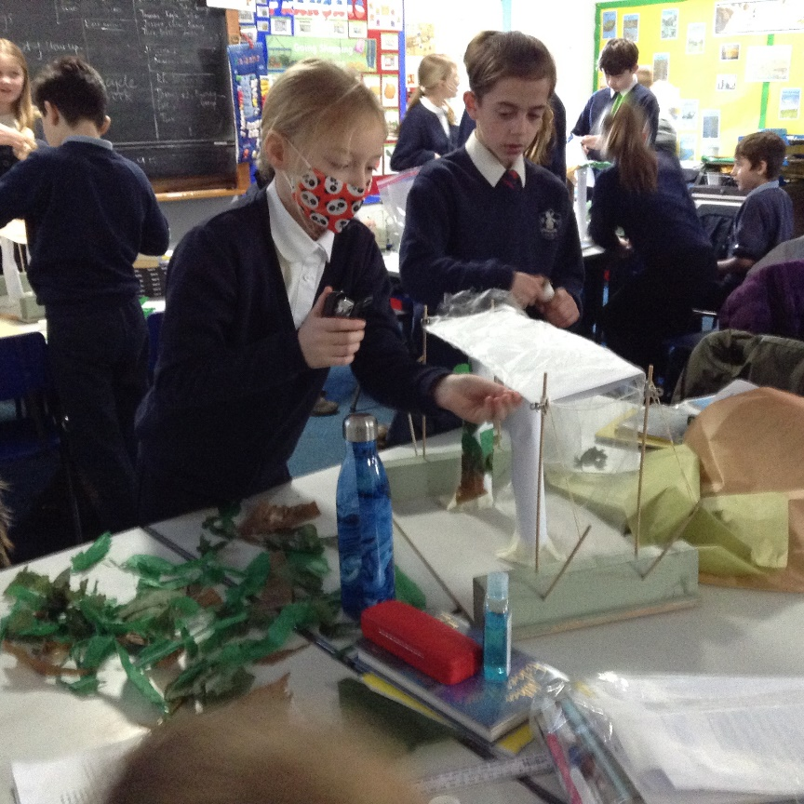
It was an incredibly close decision with only narrow margins between the winners and the two runners-up. Congratulations to Barney, Chloe, Jacob and Megan, winners on the basis of the overall stability of their structure. It was an incredibly successful day with impressive teamwork, quality products and inspired, enthused children the outcome.
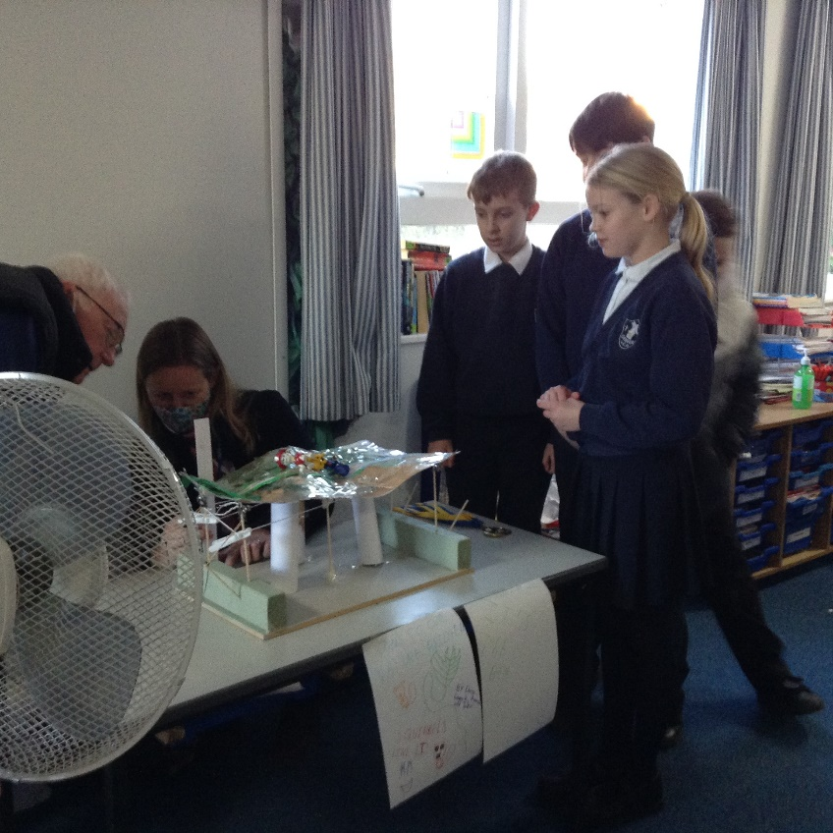

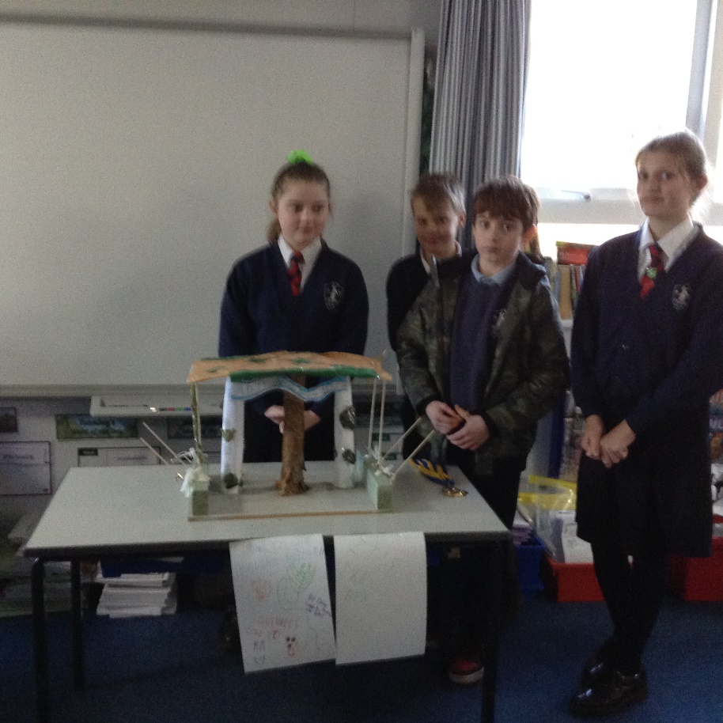
Alan and Howard were very impressed with the children’s behaviour, attitudes and their finalised bridges. They remarked that these were the best outcomes of any junior tournament that they have ever seen. High praise indeed!


