Cluster Cross Country Tournament

We were fortunate to be blessed with a mild and dry autumn morning for the first face-to-face cluster sporting event since before the pandemic.
The Downham Market cluster cross country tournament took place on the Memorial Field in Downham Market on Wednesday 10th October with five schools from across the cluster in attendance. The excitement of the children finally being able to compete in reality rather than virtually was palpable and Denver children certainly showed grit and determination, wanting to make the most of this opportunity
There were 8 races today (one for girls and one for boys from Years 3 up to 6) and Denver collected an impressive 14 of the 24 medals on offer. Well done to the whole team who were fantastic representatives of the school and who were very sporting. It was humbling to see the children offering each other so much encouragement.
All 22 of the children that attended the event today earned a top ten finish and therefore progress to the area finals at Lynnsport on 23rd November. Good luck to them all!

Here are the results from the races:
Year 3 girls
Amelia 2nd
Millie 5th
Seren 6th

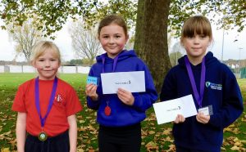
Year 3 boys
Oliver 1st
Max 2nd
Eric 4th

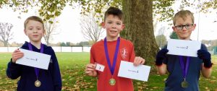

Year 4 girls
Ella-Rose 1st
Emie 3rd
Mia 4th

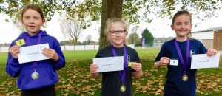

Year 4 boys
Oliver 3rd
Finley 4th
William 6th
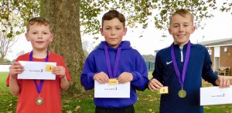

Year 5 girls
Chloe 2nd
Kayla 3rd
Evie 4th

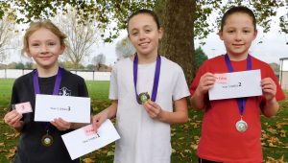

Year 5 boys
Theo 1st
Joshua-Jon 2nd
Logan 3rd
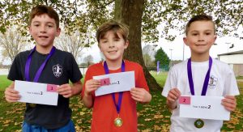

Year 6 girls
Kaylee 1st

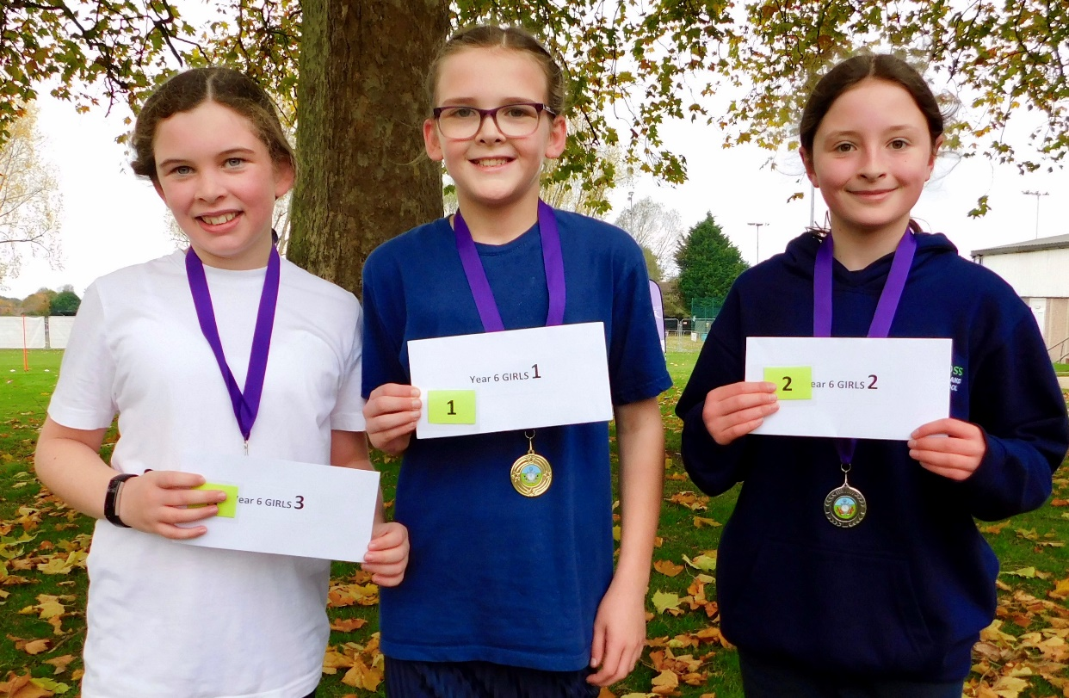

Year 6 boys
Charlie 1st
Jacob 3rd
George 5th

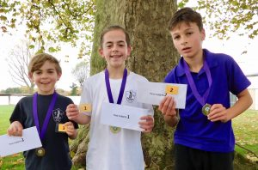

What amazing achievements! We are very proud of them all. Lovely to see the celebration photos at home –thank you parents for sending them in.



