Young Leaders – the final session (16.11.21)
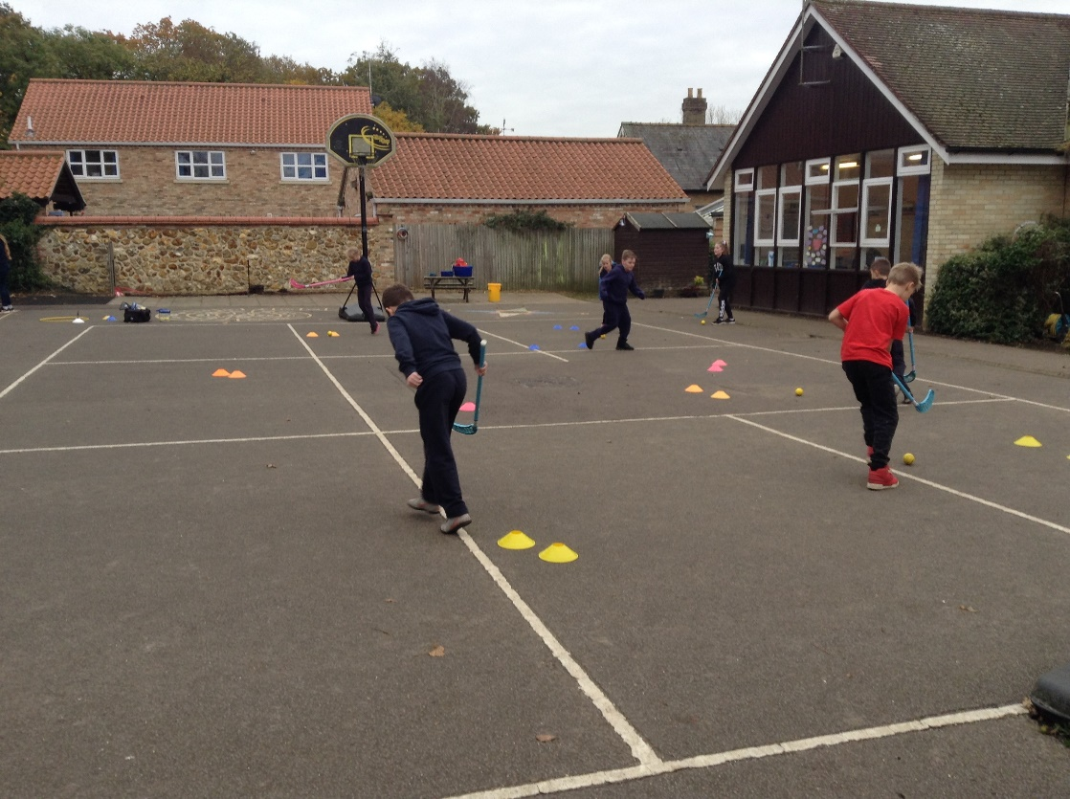
How quickly we reach the end of the programme! The final session was all about the fourth element of PACE – Equipment.

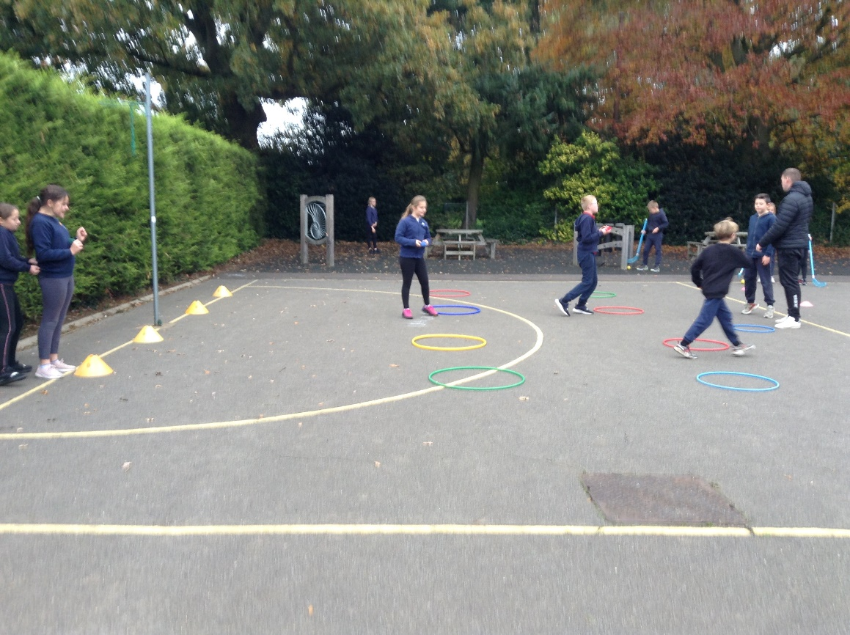

Joe taught the children about the importance of selecting appropriate equipment for the activity, checking equipment for safety and how to use equipment to adapt activities so that they can be made easier for children who are struggling but more challenging for those who are finding it too easy.
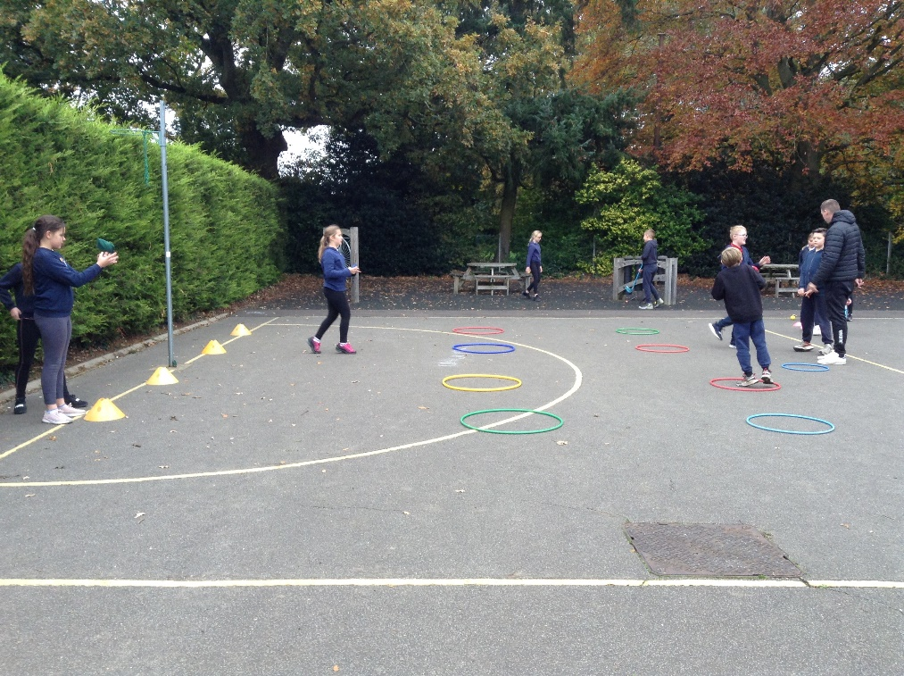

Joe was incredibly complimentary of the class and their skills saying they are one of the very best groups he has ever worked with. He praised their ability to work as a team supporting and encouraging each other- he made a point of saying how he had not seen any arguments which is very mature. He expressed how pleased he was with the level of participation and the children’s ability to think either for themselves or in groups to find solutions. He was impressed by how well those who had been really nervous at the start had overcome those barriers and found their voice. All children successfully completed the course.
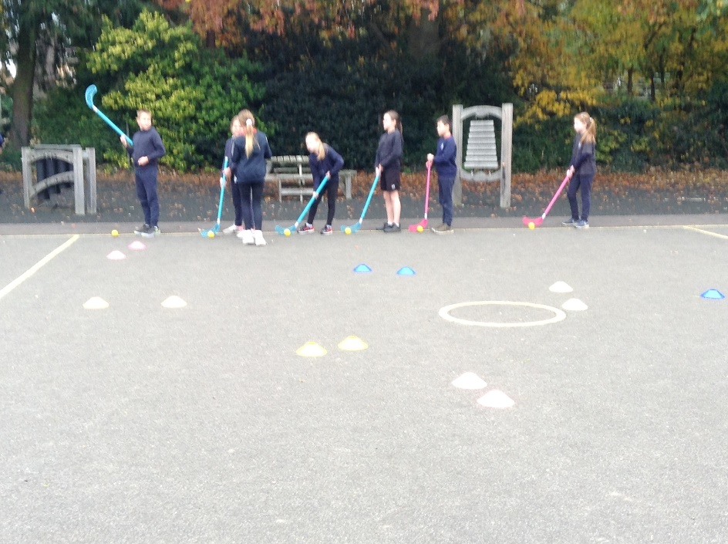
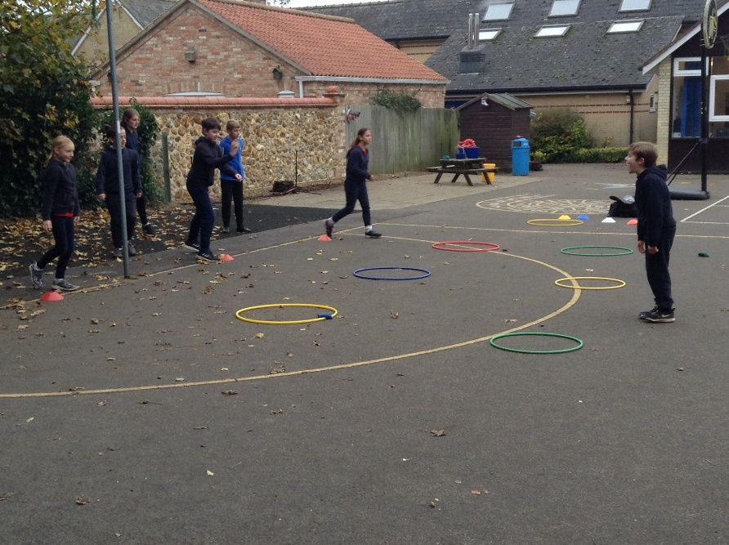
These skills can now be developed in numerous ways – each time they lead an activity at break or lunch time to younger children or organise and run an intra-school activity, they can fill in the journals they received in session 1. When five activities have been signed off by an adult, the children can earn certificates from Joe. Also, if the children are involved in clubs outside of school and are involved in leading any activity, this also counts and can be recorded in their Play Leader Journal.

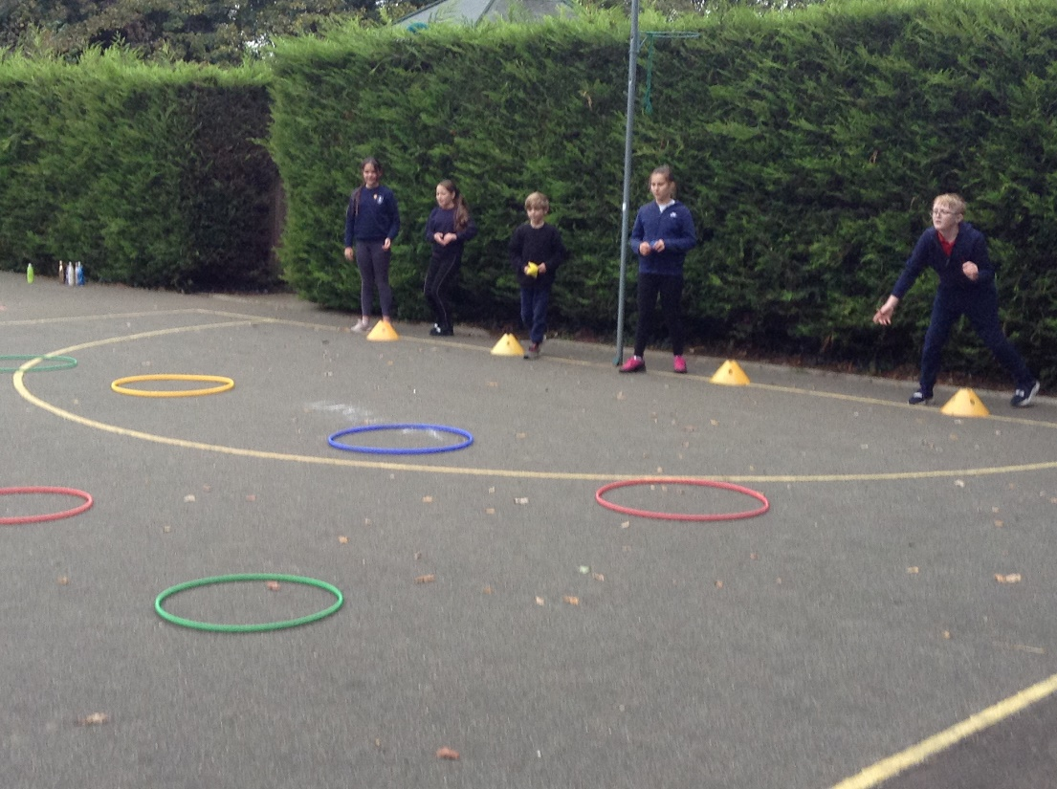

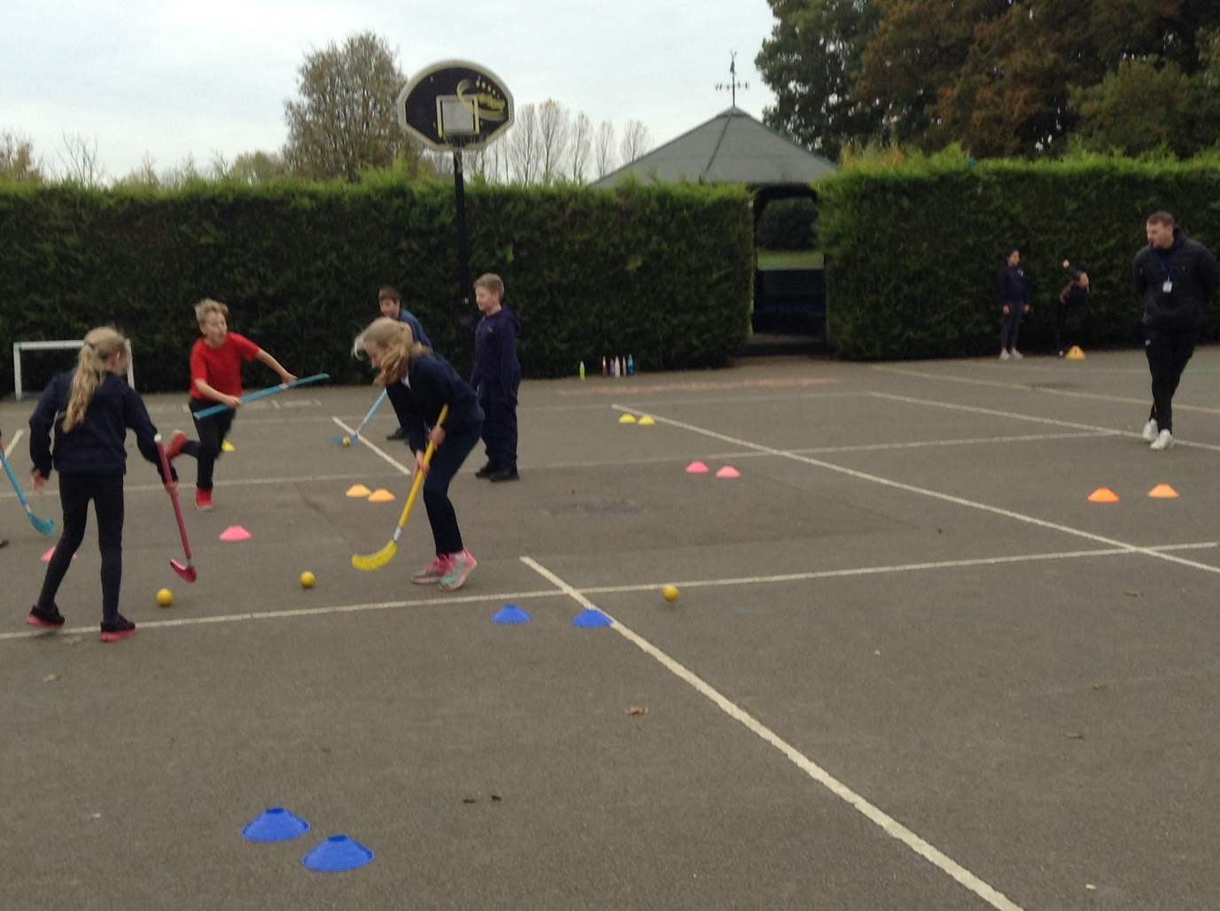

Thank you to Joe at KLCF for the encouraging teaching and for mother nature with mild, dry weather to allow this to take place outside.

