Swan Youth Project assembly
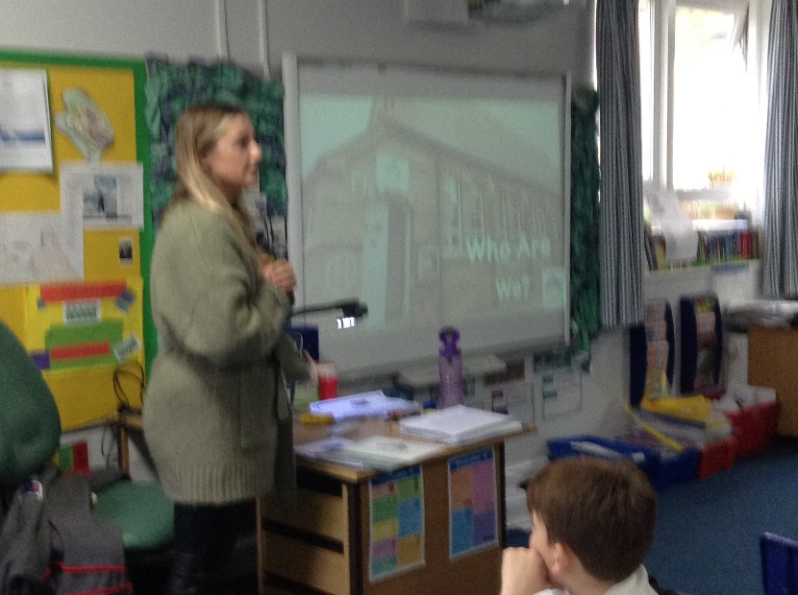
During our Wellbeing Wednesday assembly (10th November) we were joined by Holly Morton, the Community Liaison Agent for the Swan Youth Project.
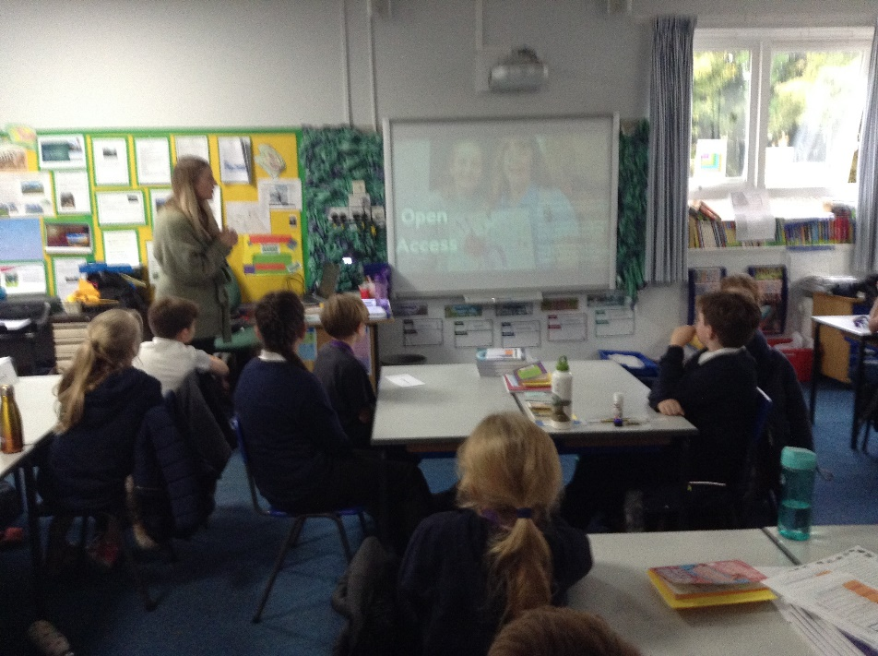

The Swan Youth Project is a community service that aims to improve recreation opportunities, opportunities to make new friends and to provide wellbeing support for children and their families. Holly in particular aimed to promote their twice-weekly youth club which is held in the old Clackclose School building on Paradise Road. The sessions are 4:30 – 6:30pm on Tuesdays and Fridays. These open access sessions are free for the first session (you can just turn up without pre-booking) and 50p for subsequent sessions.
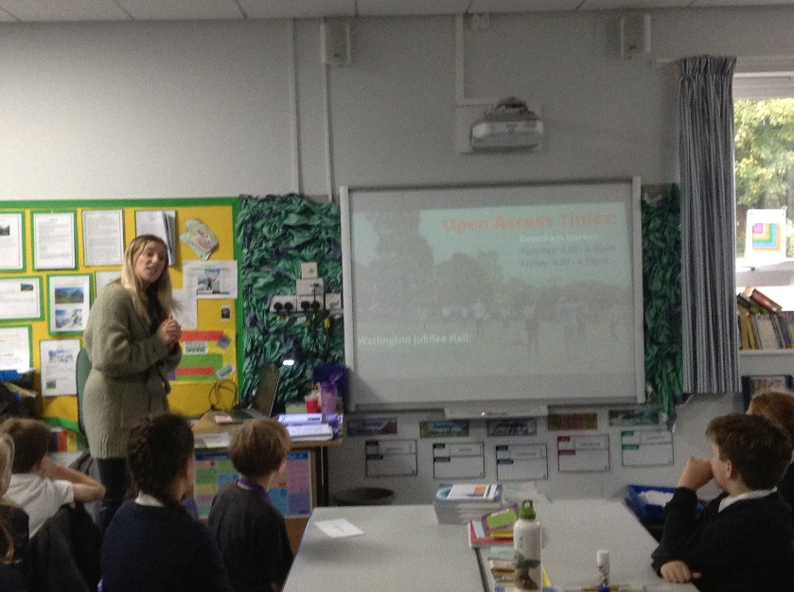

They also offer services to support families such as a clothing and hygiene bank, access to a Youth Support Worker, Parent Group Support sessions, support for children who are young carers and family support. Further information about their work can be found on www.swanyouthproject.org



