Key Stage 2 intra-cross country event
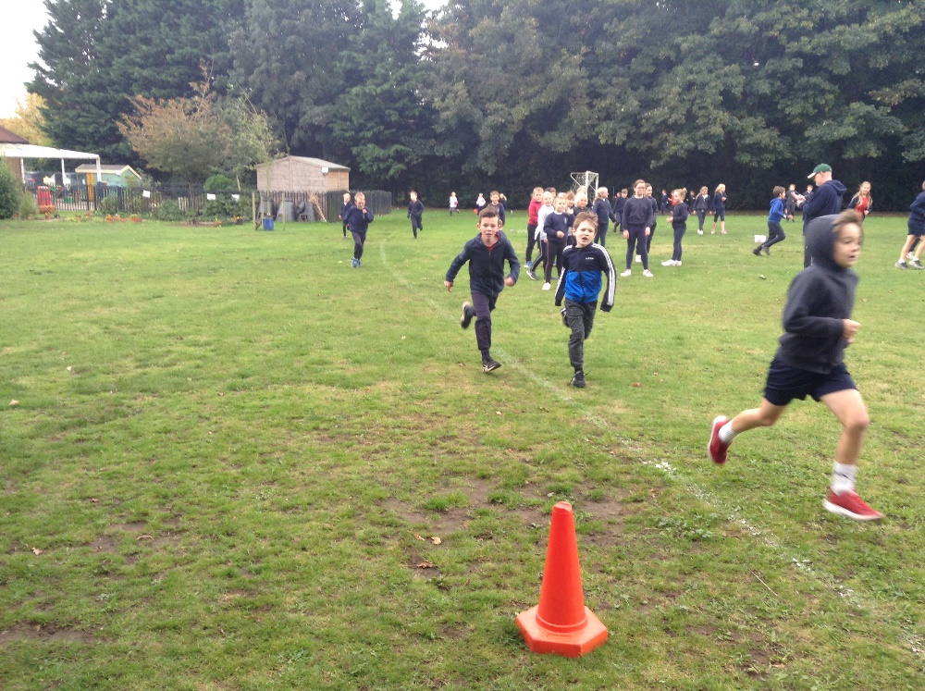
In the drizzle of a typical autumn afternoon, Tuesday 12th October, children from classes 3 and 4 took part in a house team competition in cross-country running. Top three finishers were offered a place to represent the school against other children in the cluster schools tournament, which will be held at Hillcrest on Thursday 4th November.
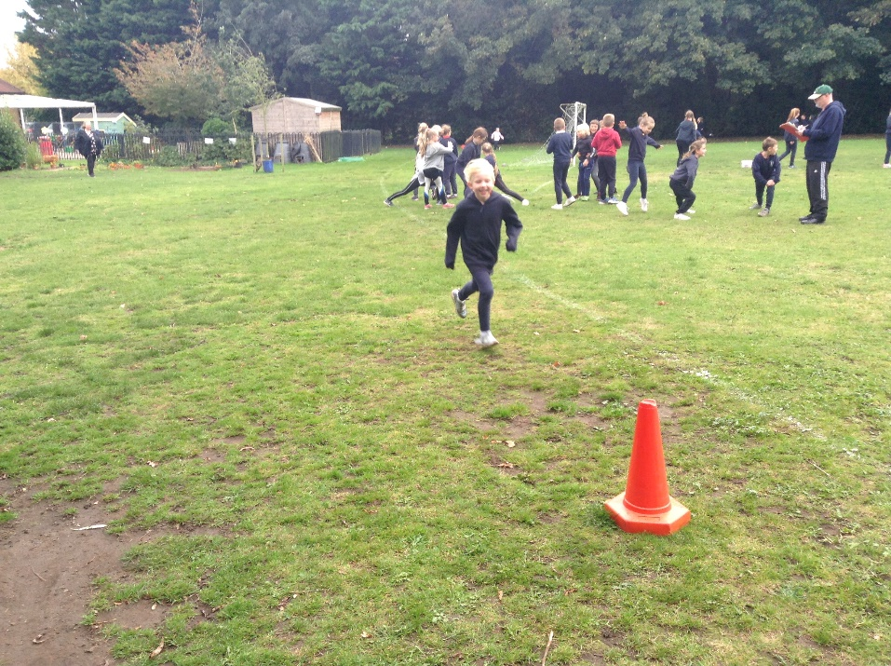

Children in Class 3 raced four laps of the Golden Mile track in their individual year groups. Class 4 children raced five laps. All laps counted towards Golden Mile certificates so everyone was a winner.
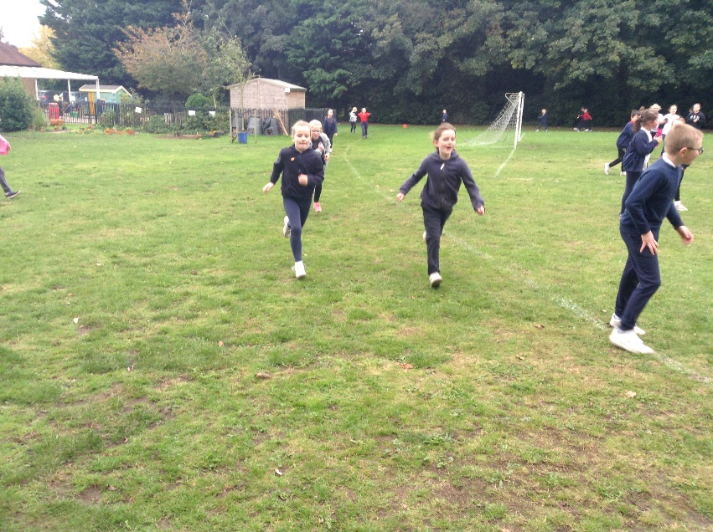
The top finishers were as follows:
Year 3
Oliver W
Eric
Max
Amelia
Millie H
Seren
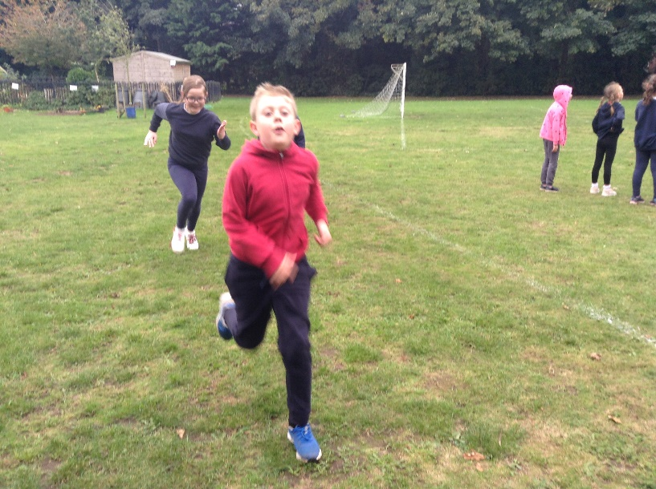
Year 4
William
Oliver G
Finley
Emie
Ella-Rose
Mia
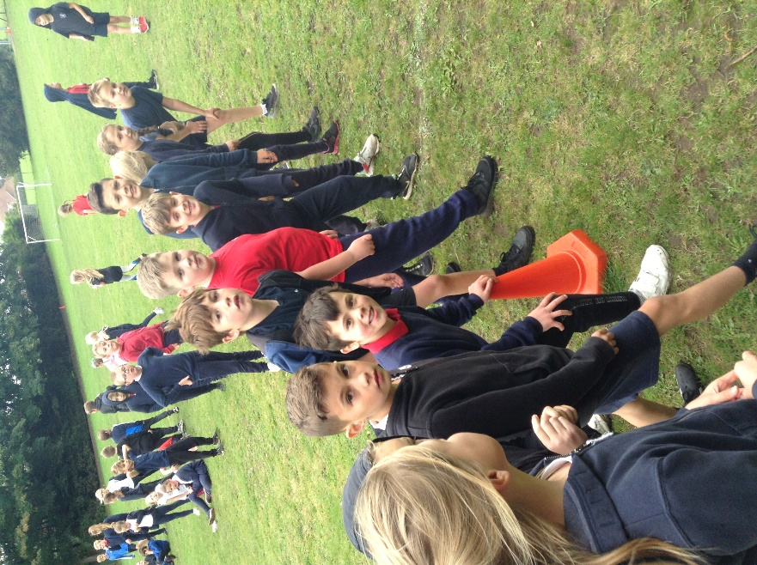

Year 5
Theo
Joshua-Jon
Logan K
Chloe
Kayla
Evie
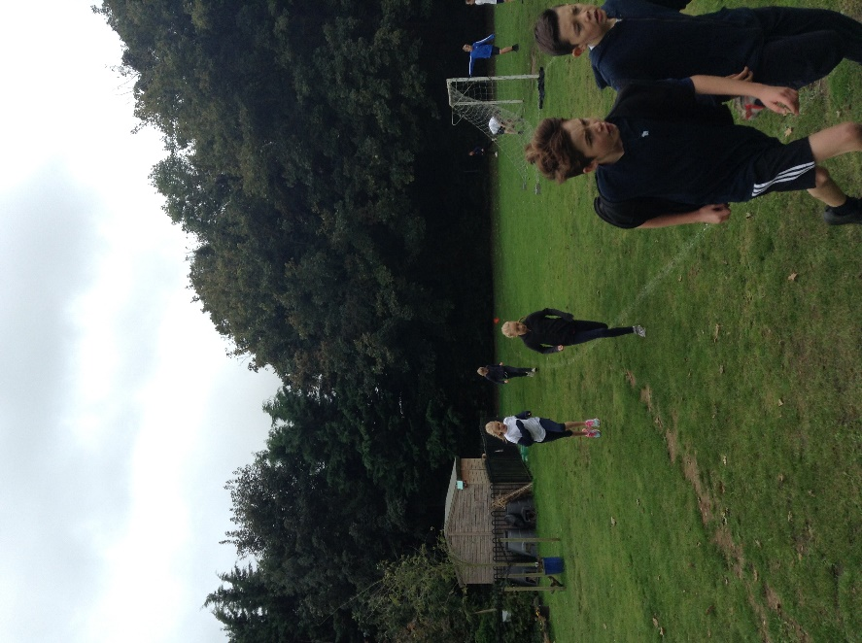

Year 6
Charlie
Jacob
George
Kaylee
Olivia
Darcy
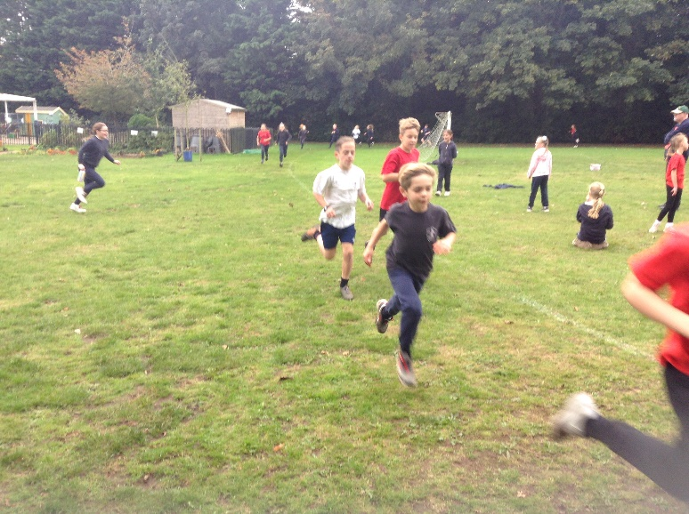
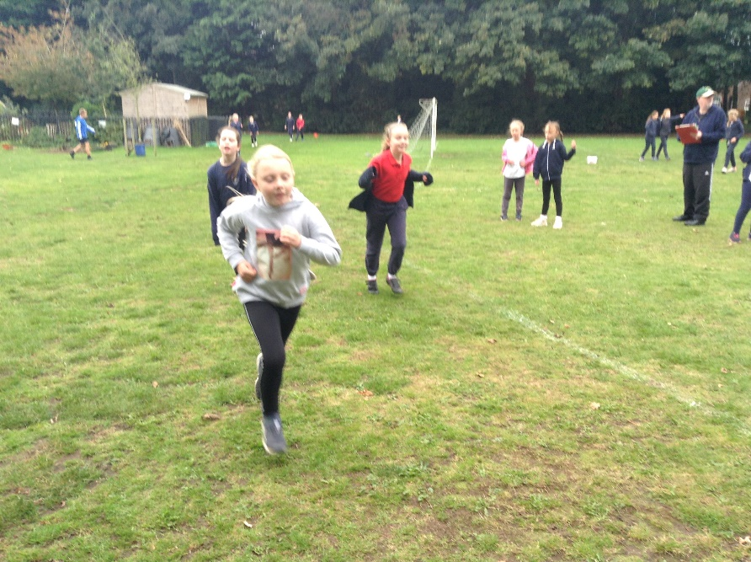
The winning house team was White Team with 19 points. Well done! Come on, Blues and Reds; it’s time to challenge White team! Good luck to all progressing to the competition at Hillcrest and well done to all children in Key Stage Two who showed such resilience here in school.
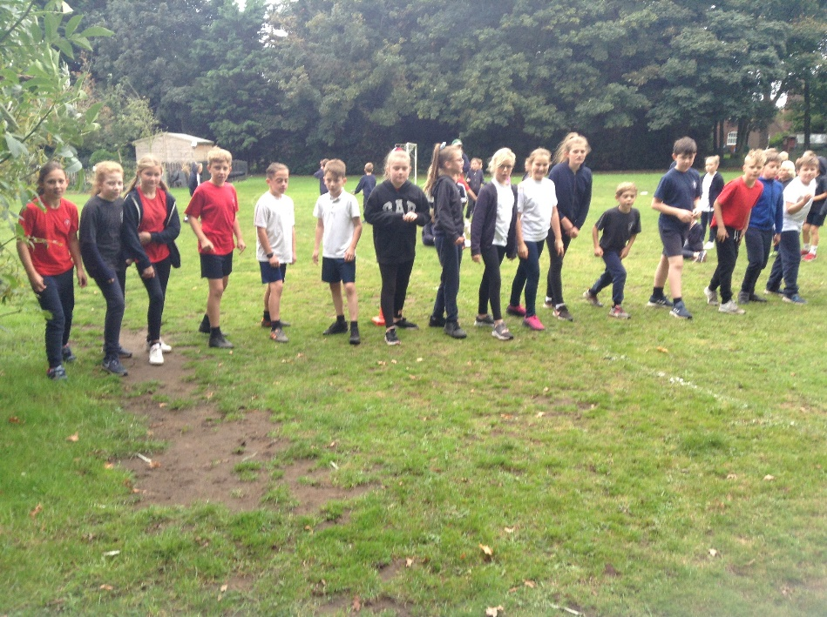
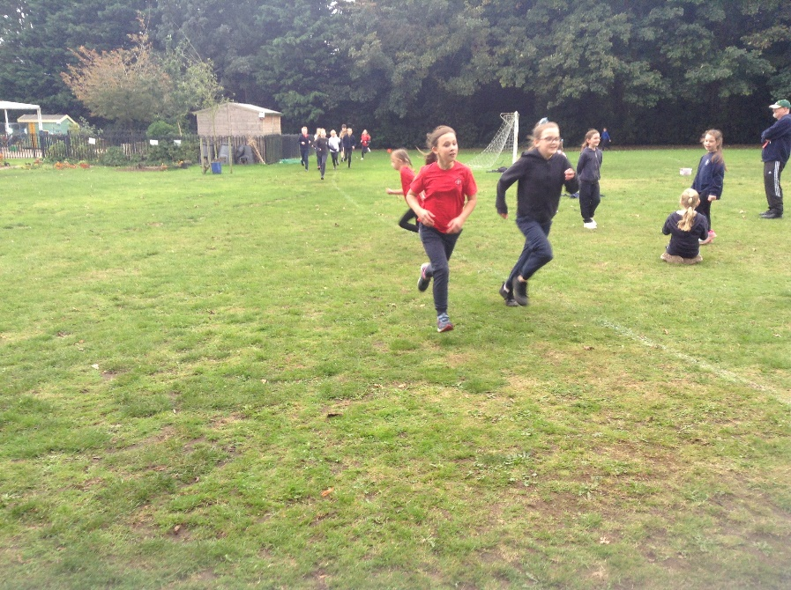
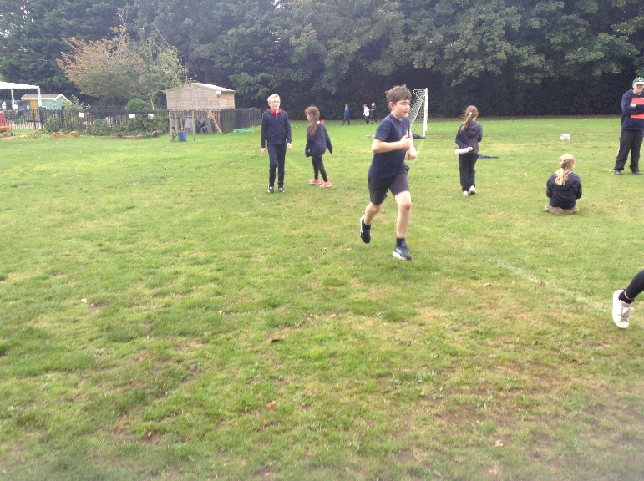
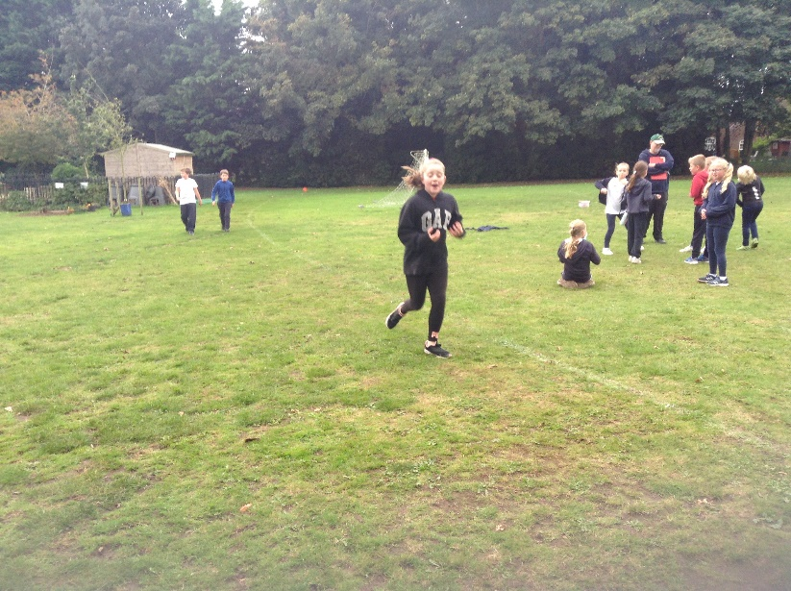
The smile of achievement at the end is wonderful!

