Bikeability Levels 1 and 2 training
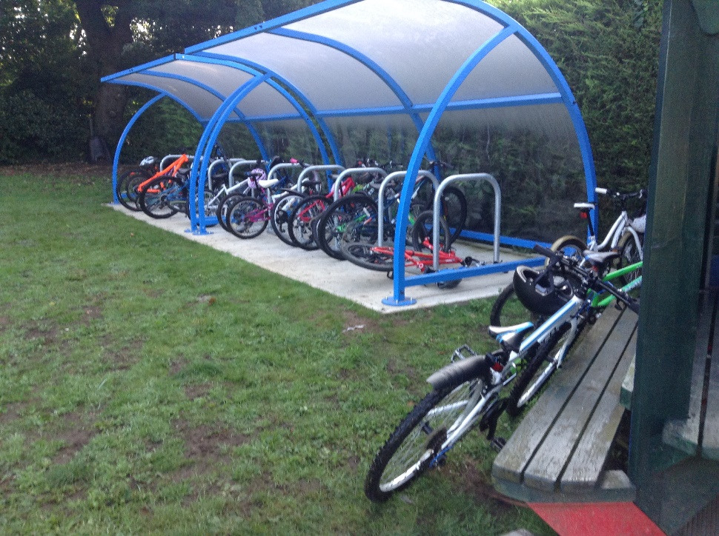
This week we were joined by two instructors from Outspoken Training for Year 5 children to receive four days of intensive Bikeability Cycling Proficiency training.
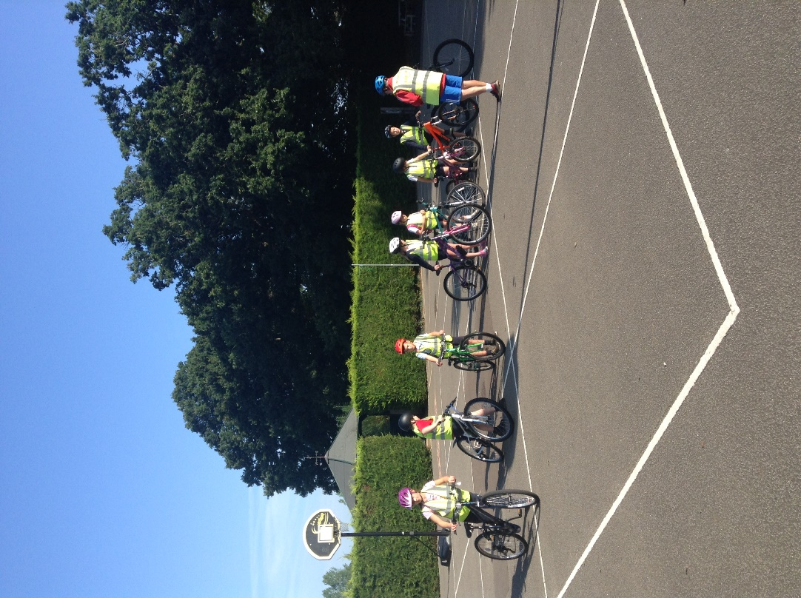

For Level One training the children were taught how to check a bicycle for roadworthiness and how to perform safe starting, stopping, turning and signalling manoeuvres from within the school grounds.
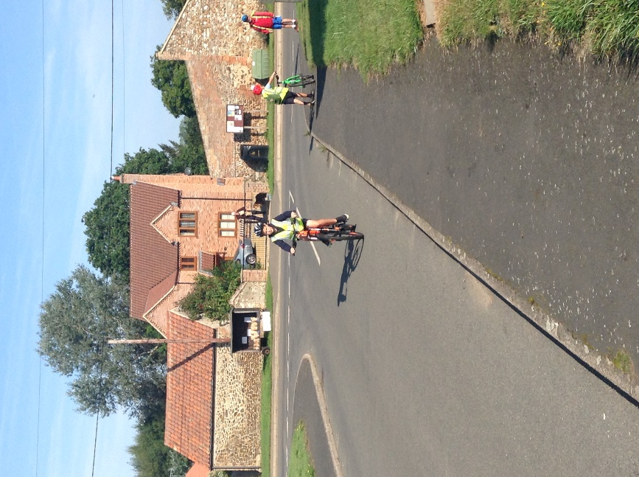
Successful completion of Level One allowed the children to move on to Level 2 and practise their skills on progressively busy roads. This is included how to position at junctions and how to navigate parked vehicles and obstacles.
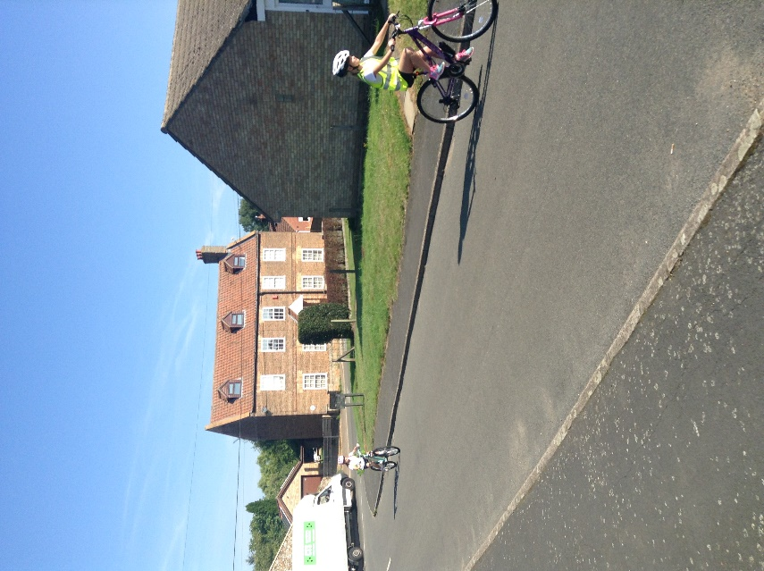

The instructors remarked upon the good skills and behaviour. The children learnt a great deal about road safety and thoroughly enjoyed the experience.
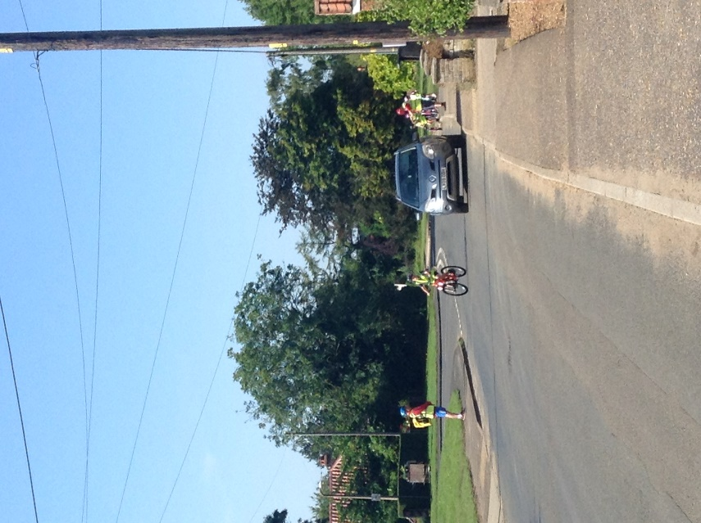

We are very thankful to the instructors and a very special thank you also goes to Mrs Dawson who kindly gave up her time to support both groups for the entire four day period.


