Mini Tennis tournament September 2021

Evie, Chloe, Ivy and Logan were finally able to take part in the deferred mini-tennis development tournament at KES Academy Tennis Centre on Friday 17th September.
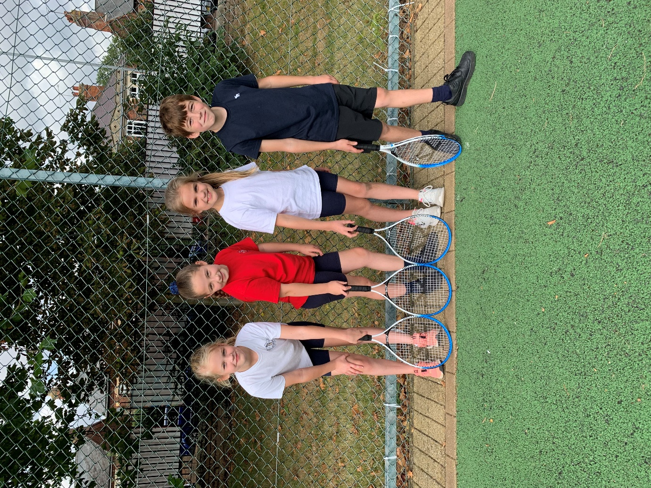
They had an enjoyable afternoon of festival fun and we are very grateful to them for representing our school. Thank you also to the parents for making it happen.

