Tennis – the finale
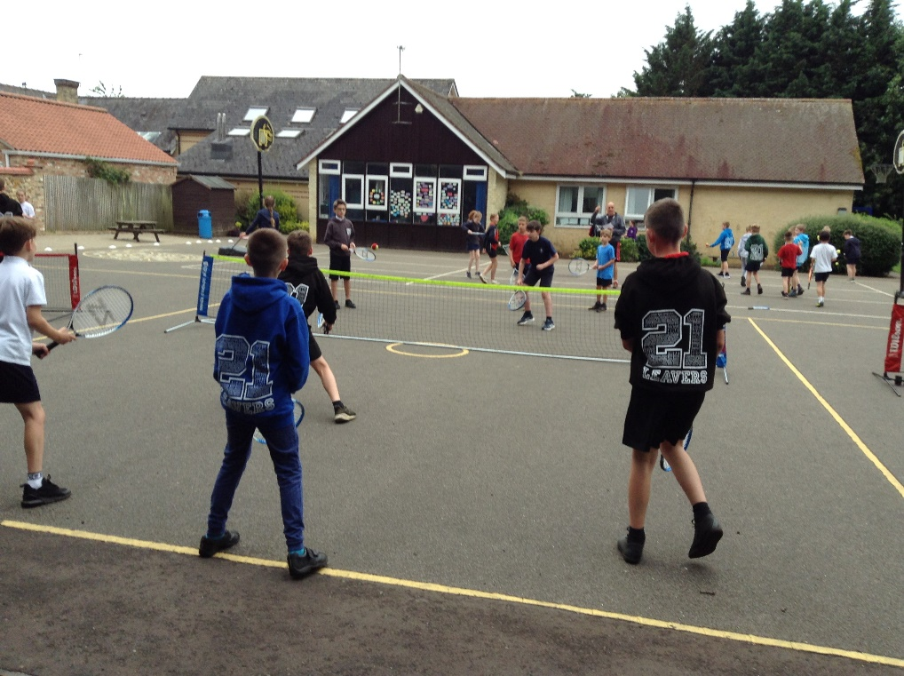

What a finale it was! At the end of the previous round, three of the four teams were tied on 12 points and one team had 13 points.

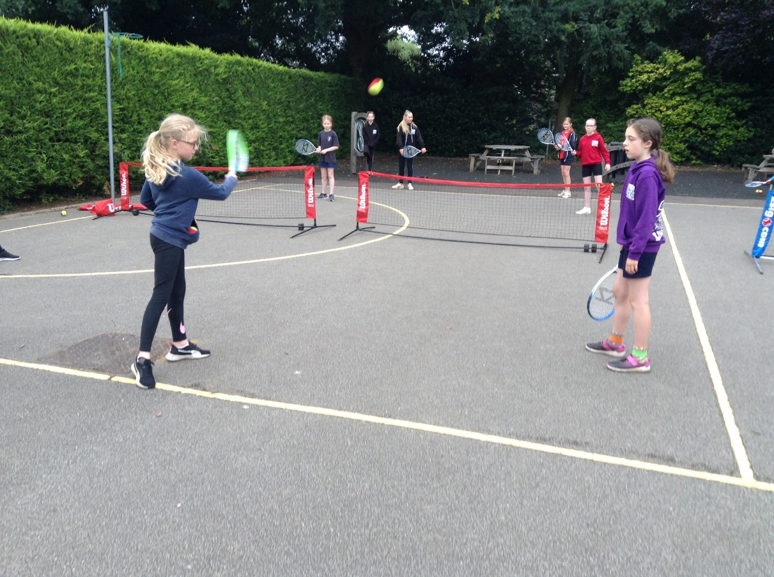

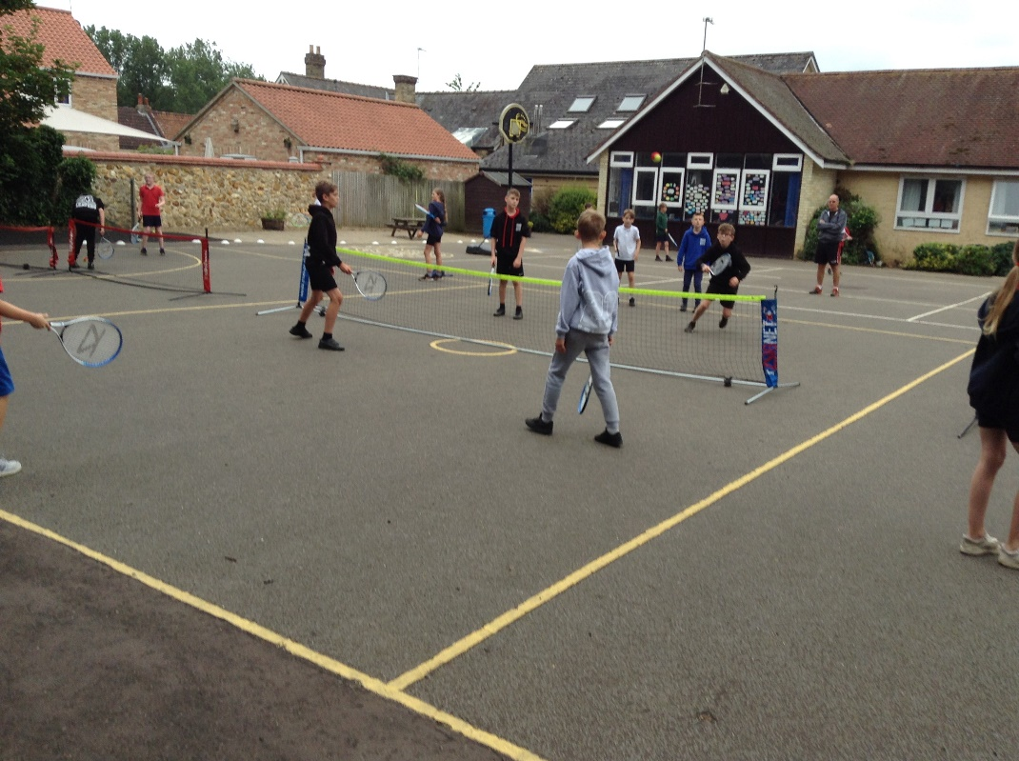

This week the teams were playing 4 vs 4 instead of 2 vs 2 to develop the lob and smash skills.
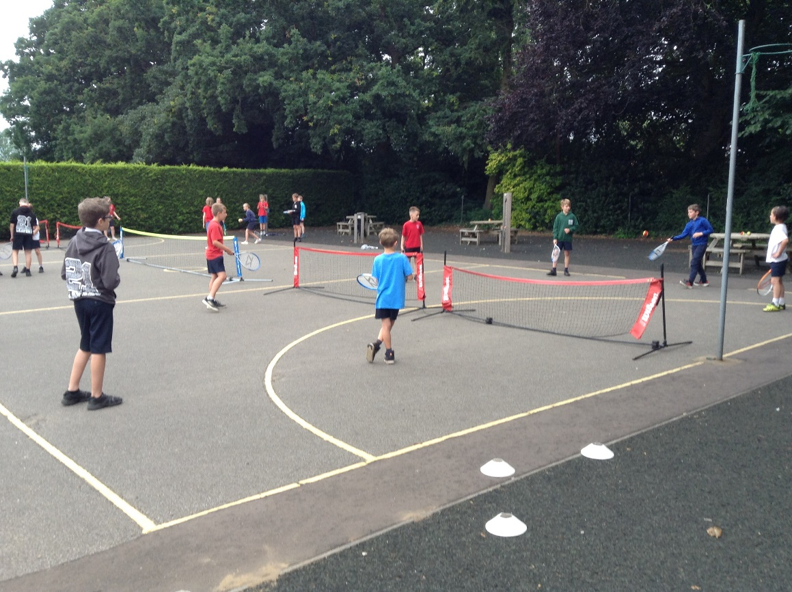

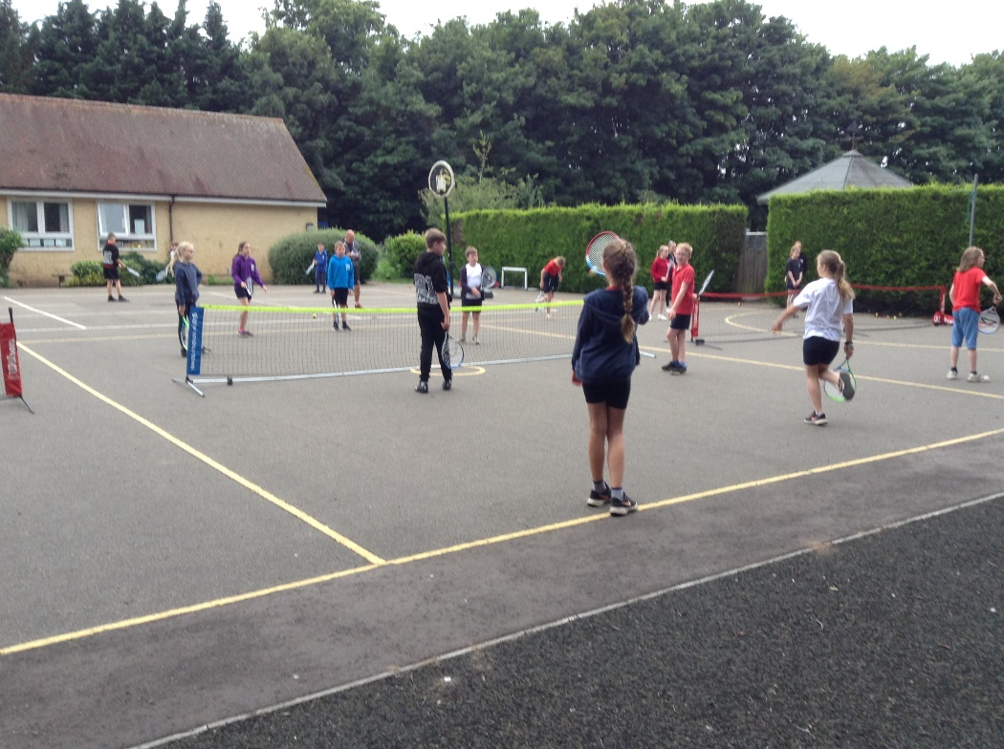
It was a very tight tournament and 2 teams ended up in first place on 16 points (the other 2 teams on 14). Jeremy gave them the choice of settling for a draw or to select a member for a challenge to have an outright win. They chose the latter. After the ‘Keepy-uppy’ challenge, Finley’s team was victorious. However, all of the class were winners with impressive skills across the board.
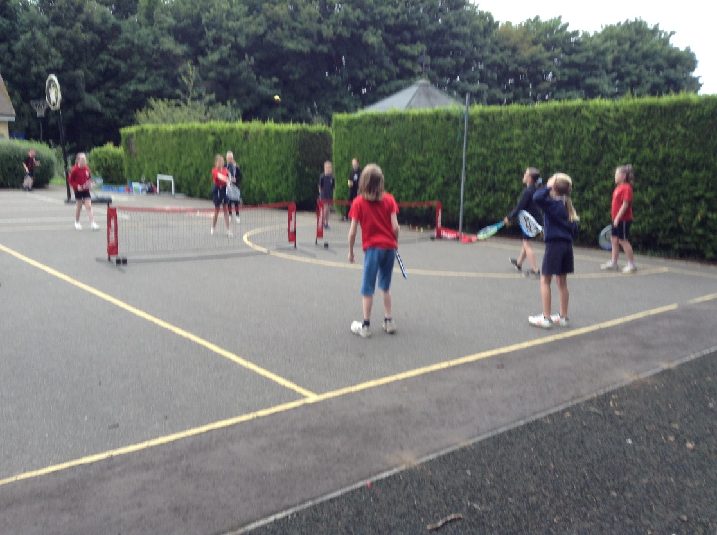

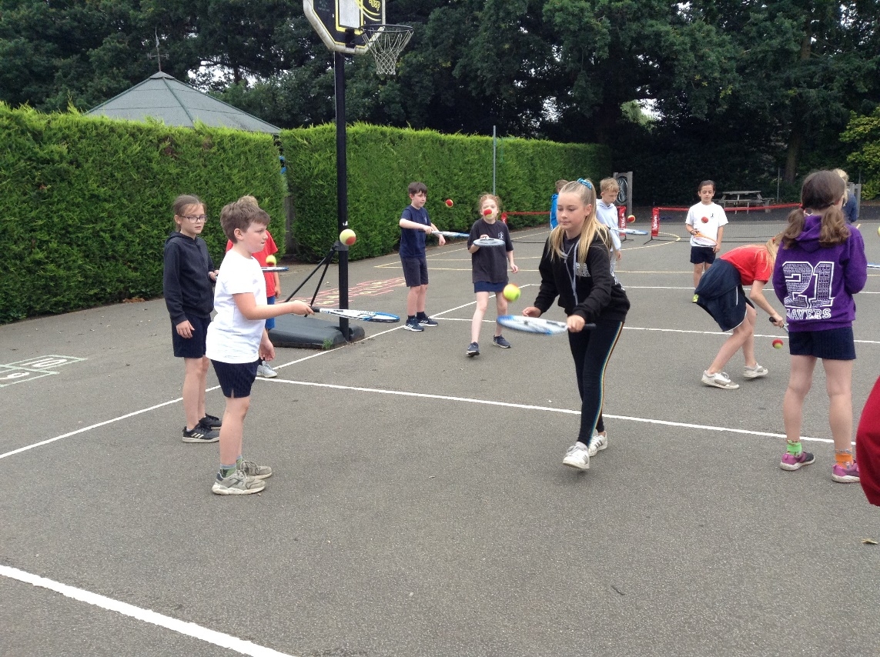
Also today the children were able to test their serving pace with a speed gun (the highest was 47 mph by Joseph and Finley).
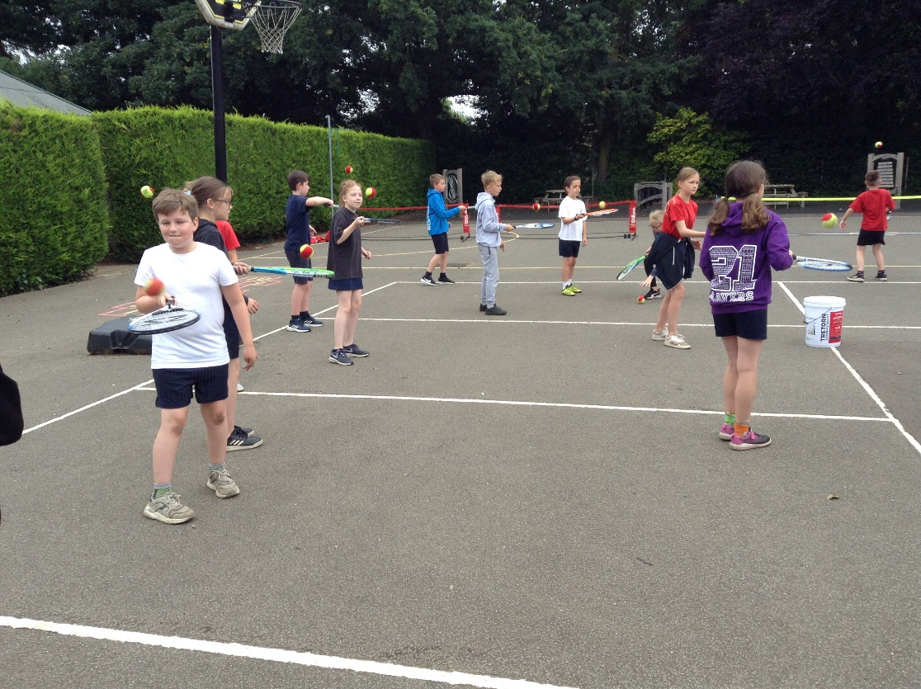

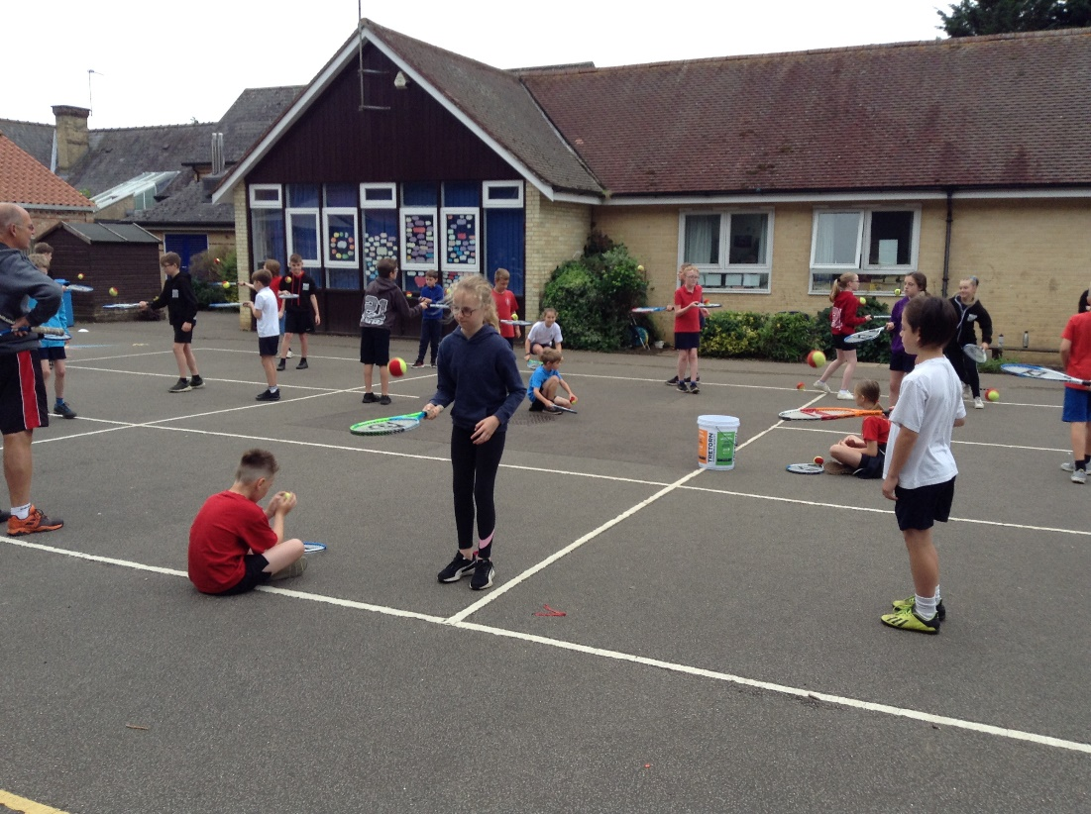

Jeremy left us with a whole range of skills and enthusiasm for tennis, some flyers for the KES tennis summer school (letters in book bags) and some sweets.

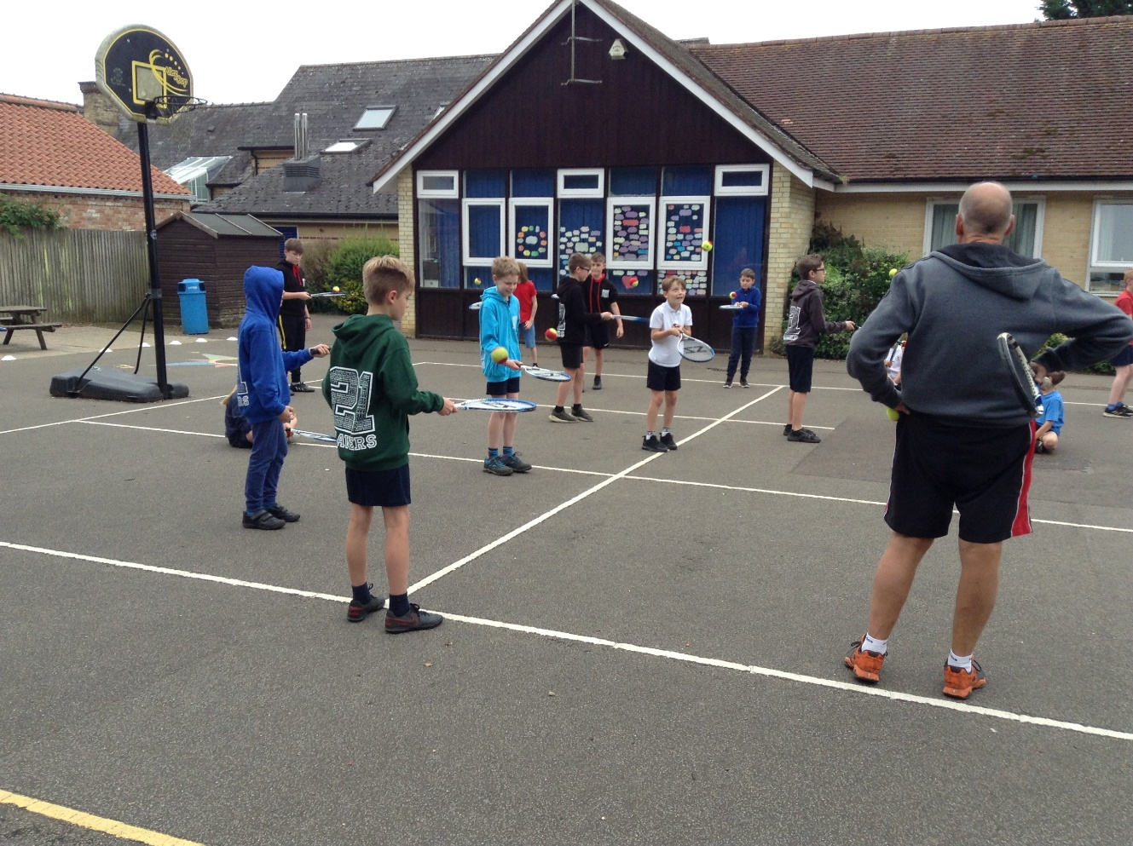
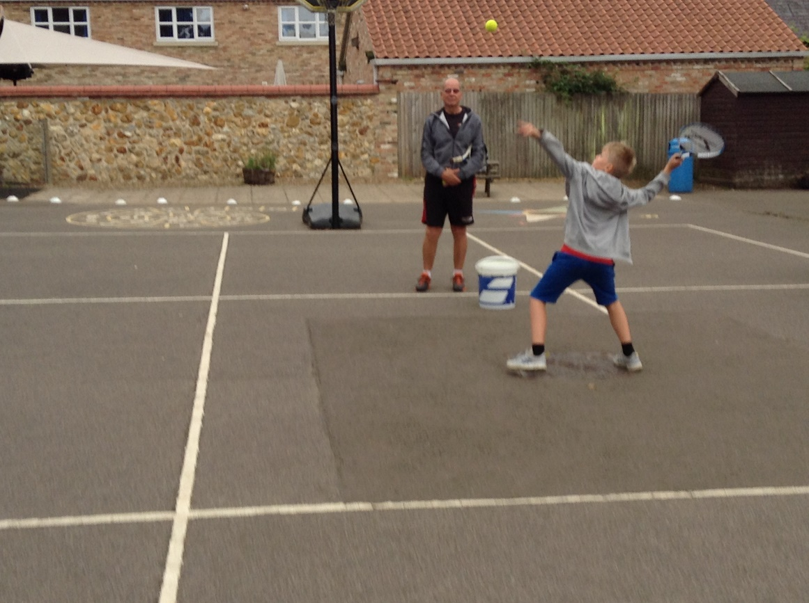

We have immensely enjoyed our coaching and are grateful to the Lawn Tennis Association for funding the sessions in return for Mrs Henden doing some online tennis coach training.
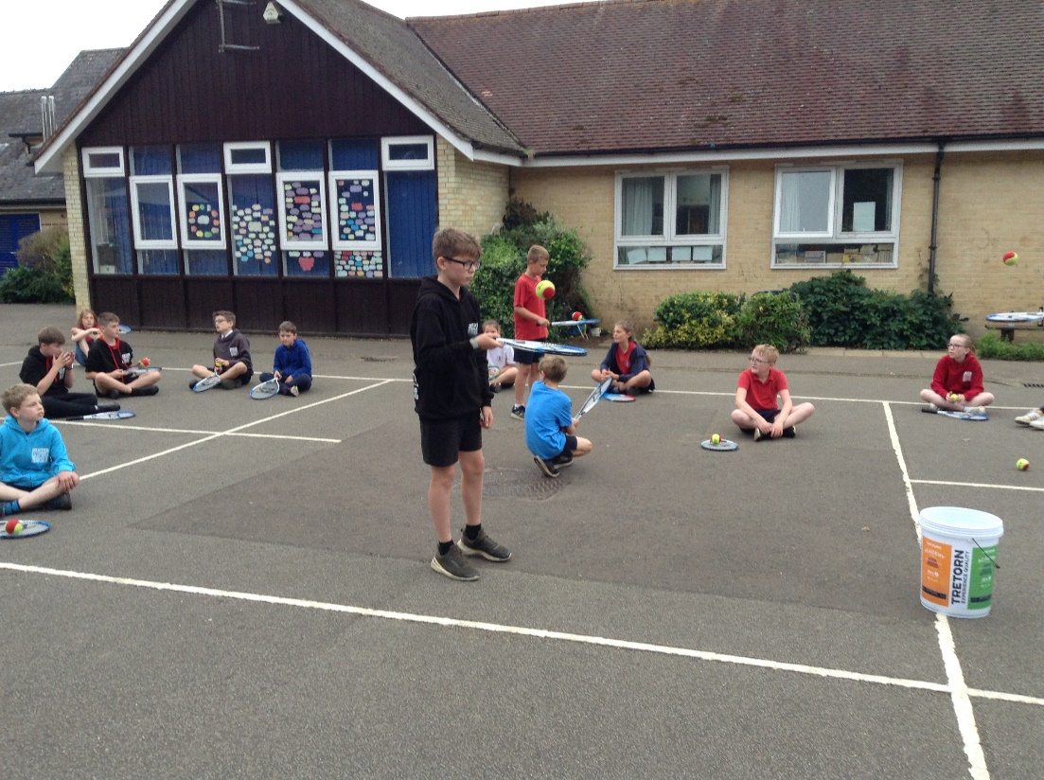

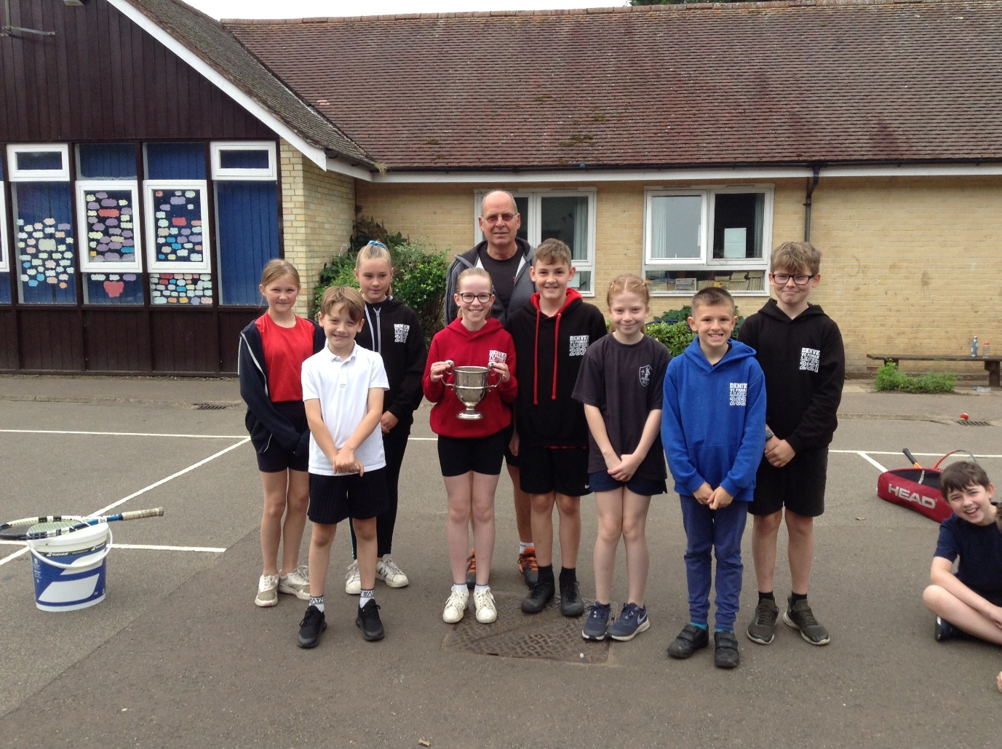
The winning team – photobombed by Jack!

