EFL – The Joy of Movement
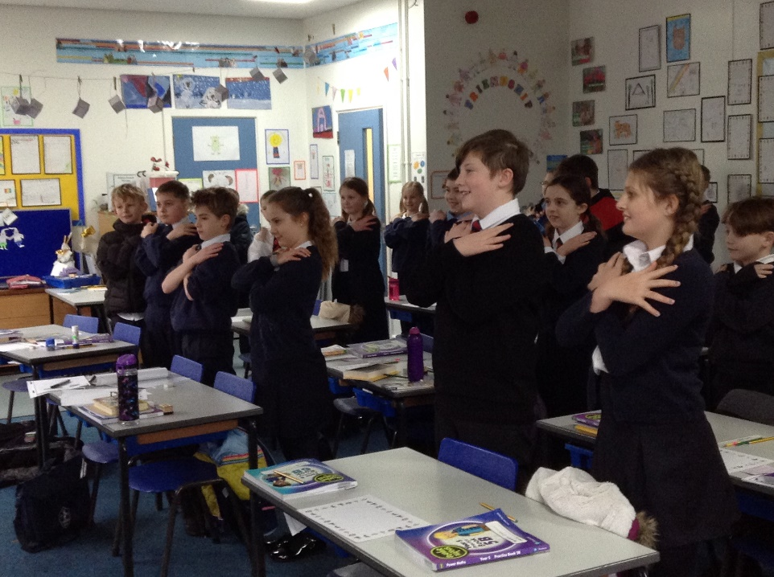
Children across the school were treated to a special welcome back assembly on March 8th focussing on the positivity of physical exercise and the values of the ‘EFL -The Joy of Movement Winter Games’ which link closely to wellbeing.
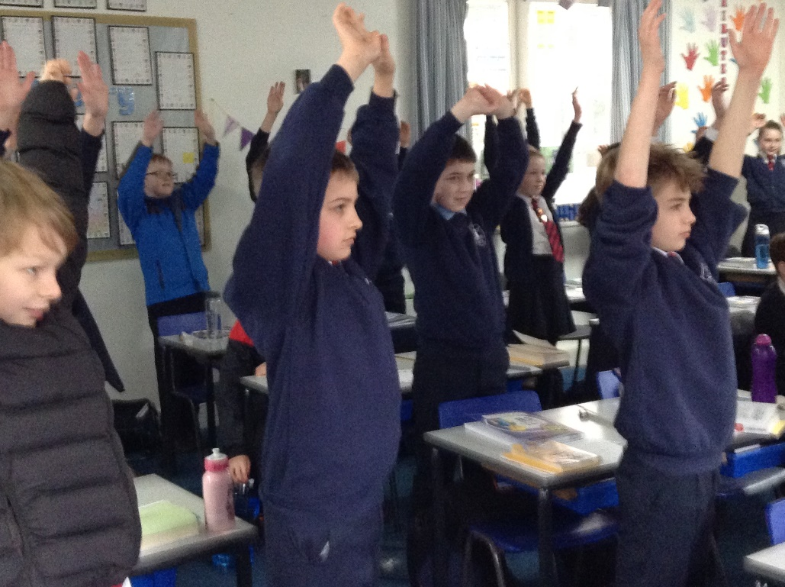

The assembly was led by Paul, Jake and Ryan who are representatives of Norwich City Community Sports Foundation. They linked up via Microsoft Teams to our 4 bubbles.
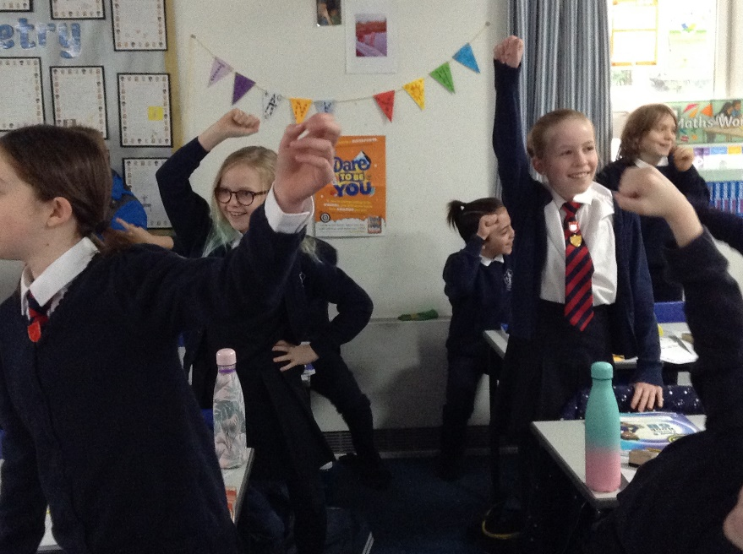
The assembly gave the children opportunities to be active by playing games such as ‘Do this, do that’ and ‘Guess the sport’. In between activities the children were given opportunities to reflect on their experiences during lockdown, celebrating achievements, their feelings about returning to school and what they hope to achieve in the coming weeks and months.
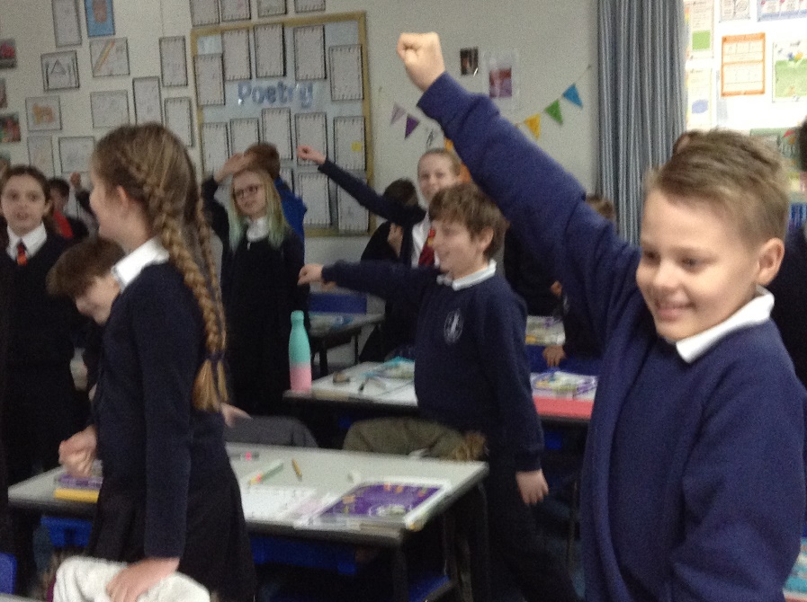

It was a thoroughly enjoyable experience that had the children smiling (as you can see from the pictures) and interacting in a positive way and banishing any butterflies on the very first day back to school after lockdown.

