Children’s Mental Health Week
Across the school (including those learning remotely at home), Children’s Mental Health Week was celebrated during the week beginning 1st February. The theme this year was ‘Express Yourself’ and began with us joining together to watch a special launch assembly online with the Oak National Academy and children’s TV presenters.
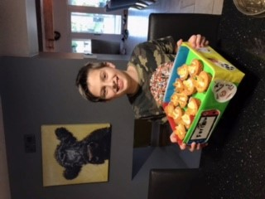
On Thursday, Mrs Henden’s live lesson to Key Stage 2 delivered the official lesson provided by the charity Place2Be. Place2Be is responsible for organising Children’s Mental Health Week, raising awareness of mental health issues and providing support. This live lesson explored what it means to express yourself, how this links to positive mental health and ideas for what we could do to express ourselves during our screen-free Friday. The children were also signposted to sources of support.
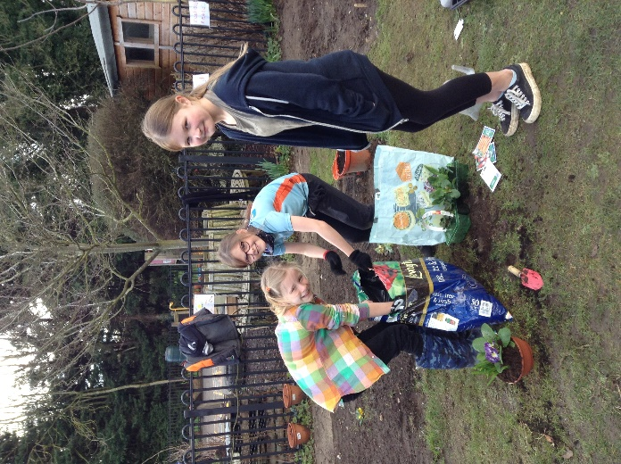
To ensure the children had plenty of opportunities to express themselves and to have a much needed break from online learning, Friday 8th March was ‘Screen-Free Friday’ for learners in school and at home. Children were encouraged to do the things that make them feel good about themselves. In school, both bubbles took part in cooking and decorating cakes, doing art and design activities, enjoying nature walks and extra PE. Our gardening group did an excellent job of brightening up the school grounds with colourful tubs of flowers. Learners at home also celebrated the day in a wide range of ways with cookery the most popular activity. The cakes looked delicious!
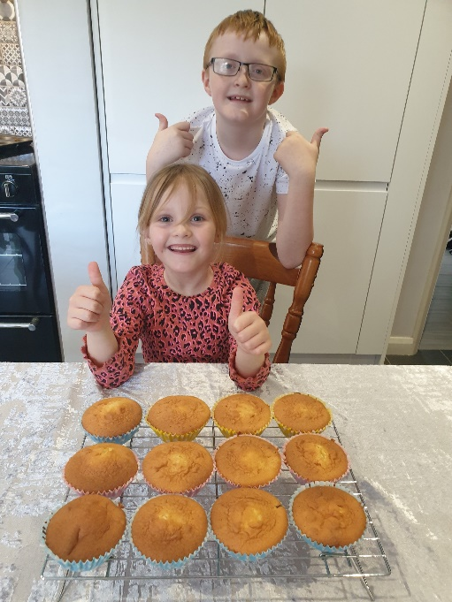

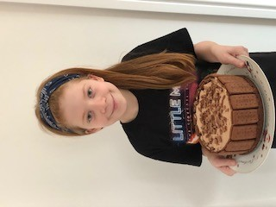
It was fantastic to see so many photos of the children with smiles on their faces clearly having a fantastic time expressing themselves. We now have a colourful display in our main corridor to share everyone’s enjoyment and the happy memories created.


