Shelters Project
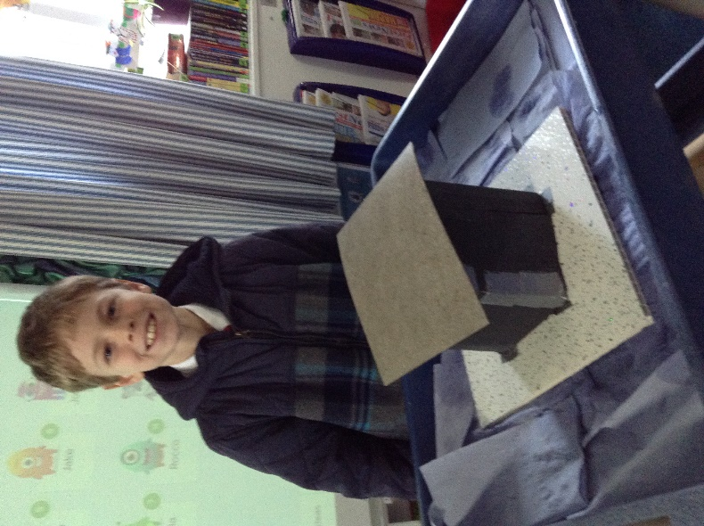
What a busy couple of days we’ve had! Our DT project for this term was ‘Shelters’. We began by testing ways of strengthening paper and by exploring which shapes are stonger. We then selected a range of materials and tested them for the following properties: durability, permeability and strength.
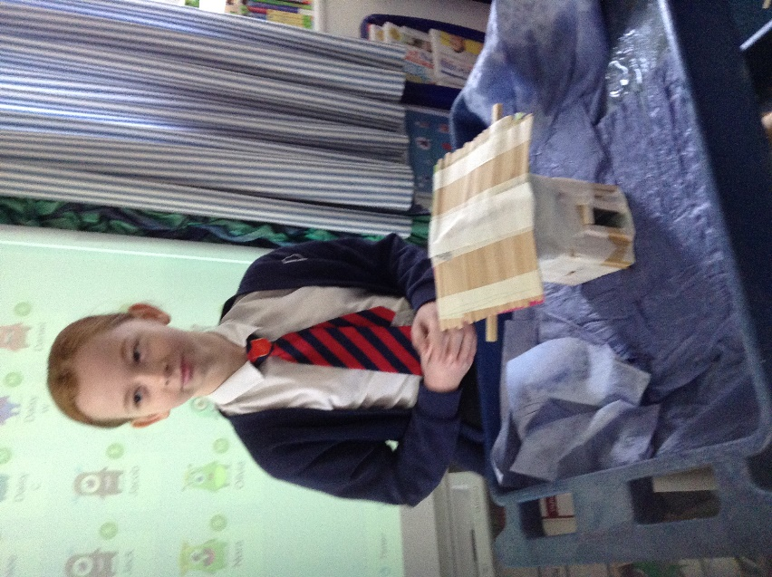
We then spent some time planning what we would build with consideration of available resources and equipment. The design brief was to build a shelter that would protect a Lego character from wind, rain and pressure from a 1Kg weight.
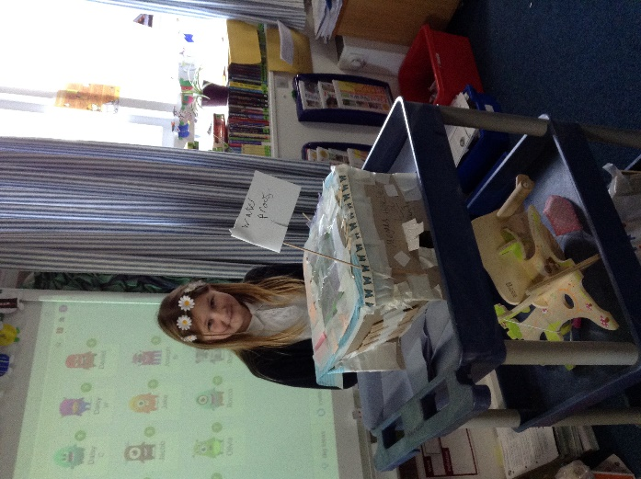

Once planned, we built our shelters from scratch.
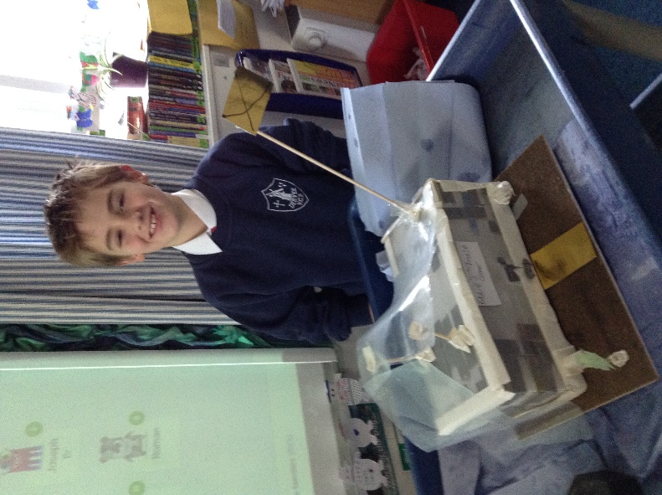

When the shelters were finished we tested them by placing a weight in the top, blowing them with a fan and squirting them with water.

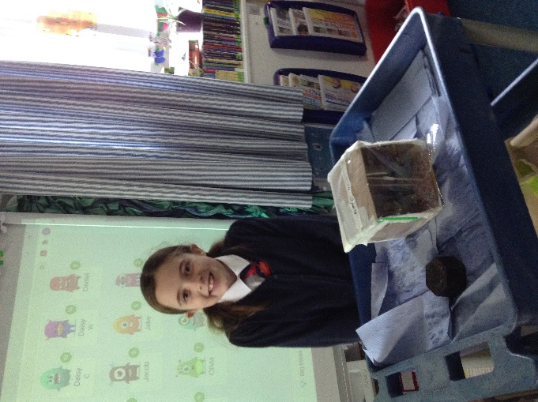
The final step was to evaluate our work. There were some impressive shelters.


