Christmas lunch
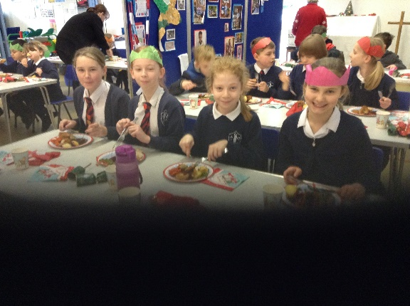
Today we ate our Christmas lunches in our bubbles. With festive music, decorated plates and cups, and crackers, which were generously donated by Denver Post Office Stores, we had a real treat.
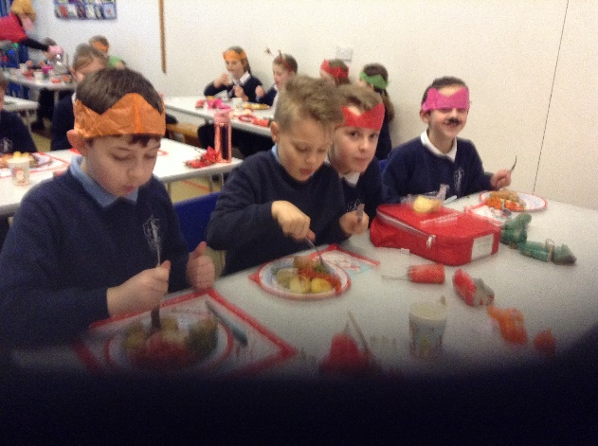
Lunch, as always, was delicious. A huge thank you to Miss Palmer and Mrs Fenn for the superb cooking and to our midday supervisors for making it such a success.
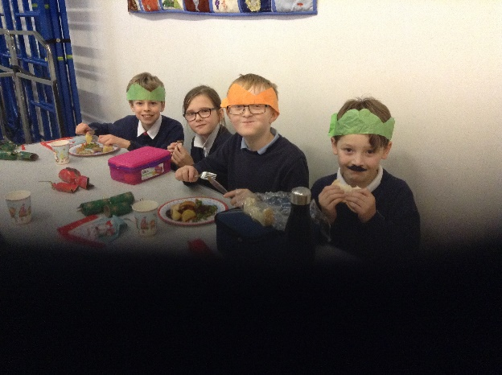

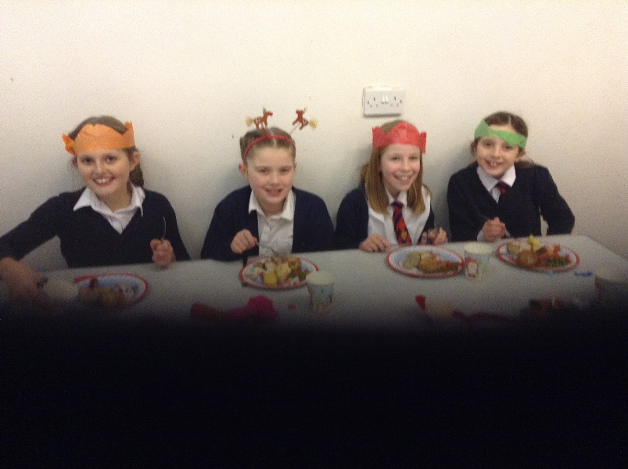

16.12.20

