Autumn Term (1) Round-up

We have had a busy first term in Class 1 and the children have enjoyed getting to know one another. In Literacy, we have read The Gingerbread Man and other traditional stories. The Year 1 pupils retold the story in their own words and are growing more confident in their writing. The children enjoyed making their own gingerbread men, and were confident retelling the story to the class.
In Science, we learnt about the types of materials we use every day and the children had fun investigating the properties of different materials, how they feel, what they are used for and what happens to them when they get wet.
We have worked hard in PE and have enjoyed experimenting with different instruments in music, exploring the outside area and becoming ever more confident in working with numbers
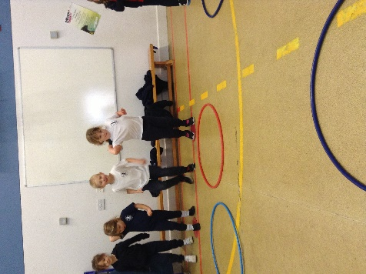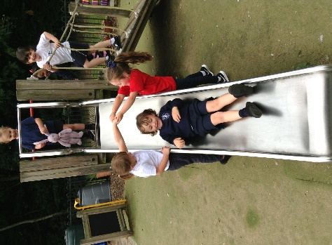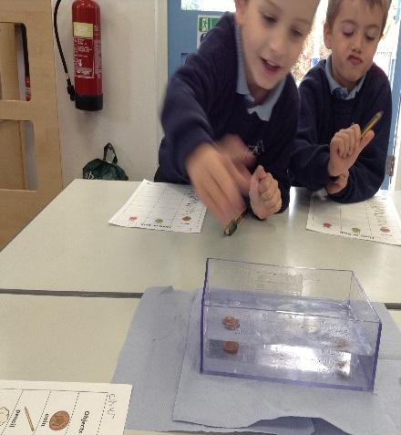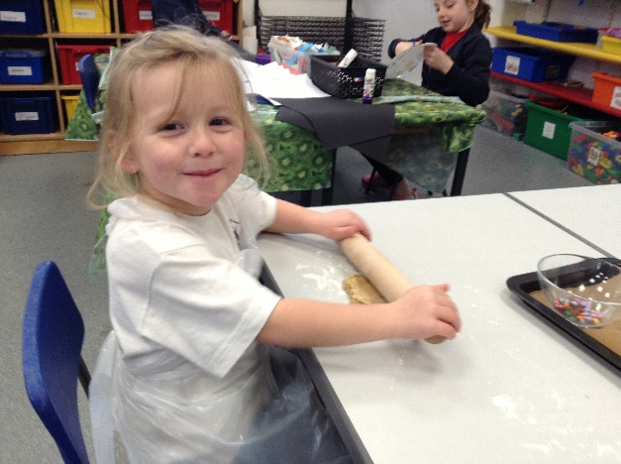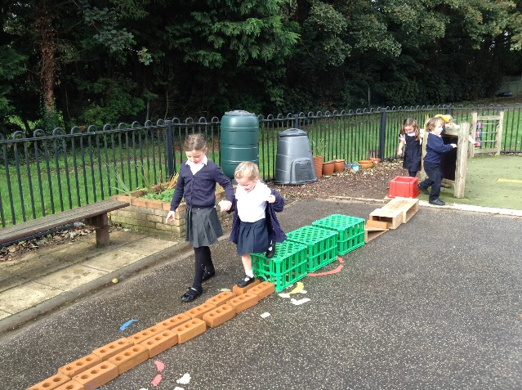
We are delighted with how well the children are settling in to school life and look forward to a busy second half of term.
All the best,
Mr. Sexton and Mrs. Alves

