National Fitness Day 2020

On Wednesday 23rd of July we were joined by Frances Rayner of Alive Leisure to celebrate National Fitness Day.
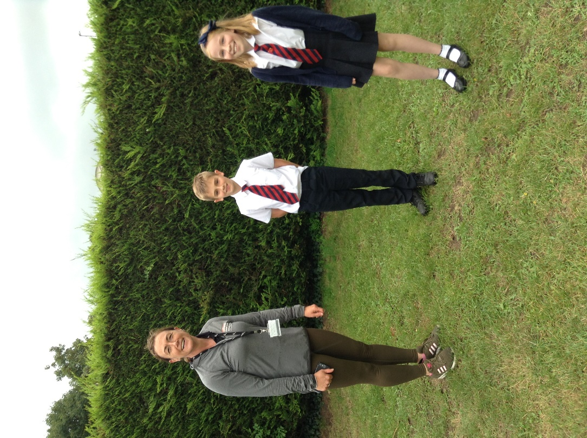
In their class bubbles, children and staff took part in running or walking an ‘Active Mile’ (8 laps of our Golden Mile track) with an aim of promoting both physical and mental wellbeing.

Our Sports Councillors were interviewed and will soon be appearing on the Alive website using the Alive Active Community link. Thank you to Edward and Laura for being fantastic ambassadors for the school.

