Our brand new sports kit
As a result of signing up to the Premier League Primary Stars website to access their resources, we were able to enter a competition to receive a new sports kit. Here are our sports councillors wearing the tops.
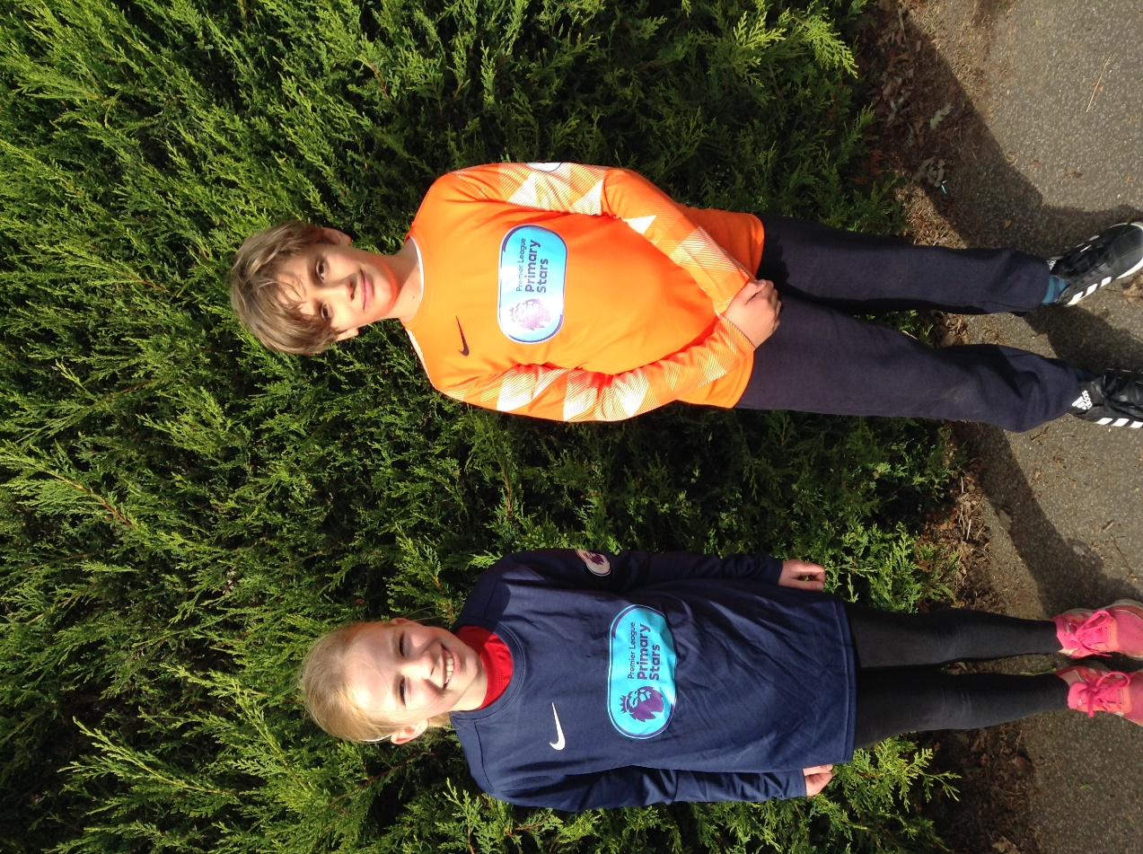
Our application was successful and we now have received a full kit comprising 1 orange goalkeeper strip, 14 dark blue tops, 14 pairs of shorts and 14 pairs of socks. These will be fantastic for when we can once again take teams to cluster and area competitions.

