
September 2020
Newsletter


I would like to welcome back all children and parents, and extend a very warm welcome to our new parents. It really is lovely to have all of our children back as we missed them greatly over the lockdown period. We have been really pleased with how they have settled back into school routines and how quickly they have adapted to the extra safety measures in place.
I would also like to thank all the parents/carers for your support in ensuring the smooth transition back into school for our children. The new drop off/pick up arrangements seem to be working well and we are grateful to you all for following social distancing measures.
These are challenging times for us all, and it will be really important that we work together as a school community to support each other over the difficult months ahead.
School Day
It is really important that the children are promptly in school for the start of the day for their bubble as we have an awful amount to fit into the curriculum each day, as well as the extra hygiene measures that take a considerable amount of time. Thank you for your support with this.
Wellies
As autumn seems to have suddenly arrived, we recommend that the children wear wellies to walk across the field to avoid getting their wet feet. Please send their school shoes in a separate carrier bag and the children can change into these before going into school.
COVID-19 App
The government have now launched the NHS Covid-19 app, which is available to download for anyone aged 16 or over if they chose to do so. The app has 6 key features that will people to reduce personal and public risk:
- Trace – alerts the individual if they were in close contact with a confirmed case
- Alert – provides the individual with the risk level associated with coronavirus (COVID-19) in their local area, based on the postcode district they enter
- Check in – allows the individual to check in to locations via the app and official NHS QR codes
- Symptoms – allows the individual to check symptoms against government guidance and to get advice
- Test – allows the individual to order a free test and to receive results and advice via the app
- Isolate – provides an isolation ‘companion’, which counts down how many days they have left to isolate and provides links to useful advice
Further information about the app is available on the NHS COVID-19 app website.
Remote Learning
If your child is off school because they are self-isolating or awaiting a COVID test, we will provide remote learning from the second day of being notified of their absence. We are currently working on a new email system which will allow teachers to send work directly to any children who are unable to come to school. Work will not be sent home for those children who are unable to be in school because they are ill with non COVID-19 related illnesses. More details about the new email system will follow shortly.
Recovery Curriculum
We have a Recovery Curriculum plan in place to support children in their return to school, academically, socially and emotionally. The plan focuses on identifying gaps in learning and how these will be addressed, and aims to promote the wellbeing of both children and staff.
Norfolk Healthy Child Programme
The Norfolk Healthy Child Programme Team has provided some helpful guidance for parents/carers about the services and support available to families in these challenging times. You can access this information at:
file:///C:/Users/Mrs%20Jones/Downloads/Healthy%20Child%20Programme%20Parents.pdf
Free School Meals
We realise that some families may be struggling financially as a result of the pandemic and would like to make you aware of the following website for information about free school meals: https://www.norfolk.gov.uk/education-and-learning/schools/school-meals-and-milk. If you do need more support in this area, please contact the school as we may be able to signpost you to other agencies which can offer support.
Staff News
Mrs Bridget Chilvers, our Secretarial Assistant, is sadly leaving us at the end of September. Bridget has done a fantastic job in the school office over the last few years; we will all really miss her and wish her all the very best for the future. Chloe Loveridge, a Level 3 Teaching Assistant student, is continuing her placement with us this term. She will be working in school 2 days each week and will provide support in Class 3.
Uniform
Please remember that trainers should only be worn on days when children have PE, and not worn routinely at other times. Jewellery should not be worn, other than watches and stud earrings, and these must be removed for PE. Long hair should also be tied up to avoid children touching their faces. We ask that hair accessories are small and in school colours.
New School Website
I am really excited to inform you that our new school website will be going live very soon. We were hoping to have it up and running for the beginning of term and I apologise for the delay. I have been working with the website design team and I am really pleased with the new format. I hope that you will find it much more user friendly and easier to navigate. We will let you know as soon as it goes live.
New Behaviour Policy
We are really pleased to have implemented our new Positive Behaviour Policy this term. The policy, which focusses on positive behaviour strategies and consistency through the school, can be found on our website. If you have any questions about the new policy, please do not hesitate to contact me.
Class Dojo
Central to our new behaviour policy is our engagement with Class Dojo, an interactive system which encourages positive skills such as perseverance and teamwork in our children. It is a simple secure system and will allow you to see and celebrate with your child how many Dojo points they have received. The free app can be used on any iOS or Android device or at classdojo.com on your computer.
So that you can access the system you will need to sign up for a parent account, but we will send an invite to the email address you have provided on your permission forms
If you would like to find out more about Class Dojo, please visit the website at https://www.classdojo.com/en-gb/learnmore
Denver Bright Star
We were really thrilled to receive the Denver Bright Star at the end of term. It was an extremely generous and thoughtful gift which we all really appreciated in school. I spend many an evening gazing into the night star looking for our star and reflecting on the many positives that have come from such an extraordinary year. The certificate is now sitting proudly down the corridor. Thank you so much once again.
Friends’ Update
Unfortunately, due to pandemic, the Friends of Denver School were unable to go ahead with any of their planned fundraising events in the spring and summer terms, such as the Sponsored Walk and the Village Yard Sale. As a result, the Friends’ funds are looking rather depleted and in much need of a boost. If anyone did participate in a sponsored event, e.g. the Sponsored Summer Read, or would simply like to make a donation, please transfer any funds directly into the Friends’ account:
Sort Code 20-46-65
Account Number 90026174
Ref: Child’s name and class
The Friends are looking for new members and fundraising ideas for the coming year and have arranged a planning meeting on 6th October.
Christian Values
This year we have decided to agree a number of Christian Values which will be at the heart of everything we do in school. At the beginning of term, each class discussed Christian Values they felt were important and we have created a 2 year rolling programme of these. Each half term we will focus on a different Christian Value. This will be done explicitly through our Collective Worship time, but also throughout our curriculum. Children will have regular opportunities to reflect on each value and to develop an understanding of each value in action. We will celebrate children who demonstrate these values in our class reflection areas and in our celebration assembly each Friday. The value we will be focussing on this half term is ‘Thankfulness’.
Volunteers
We have a number of regular volunteers who kindly give up their time to listen to readers, help out on school trips etc. The government guidelines still allow volunteers to come into school, therefore if any parents feel that they have some spare time to offer, please contact the school by telephone or email.
School Lunches/Drinks
All children in Reception and KS1 are entitled to receive a daily free school lunch as part of the government’s Infant Free School Meal scheme. In order to receive a nutritionally balanced meal across the week, we ask that parents stay with one option for the half term, rather than swapping between the free school lunch and a packed lunch from home. Please remember that there is now a school packed lunch option on the menu. Thank you for your support with this.
Snacks
All children in Reception and KS1 also receive a piece of free fruit or vegetable as a snack each day, therefore there is no need for children to bring in additional snacks. Children in KS2 may bring in a healthy snack if they wish to.
Drinks
All children are able to purchase a drink (either milk, flavoured milk, apple juice or orange juice) to have at morning break time for 20p each day. Please ensure that your child is aware of if they are having a drink and pay via BACS on a weekly or monthly basis if possible.
Allergies
We have a number of children in school with nut allergies, therefore we ask that parents avoid sending in any nut products, such as peanut butter, in packed lunches. Thank you for your cooperation.

TT Rockstars
This year we are pleased to offer access to TT Rockstars to all of our children. Your child/ren should have received their login details and we encourage them to access the programme at home as much as possible to support their learning of times tables in school. It has been really noticeable in those children who have been regularly logging in to practise at home.
School Jam and Maths Flex
We are really excited that our children in KS1 now have access to School Jam. Miss Pennock and Mr Sexton will allocate homework, via the app, linked to the learning the children have been doing in school. Please engage with the activities at home with your child as they provide excellent consolidation of the unit of work they are currently focussing on. There is a similar programme for KS2 called Maths Flex and we are working hard in school to get this up and running as soon as possible.
Reading
Please can we encourage you to listen to your child/ren read as much as possible at home and record this in their reading diaries so we can monitor in school. Regular reading is so very important for all children and it is imperative that they all get back into the habit of daily reading, as this is the foundation for all other learning.
Gardening Wellbeing Group
The wellbeing of our children is of utmost importance in these challenging times and we have consequently introduced a wellbeing gardening group for those children who need support in this area. The group are writing to local garden centres to see if they might donate any gardening equipment and they would be very grateful for any unwanted equipment, seeds etc. from parents. If you are able to help us at all in this area, please contact the office or approach me at drop off/pick up time.
Little Princess Trust
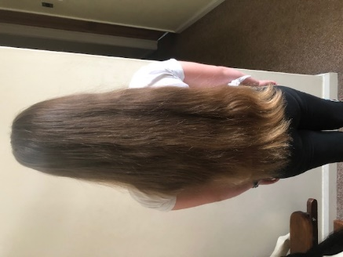
The Little Princess Trust provides real hair wigs, free of charge, to children and young people who have lost their own hair through cancer treatment or other conditions. Daisy W, in Class 4, decided that she was going to have her hair cut, which she has been growing for many years, to raise money for this worthy cause – she had an impressive 17 inches cut off in total! We are really proud of Daisy for her thoughtfulness towards others. If you would like to sponsor Daisy, there will be a donation pot on a table at the field gate after school each day over the next few weeks. Here are the before and after photos:
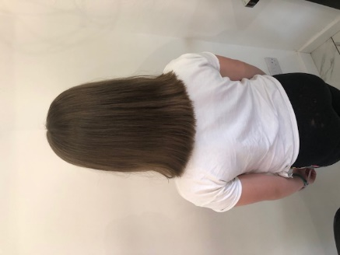
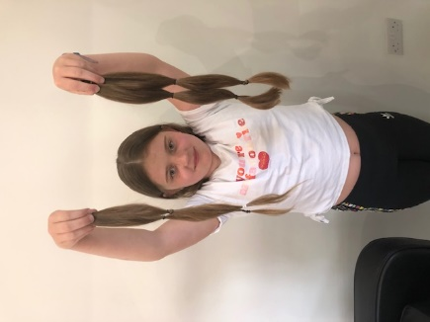

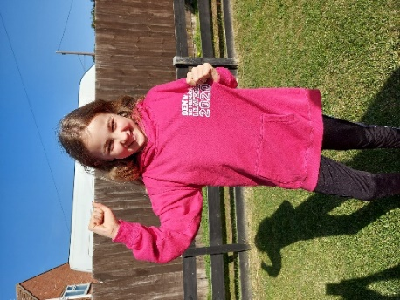
Denver Leavers’ Hoodies
We were really disappointed that we were not able to offer the usual end of year events for our Y6 leavers at the end of summer term, and we wanted them to leave us with a memento of their time at Denver. We therefore gave parents the opportunity to buy a leavers’ hoodie. Here is Hollie, one of our former pupils, proudly wearing her hoodie.
Office News
To enable us to ensure the safety of children and staff in school, the School Office is unable to accept any forgotten items to pass on to children. If they are essential, please make sure you send them with your children in the morning.
Thank you to everyone who has been using on-line banking to make payments into school. We are still getting to grips with the new system but so far, it is working really well. It is especially helpful when you let us know you have made a payment. We would be grateful that you continue to let us know by emailing us at payments@denver.norfolk.sch.uk
Our new online uniform ordering service is in the process of being set up. Bookbags and PE bags will still be available to purchase from school, the order form for which will be accessible from our new website. Regretfully, will not be able to send these items home until payment has been received.
If your child if absent from school, please could you report the absence to: absence@denver.norfolk.sch.uk.
We have recently sent home permission forms for all children - thank you for everyone who has already completed and returned them. If you have not already done so, could we ask that you please return them to us as soon as possible.
Unfortunately, there are times when we are unable to answer phone calls. Our answerphone system is always switched on, so if you need to ring us but we are unable to answer your call, please use this facility to leave a message.

Forthcoming Events
Bags2School – 12th October
The Friends of Denver School have organised another clothes and shoe collection with Bag2School on Monday 12th October. The last collection raised £148 and we hope to be as successful this time. Please bring any bags to the front of school (near the office) where they can be left. If wet, we will open the hall fire doors and bags can be left here. We hope you will be able to support us with this fundraiser.

Parent Consultation Evenings
We would normally hold our Parent Consultation Evenings just before half term, however we unfortunately cannot invite parents into school at this current time. We have, therefore, decided to offer you telephone consultations with your child’s class teacher. These will be limited to 10 minutes for each child. We have decided to wait until November for these consultations to allow children more time to settle back into school and staff to assess where children are working at. A list of available times will be made available as usual, although you will have to contact the office for an appointment. We hope that you will understand our reasons behind the changes. More information will be sent out after half term.
Class Sponsored Walks
As mentioned earlier, we were really disappointed to not be able to have our annual sponsored walk back in May. Instead, we have decided that each class bubble will hold their own sponsored walk in the week before half term. Each class will have a ½ hour time slot to complete as many laps as possible, either walking or even running if they are feeling energetic! Sponsor forms will be sent out to you soon and we hope that this event will raise some much needed funds for The Friends.

Sports News
Active Mile
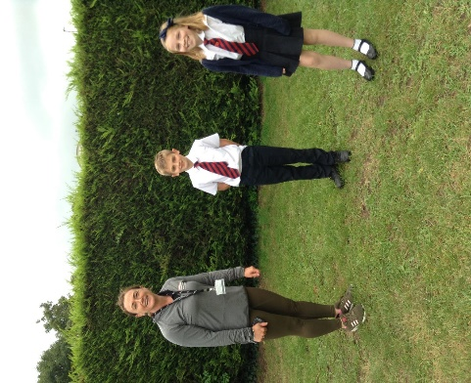
On Wednesday 23rd of July we were joined by Frances Rayner of Alive Leisure to celebrate National Fitness Day. In their class bubbles, children and staff took part in running or walking an ‘Active Mile’ (8 laps of our Golden Mile track) with an aim of promoting both physical and mental wellbeing. Our Sports Councillors were interviewed and the interview can be found on the Alive website using the Alive Active Community link. Thank you to Edward and Laura for being fantastic ambassadors for the school. Thank you to Mrs Henden for organising the event, and to all the parents who also engaged.
Sporting Events
We will still be participating in cluster sporting events this year, although these will happen virtually. Our first event, the Active Kids sessions for Y1, will take place in the children’s own PE sessions. The theme is target games and I’m sure the will be just as exciting for the children.
Sporting Stars
We would like to continue to celebrate the children’s sporting achievements outside of school on our ‘Sporting Stars’ display board, therefore please email any appropriate photos or certificates and these will then be added to the board.

Clubs
I am really pleased that, despite restrictions, we have been able to offer an after school sporting club for each class bubble. The children have really been enjoying attending these sessions over the last few weeks and the coaches have given very positive feedback about the engagement and behaviour of our children. If your child would like to participate, there are still some free spaces, therefore contact the office to confirm a place.
Golden Mile
This year, we will once again be engaging with the Golden Mile. For those of you who are new to the school, the children spend some time each week walking or running around our 200m Golden Mile track on the field. Their laps are counted at the end of each week and certificates are awarded when the children reach certain milestones, the first one being 10 miles. This activity is even more important this year as it keeps the children active, promotes positive mental health and gives them time outside in the fresh air. The children will start from scratch this year and I’m sure will be very competitive in clocking up the miles.
And finally…
Please remember that we are a listening school and are still keen to engage with parents and hear your feedback. I realise that current restrictions mean that it is not as easy to speak to the class teachers, however I will be at the field entrance at drop off and pick up each day (come rain or shine!) so feel free to come and talk to me, or ask me to pass on messages you might have for class teachers. Alternatively, you can email or telephone the school office and we will get back to you as soon as possible.

Dates for your diary- please keep for future reference:
Autumn Term
Autumn Term

October 2020 | 12th | Mon | Bags2School Collection
October 2020 | 22nd-30th | Thu | School closed for half term
November 2020 | 2nd | Mon | Children return to school
November 2020 | 4th | Wed | Flu immunisations
December 2020 | 18th | Fri | Last day of autumn term

Spring Term

January 2021 | 4th | Mon | Children return to school
February 2021 | 15th-19th |  | School closed for half term
February 2021 | 22nd | Mon | Children return to school
March 2021 | 26th | Fri | Last day of spring term

Summer Term

April 2021 | 12th | Mon | Children return to school
May 2021 | 3rd | Mon | School closed for Bank Holiday
May 2021 | 31st – 4thJune |  | School closed for half term
June 2021 | 7th | Mon | Children return to school
July 2021 | 21st | Wed | Last day of summer term

