Pen pal correspondence (June 2nd 2026)
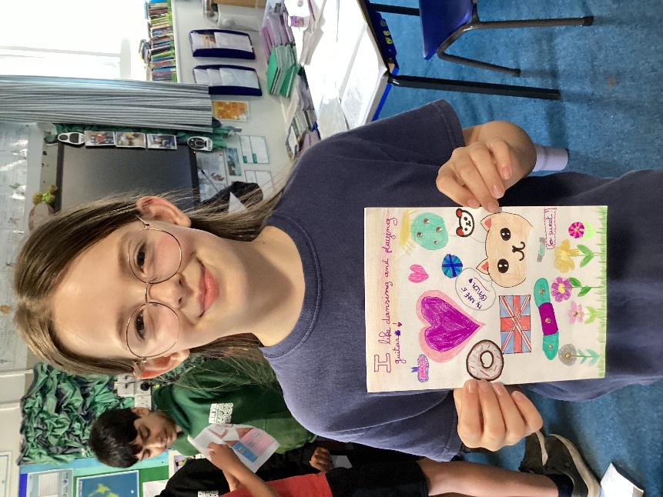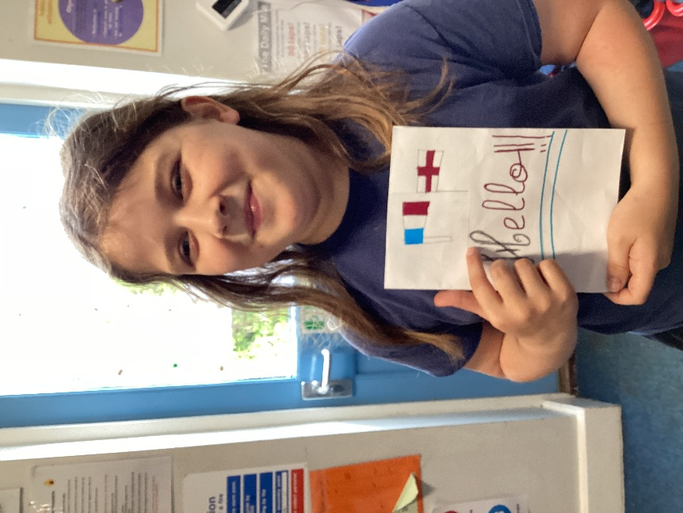
As part of our learning in French, earlier in the year we wrote letters to introduce ourselves to the children of a primary school called Saint Victor which is in Paris. The aim was for us to practise our French but also to acquire pen pals.
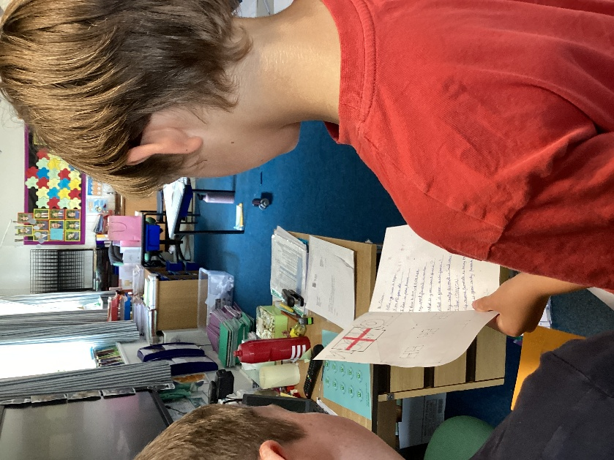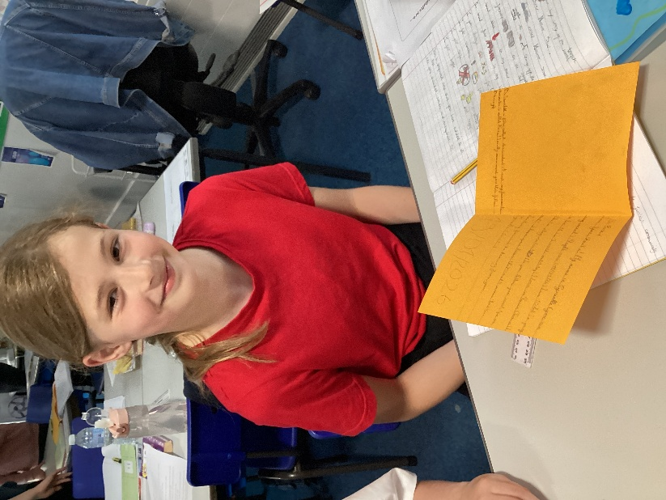

We were delighted to finally receive some wonderful cards from our French counterparts. We shall make sure to write back to them in our next French lesson to keep up the communication.



