A visit from a New Zealander

Class 4 children had a great time learning about their geography topic, New Zealand, through a guest visitor, Laura, who originates from New Zealand. She will be travelling back to visit her family this summer.
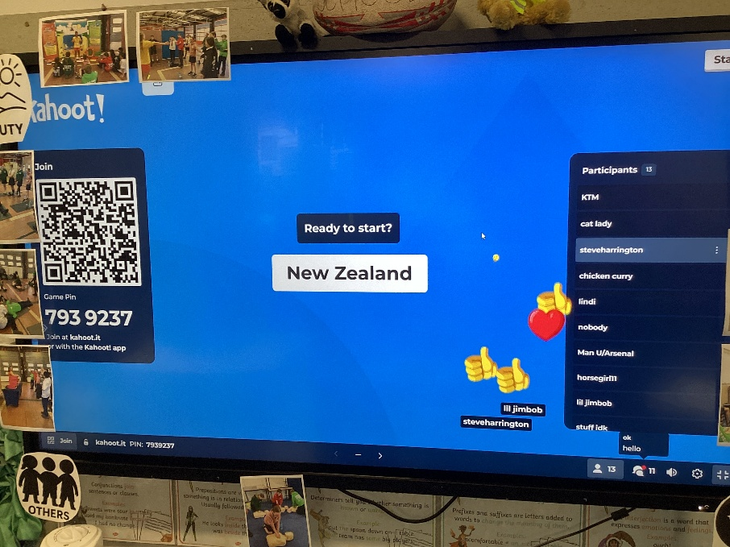

It began with Laura greeting us in Maori language followed by an exciting, interactive Kahoot quiz to learn different facts about New Zealand. Thankfully, this showed that they have been learning well in class!
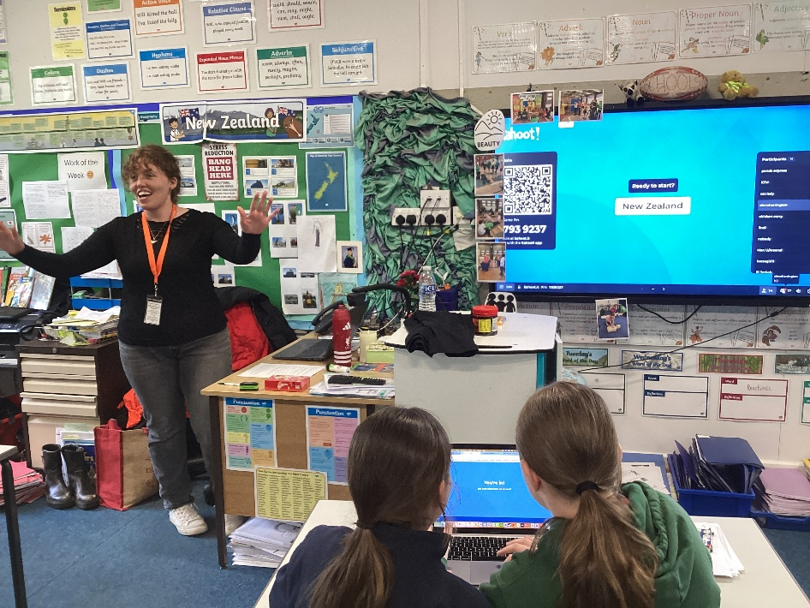

Laura then shared some information about the climate, landscapes and main cities, including sharing some images of her home city, Napier. She explained what it is like to live with the threat of earthquakes (which we didn’t realise happened every day) and the emergency drills they learn to do at school.
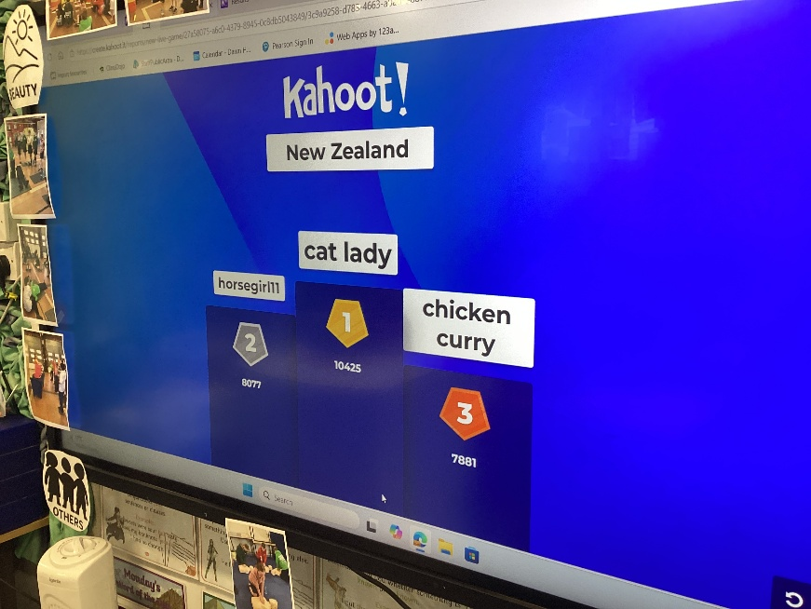

Laura shared some New Zealand items, including her All Blacks team shirt. The Marmite was just like in the UK: you love it, or you hate it! There was a chance to ask questions to find out more.
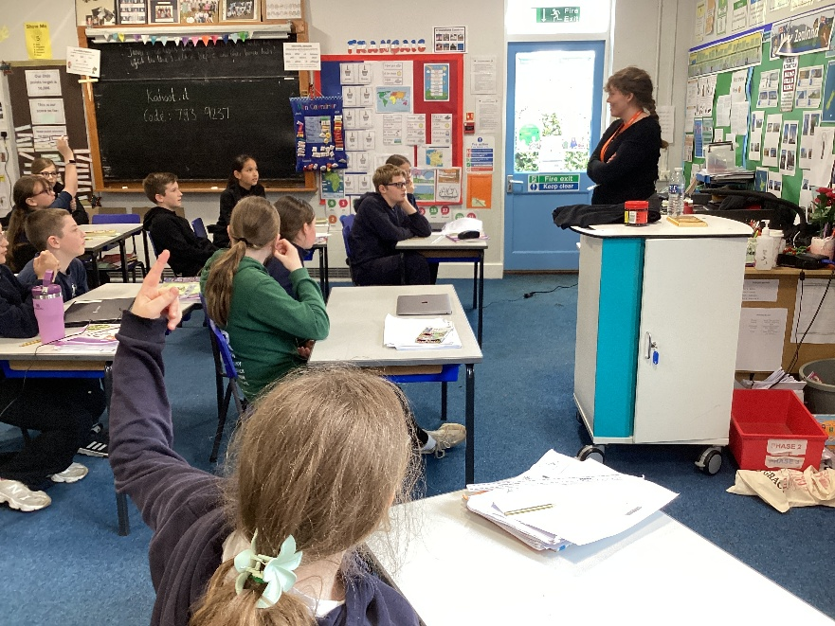

This has been a very valuable experience and we are very grateful to Laura for her time and a thoroughly enjoyable afternoon.

