Crucial Crew at King’s Lynn Fire Station

This year’s Crucial Crew for Year 6 children across the King’s Lynn area was a great success. We joined the final group on Friday 1st May.

Throughout the afternoon plentiful knowledge was gained about how to be safe in a range of situations as the children visited a host of workshops to enrich their personal, social, health and safety education.

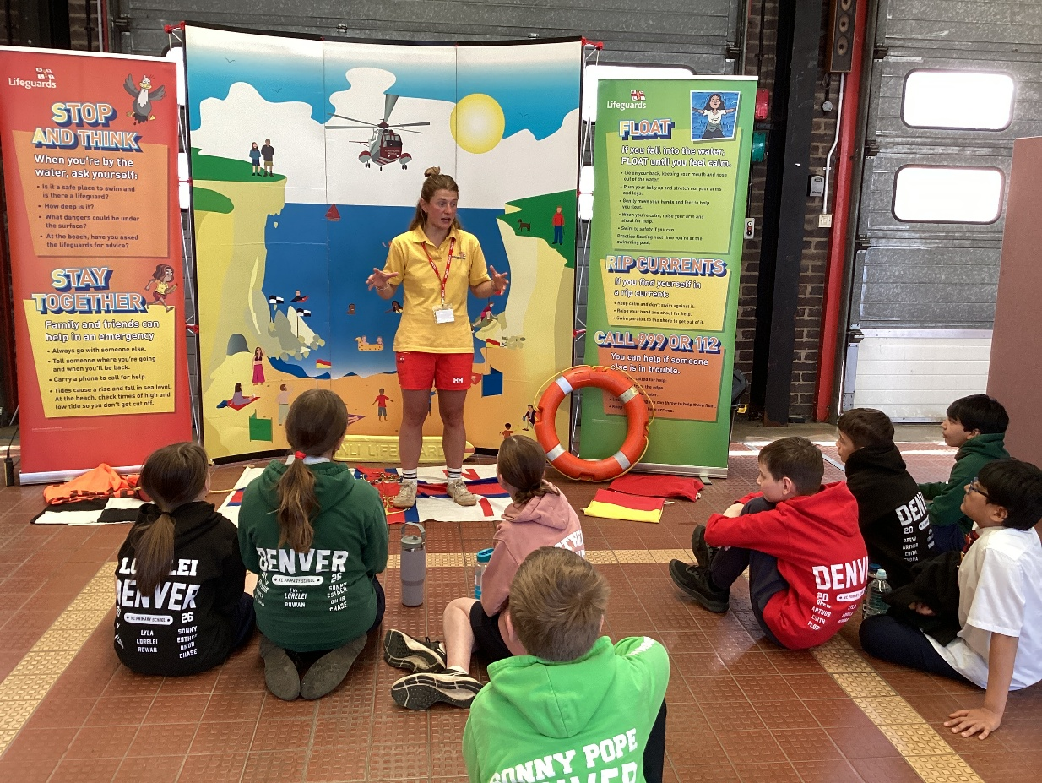

The first stop was with the RNLI station where dangers by the sea and beaches were identified and then a full explanation of how to deal with them. The children practised shouting for help and how to lay on their backs in a star position if they are stranded out in the sea or rivers.

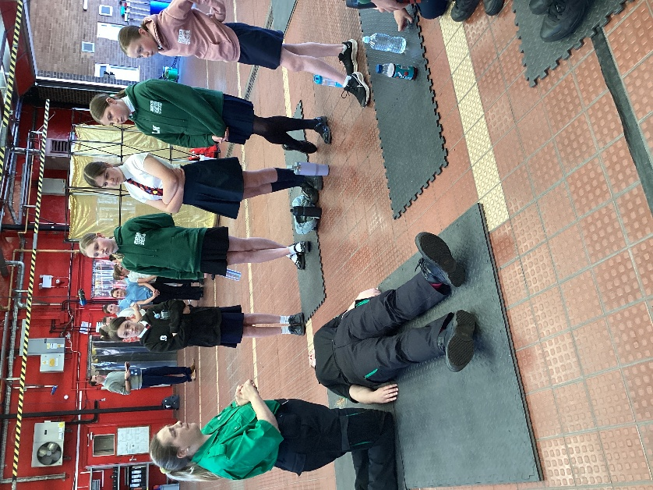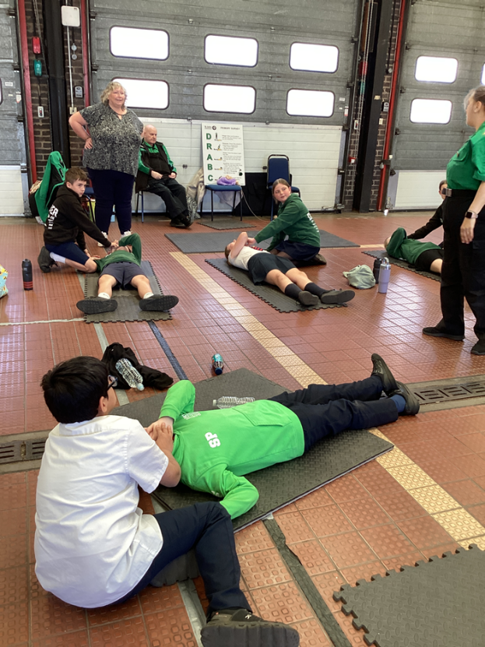
The second stop was with St John’s Ambulance volunteers who explained the DRS ABC procedure for dealing with casualties then a hands-on opportunity to practise calling for help, checking for breathing and whether responsive, clearing the airway and putting partners into the recovery position.
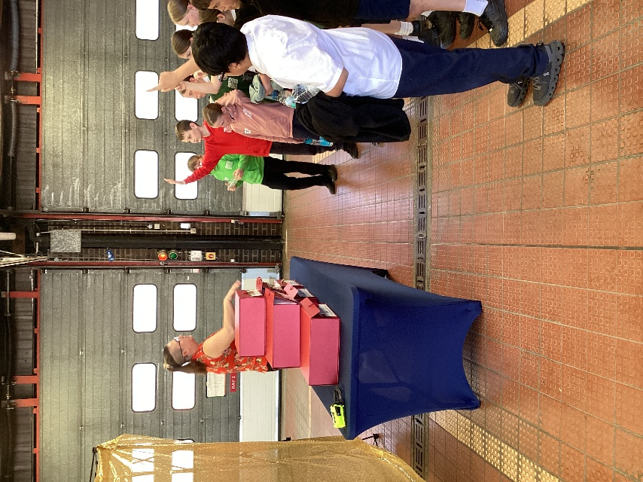
Another station was manned by Norfolk Fire and Rescue Service volunteers. They had made a mock-up of Deal or No Deal renamed ‘Spark or No Spark’ about fire hazards. Together the children found the hazards and worked with the expert fire officer to discuss how the risks could be eliminated. The fire officer also stressed the importance of checking smoke alarms on a weekly basis – and not just when food has been burnt in the kitchen! Apparently, that is not an effective check: the button must be pressed to check the unit is functioning properly.
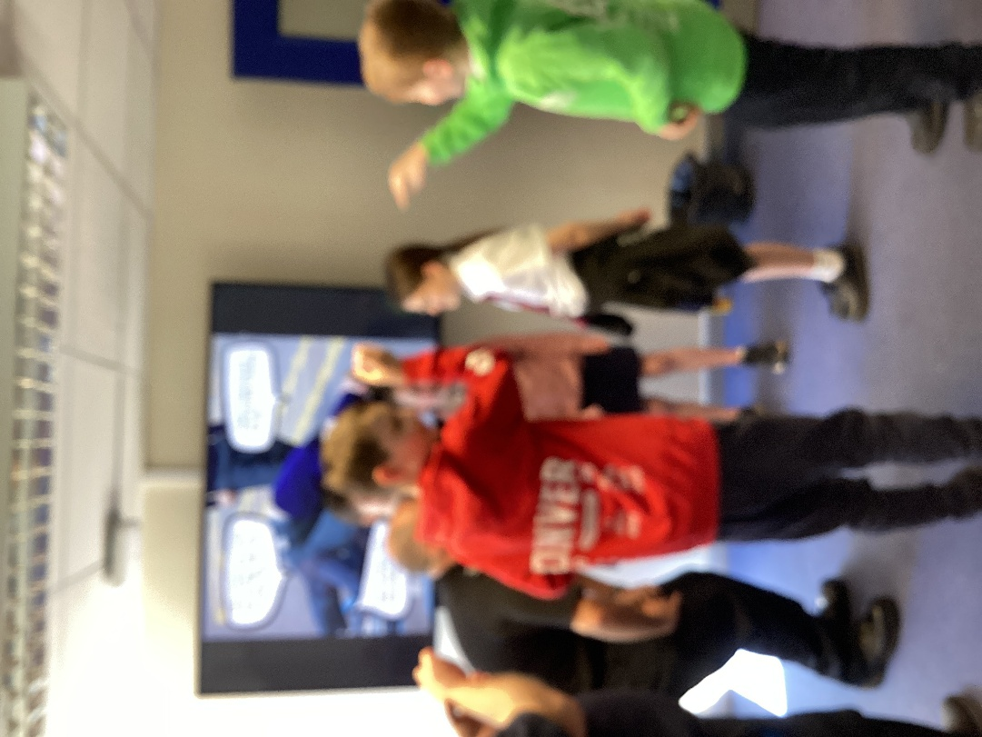

From there, the next workshop was led by two police officers from Norfolk Constabulary. They shared very common-sense advice about fighting and criminal responsibility. We learnt that criminal responsibility starts at age ten. We also discovered that you can get a criminal record if you film a fight and upload it to social media.

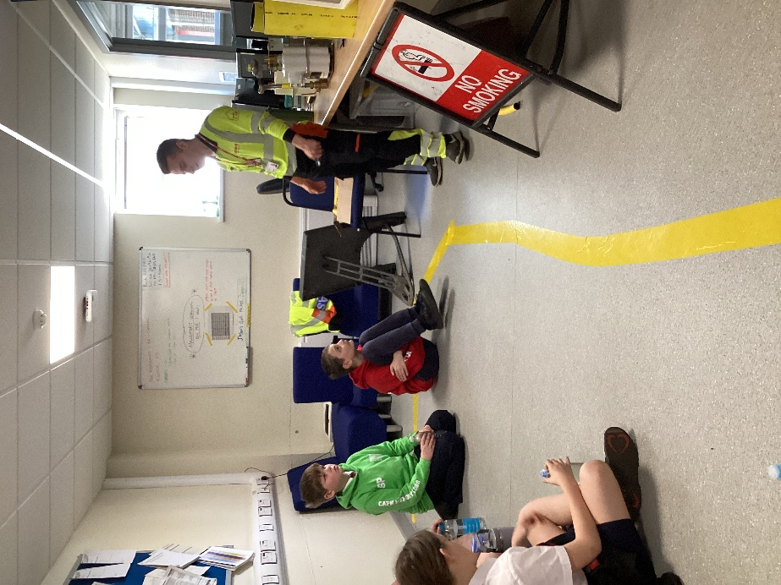
Luke from Cadent had everyone entertained by his lively and humorous talk about what to do in the event of a gas leak to prevent explosions. He taught us the helpline number, to open doors and windows for ventilation, to get out fast and seek help and that you should never flick switches on or off if you smell gas because the small spark in the socket could trigger an explosion.
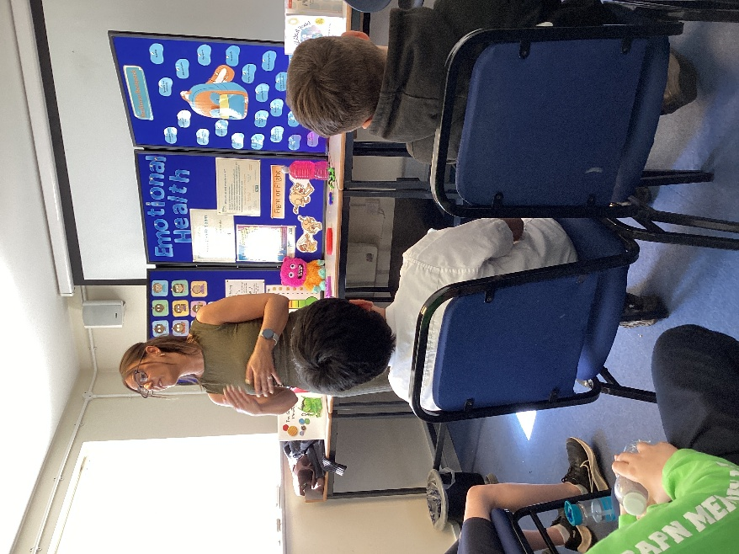
The sixth stop was with NHS wellbeing practitioners who talked through some helpful strategies for grounding when you are really anxious and need to get out of panic-mode.
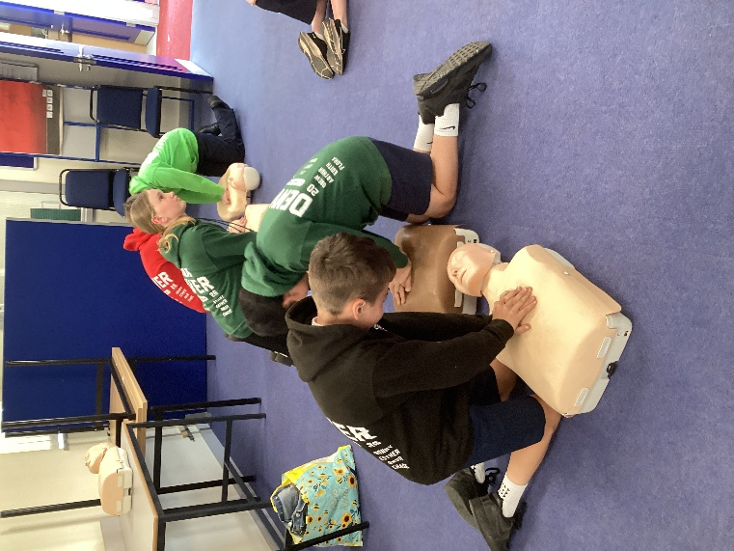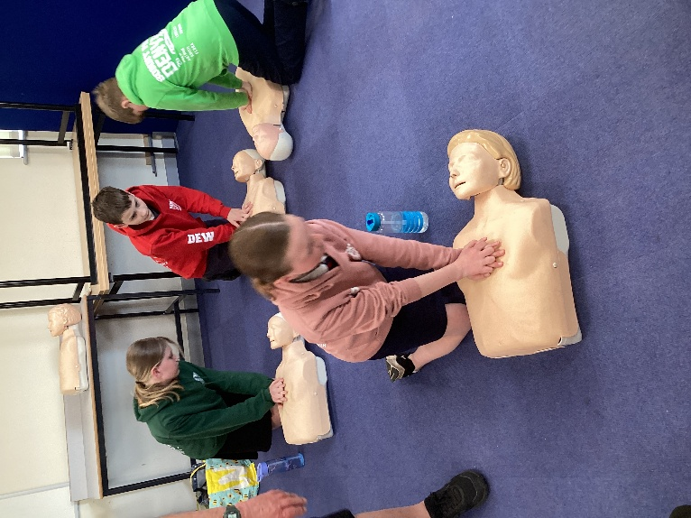
The last stop was with paramedics from the East Anglian Air Ambulance who explained how to make a 999 call, the information that would be requested in an emergency and how to perform CPR using dummies. It was an eye-opener what hard work it is to make continuous and deep enough chest compressions. A few seconds of it was hard work. In a real event this could take 30 minutes before a responder arrives.

If there are some takeaways from today for parents to help with, they are about making sure your child knows their postcode so that help in any emergency at home can arrive in the most rapid way. It was highly recommended that when out of the home, anyone with a phone downloads the What Three Words app to be able to pinpoint specific places for rescue services to attend in the event of an emergency.

The whole event was free thanks to the charitable institutions mentioned above that run these sessions on a voluntary basis.

Many thanks to Mrs Collins for coming with us and to Mrs Jones who was teaching the year 5 children while we were out so that we could attend a valuably important event, the knowledge from which could one day help the children to save a life.

