Girls only football tournament 21st April 2026
Following on from previous successes for England Lionesses in international competitions. West Norfolk Schools Sports Partnership continues to encourage grass roots football for girls.
Ever since girls only football has been introduced in the area, we have ensured that we have engaged with our area’s Downham Market Cluster competition run by WNSSP.
We are so fortunate to have such an array of talent in the school that we were able to enter two teams into the tournament which was open to girls from years 4 to 6.
Denver Athletic (in red) displayed great courage and resilience finishing in 5th position.
Very well done!
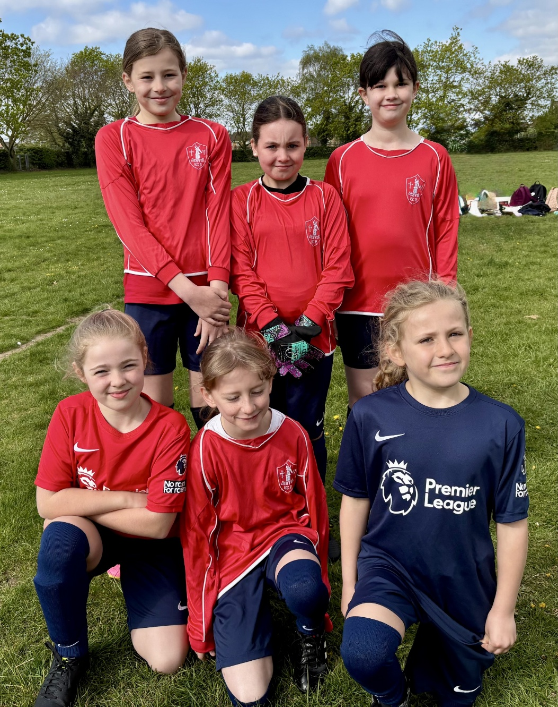

Denver Dynamos (in blue) enjoyed spectacular success winning all of their games. They scored a total of 44 goals without conceding any at all. They returned to school wearing huge smiles and gold medals. Congratulations!
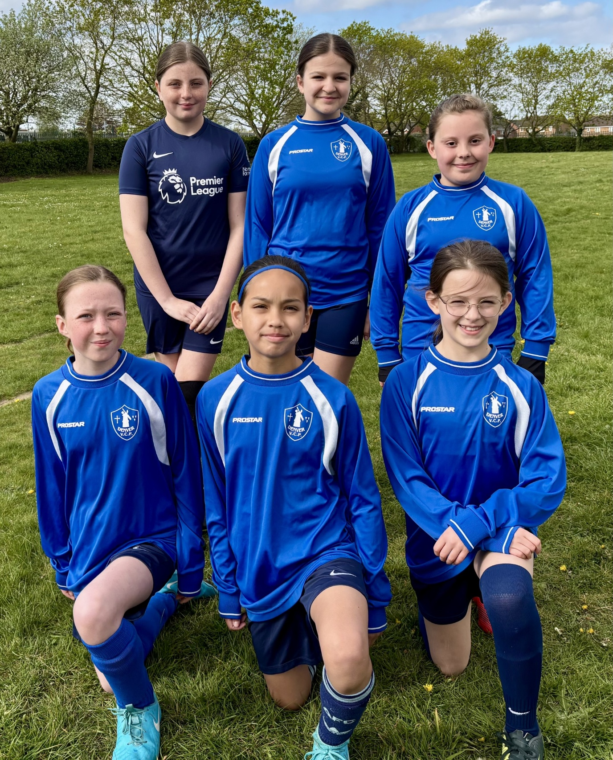
We are very proud of all of the children from both teams who have been a credit to the school. Thanks also go to Miss Boddy and Mrs Stansfield who took the girls to the event and provided encouragement and support.

