Cricket Resources

Keen cricketers Monty and Sammy and their family who take part in Downham and Stow Cricket Club have kindly donated cricket sets for all children to use during breaktimes, lunch times, PE lessons and our forthcoming cricket club with Luke.
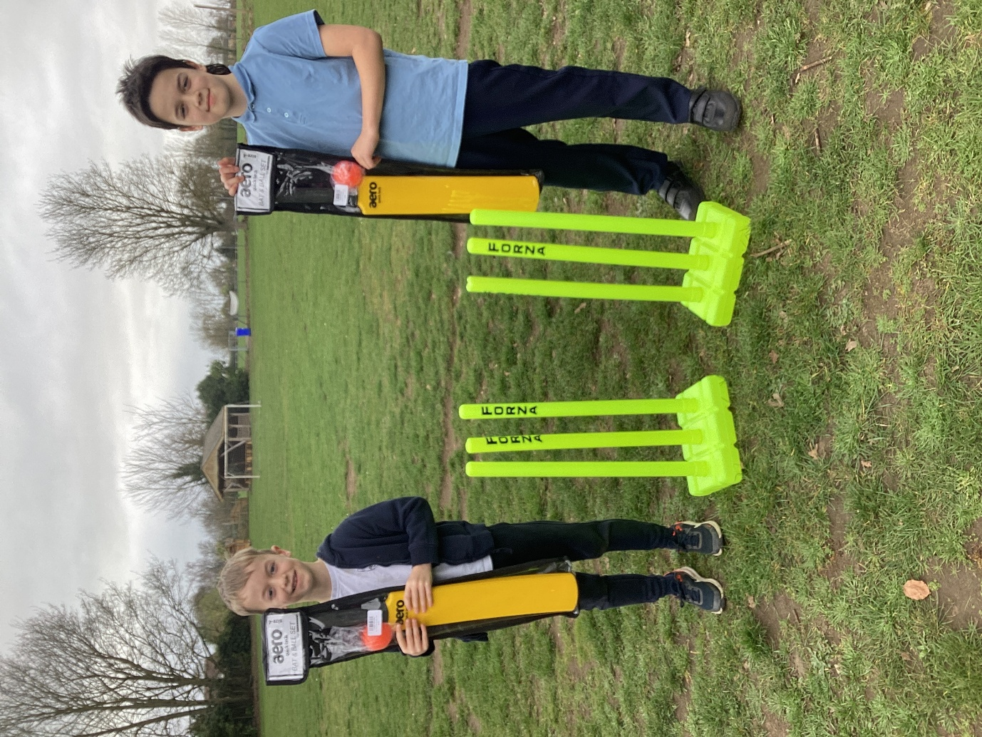
We would like to offer our thanks for this very generous gift that we are sure everyone will enjoy.

