Downham Market Rotary Club Visit – War is Brewing
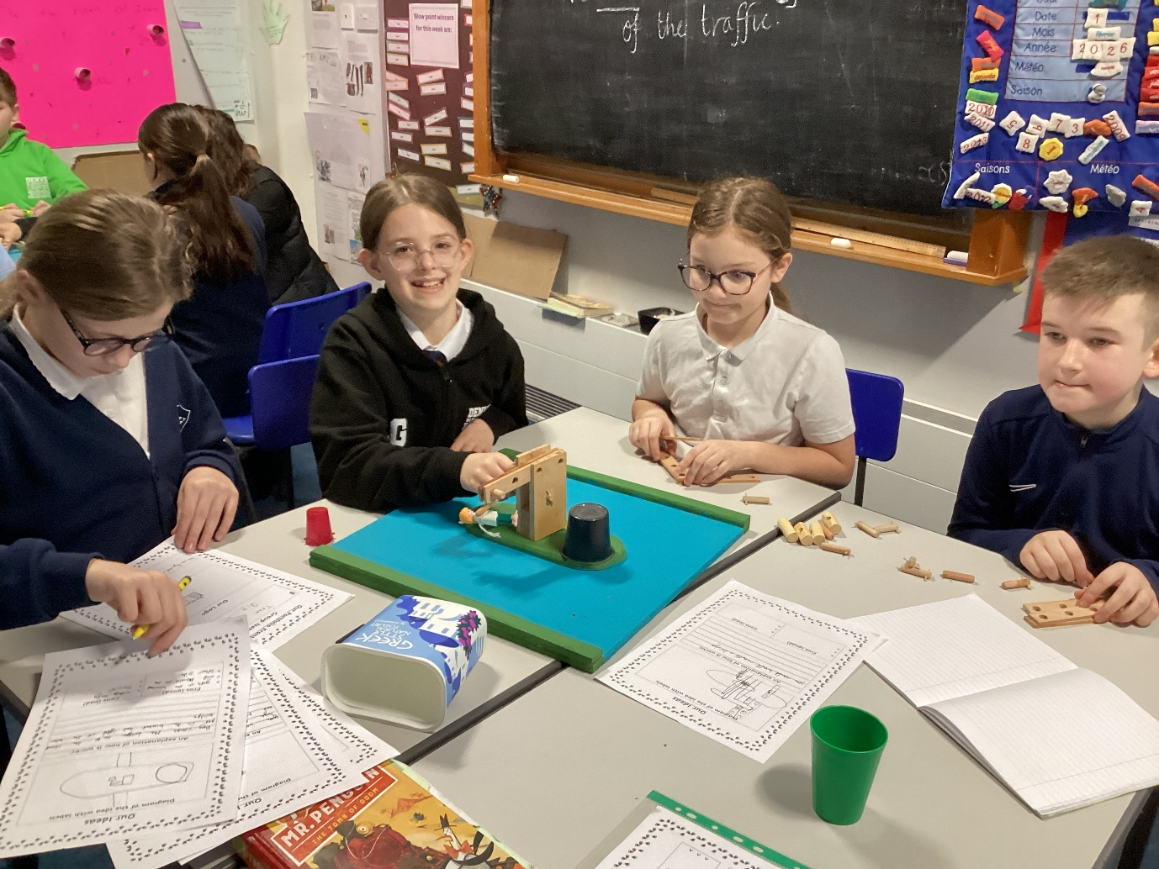
On Tuesday 10th February, children in Class 4 enriched their learning in DT through a thought-provoking challenge delivered by Downham Market Rotary Club.
This is the rationale behind the event:
Rotary Technology Tournaments are one day events organised by Rotary Clubs across the Country.
Schools and colleges are invited to enter teams of four students to undertake an unseen challenge by designing, constructing and testing their models against strict criteria.
The task compliments the requirements of the National Curriculum, supports the Government’s STEM initiative and is recognised as a qualification by the Crest Awards Scheme.
The tournaments are designed to develop team building and communication skills, to highlight to students the importance of planning and time management and to expose them to a scenario requiring the application of design and technology skills.
It is hoped that the tournaments are challenging and enjoyable and foster an interest in science, technology, engineering and maths that might lead to students considering careers in engineering.
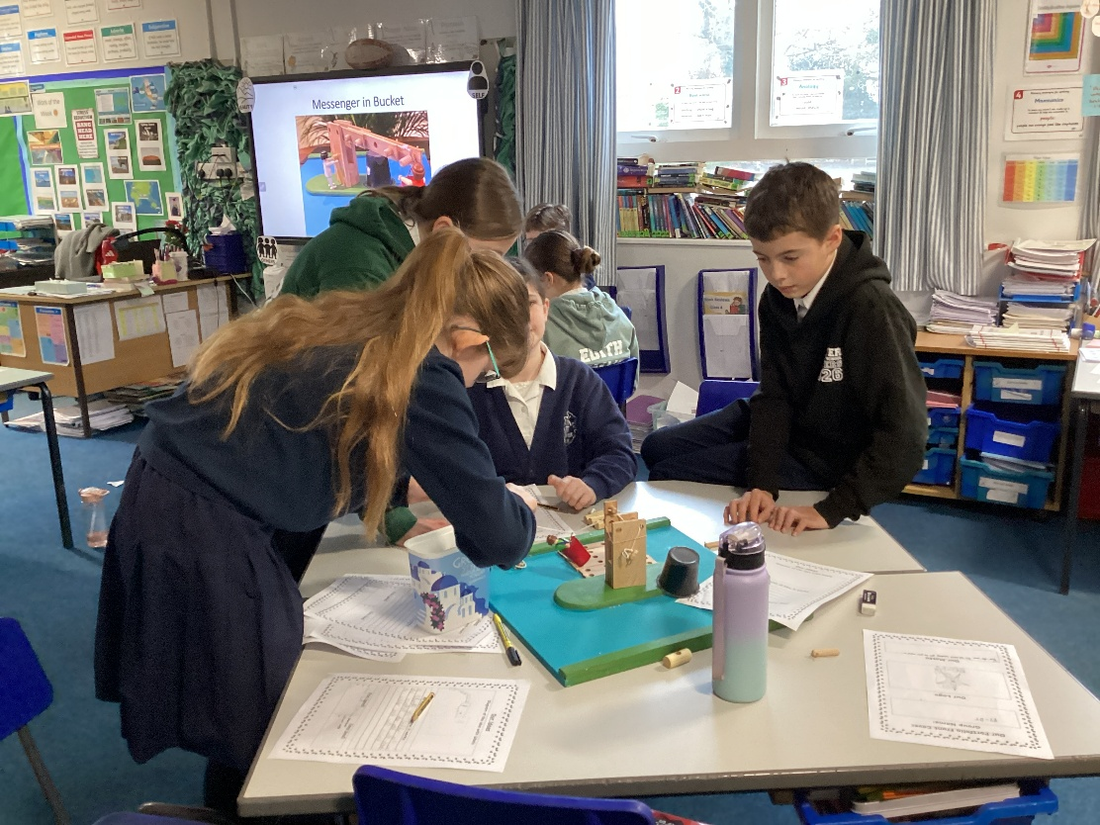

The challenge involved a limited amount of equipment and a lot of imagination. This was the brief:
War is Brewing - The year 1540
King Henry VIII is watching the arrival of an enemy force gathering out at sea. He can see his army will need more men if they are to repel the invaders.
He sends a messenger to a nearby town with instructions to tell the mayor to send at least 300 fighting men immediately. To make sure he hurries, the King threatens to chop the messenger’s head off if he fails to return with the reinforcements in two days.
On route the messenger comes across a river. In the middle of the river is an island with a dilapidated crane. The crane had previously been used to unload barges bringing food and supplies to the town but had not worked since the river silted up.
Although now only half a metre deep, the river is unusual as it is the only one in England to be infested with piranha fish. This makes it very dangerous to paddle or swim in.
The crane driver still lives on the island. He hopes one day the barges will return as he used to make his living from charging a few pence for helping them unload.
The crane driver is very poor now that his income has gone. He lives on the island eating nothing but piranha fish, except on Christmas Day when he treats himself to a dinner in the town, paid from his meagre savings.
The only furniture the crane driver possesses are the wooden bollards used to moor the barges. He keeps all his wooden items tied to the crane so they won’t float away if the river floods.
The task is for your team to create a portfolio describing and drawing a picture of each of the many different methods of crossing the river safely using only the items on the island.
It is not necessary for you to actually build a model of each method but just build enough to prove to yourselves it could work then describe and draw the method in your team portfolio.
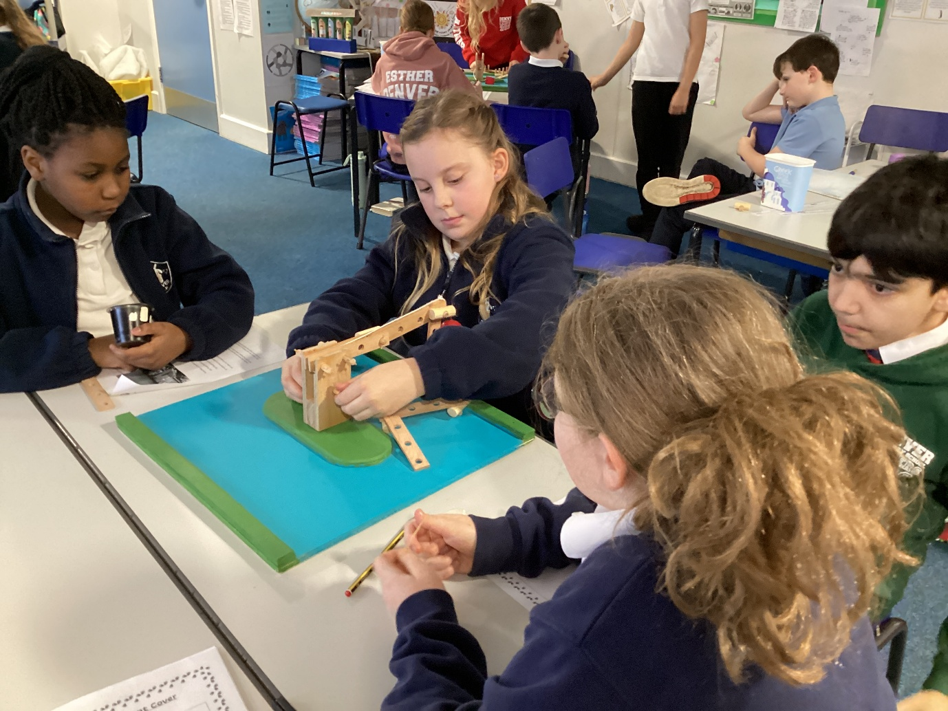

The children set off in their groups of four creating some great ideas along the process. The panel then judged each teams’ practical work and portfolios against set criteria.

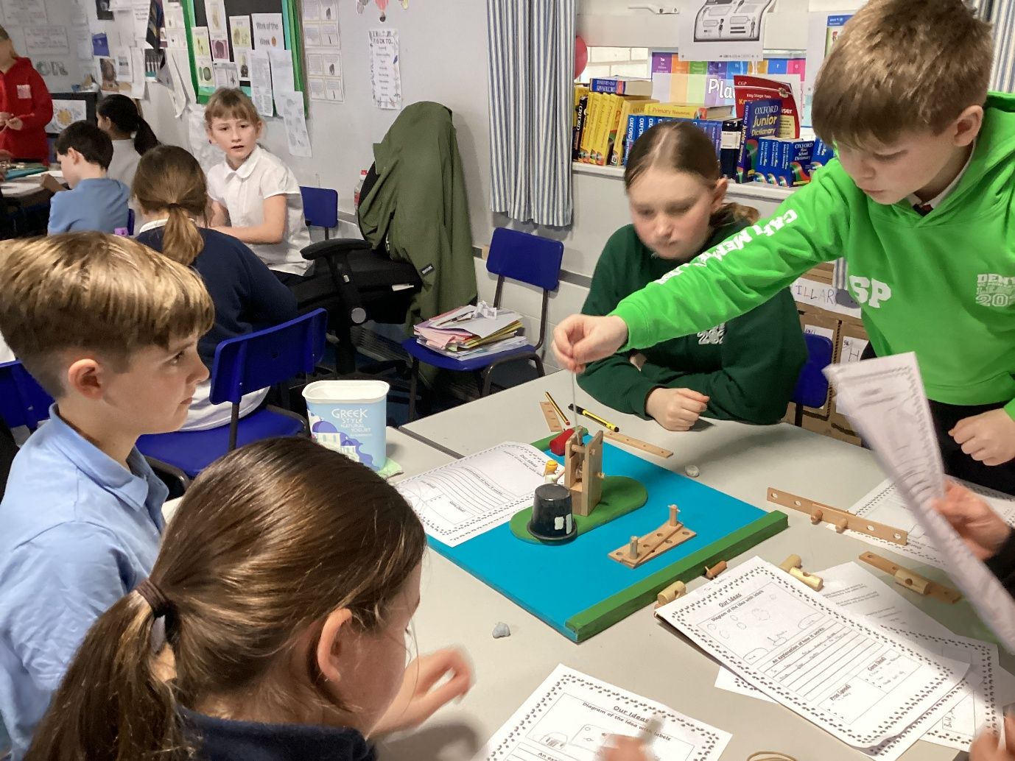
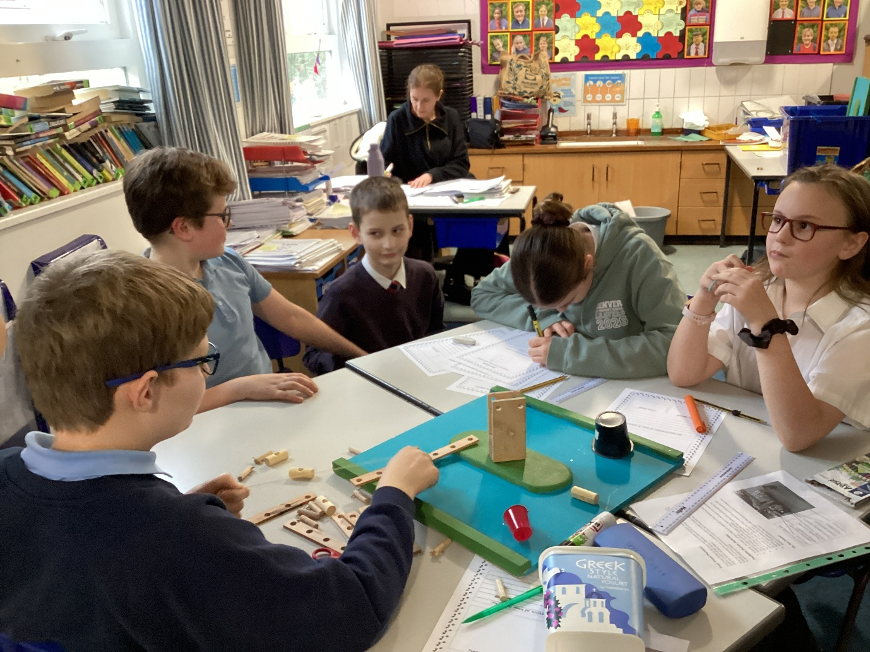
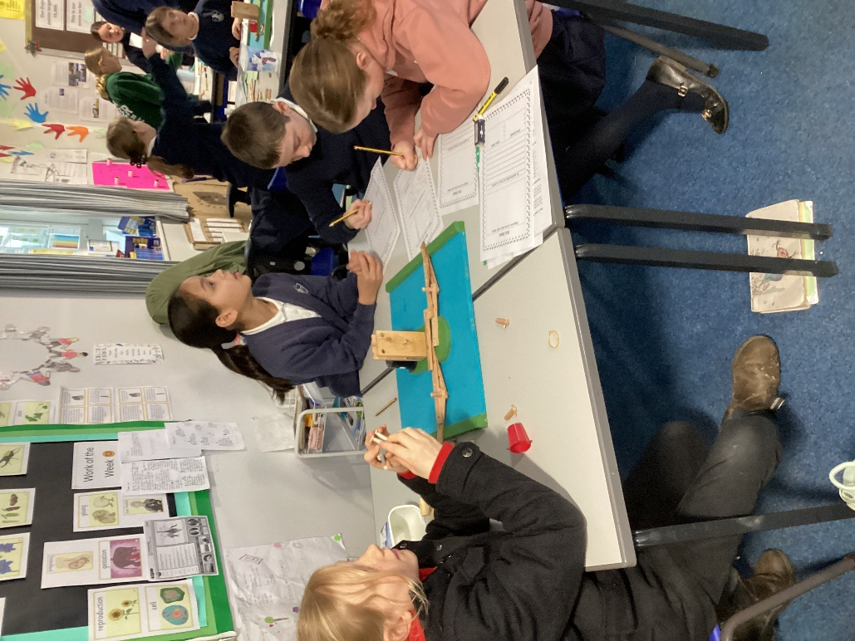
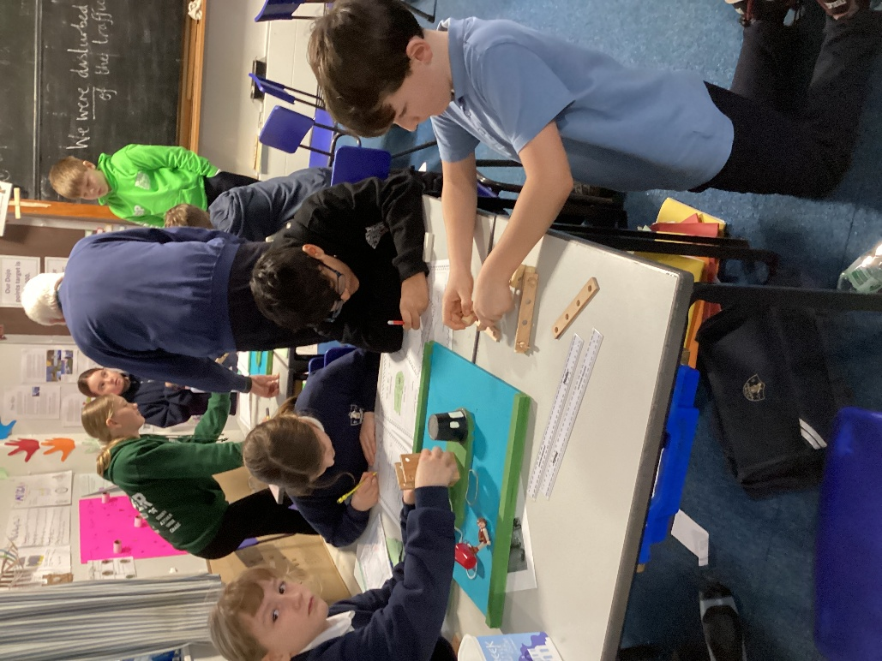

Everyone did a fantastic job. The overall winners were The Fantastic Four: Flora, Sonny, Osian and Indi who received medals. Well done to everyone. We are very proud of all of the children!
Thank you to Alan and Claire for a memorable day.


