Our visit from Father Christmas 2025
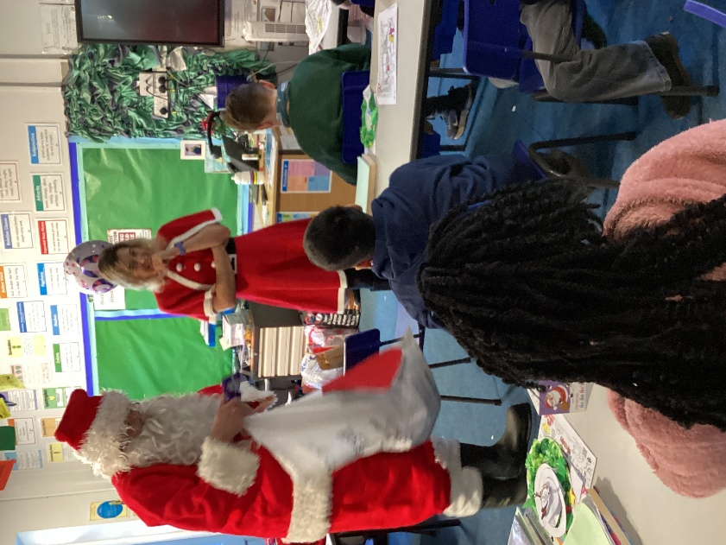
On the last day of term, Father Christmas came to visit us in class. He was very impressed by the curiosity of the children.
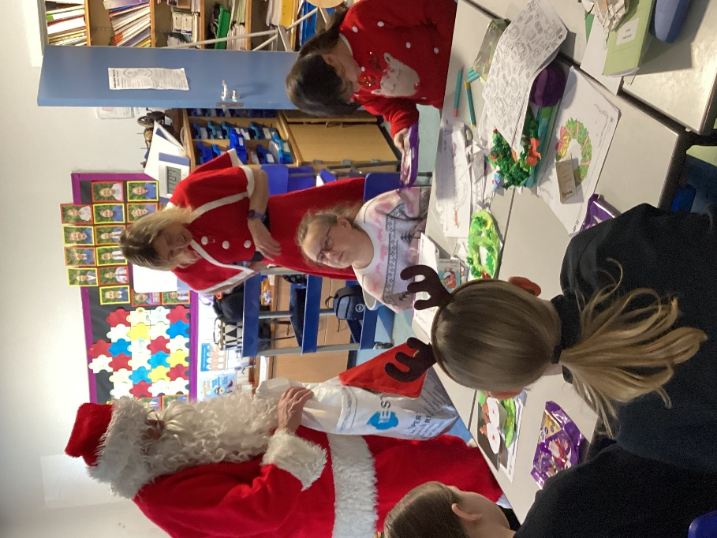

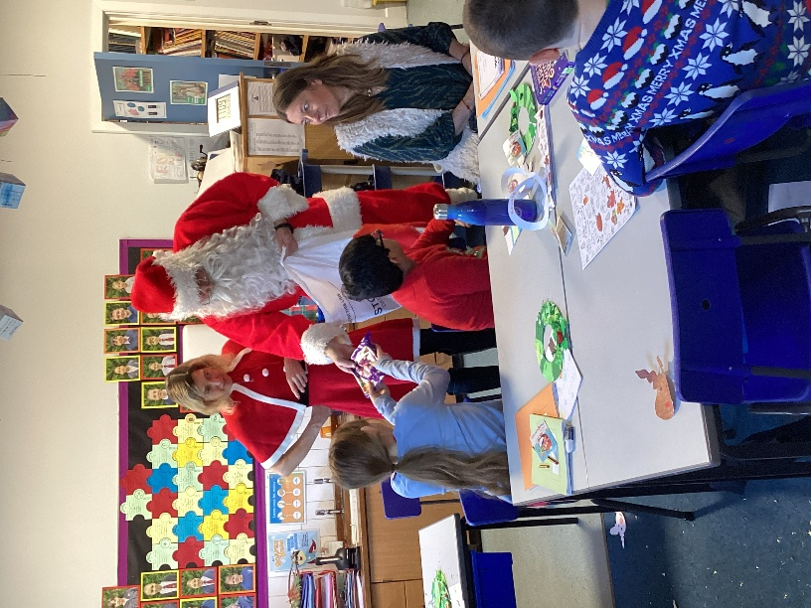

Thank you to the Friends for arranging this to happen.



