Class 4 Christmas Party
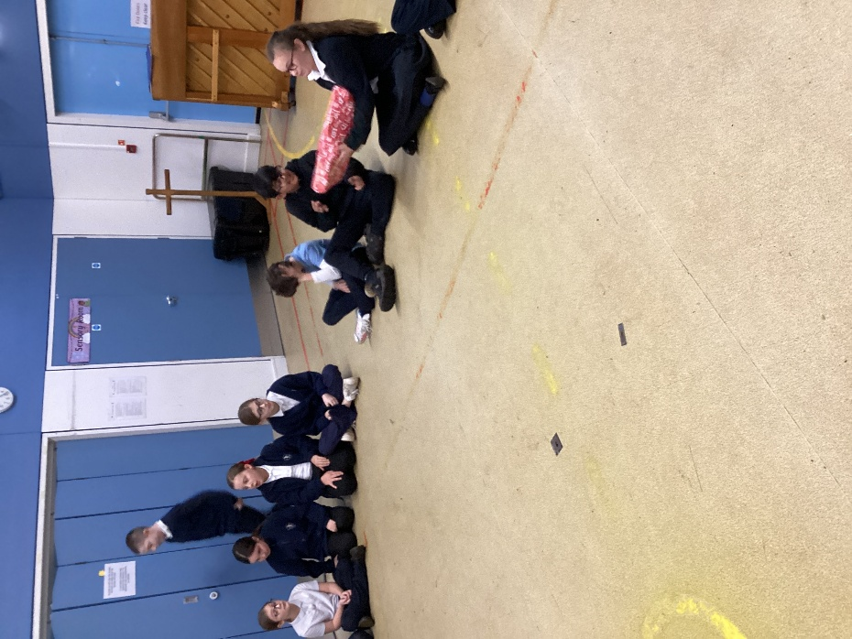
The Christmas spirit is now in full flow in Class 4 following on from our class party on Tuesday 16th December. Formal lessons were abandoned all afternoon in favour of songs and games.
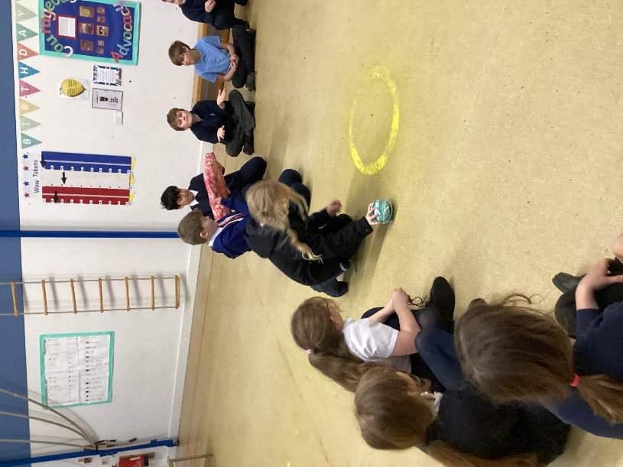

Traditional games were played such as ‘Pass the Parcel’ and ‘Musical Chairs’. The ‘Corners Game’ proved popular as always.
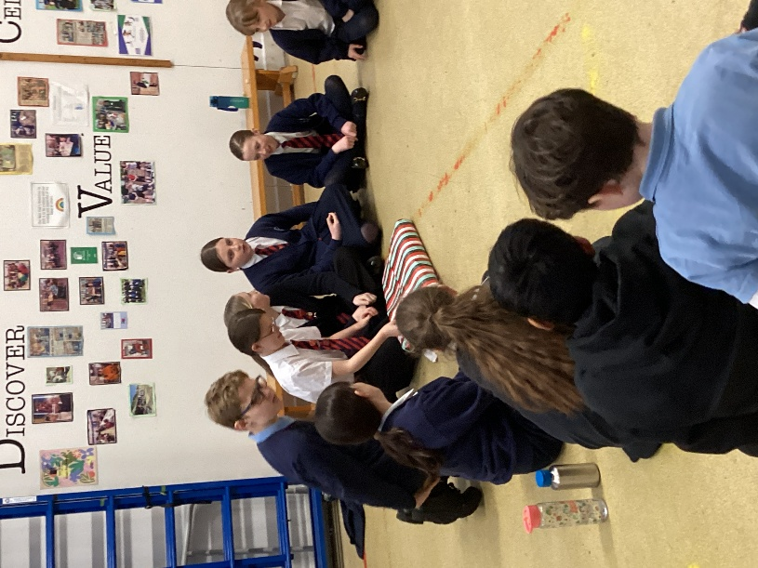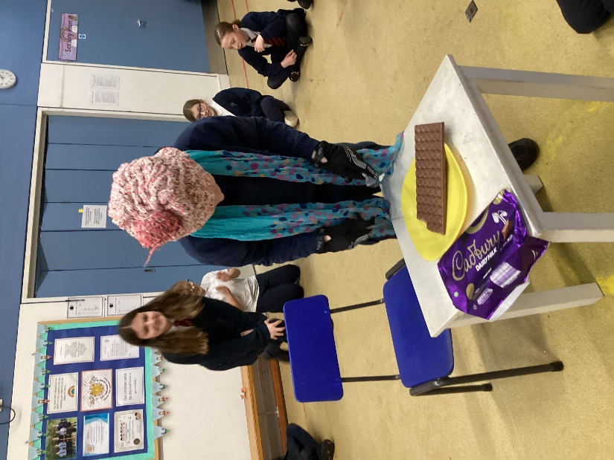
One game in particular, that caused excitement, was the ‘Chocolate Game’. You had to throw a die and if you were successful in scoring a six, you then dressed in a hat, scarf and gloves and while using a knife and fork, attempted to cut up and eat a huge bar of chocolate before anyone else could score a six and take their place. This was a competitive game that revealed who had a strong love of chocolate and/or winning!
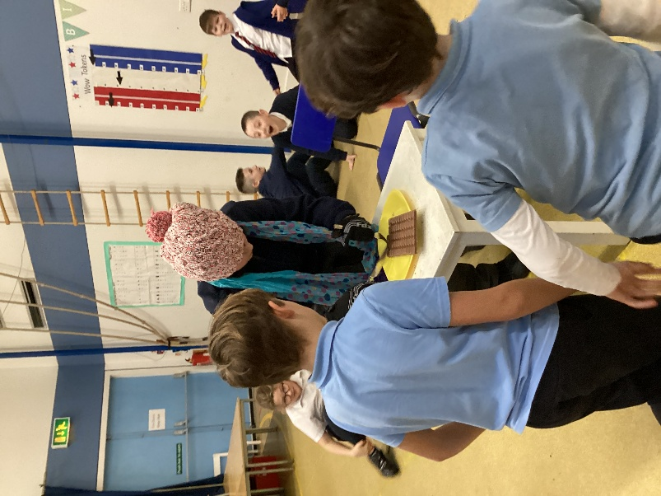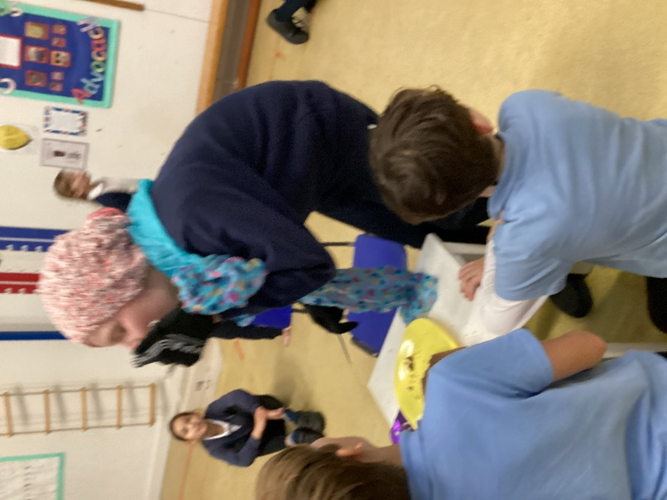
Huge thanks from all of the children and staff of Class 4 to the Friends for their support with the making the ‘Pass the Parcel’ and providing the prizes, and to Mrs Adams who was an excellent helper.
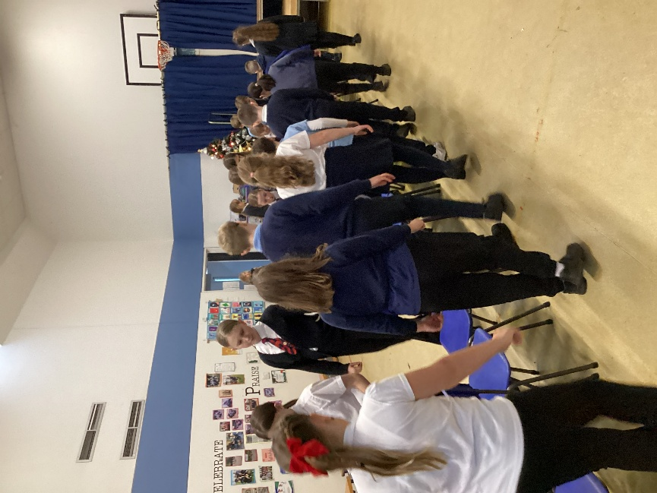
Merry Christmas!


