Decoration Day 2025
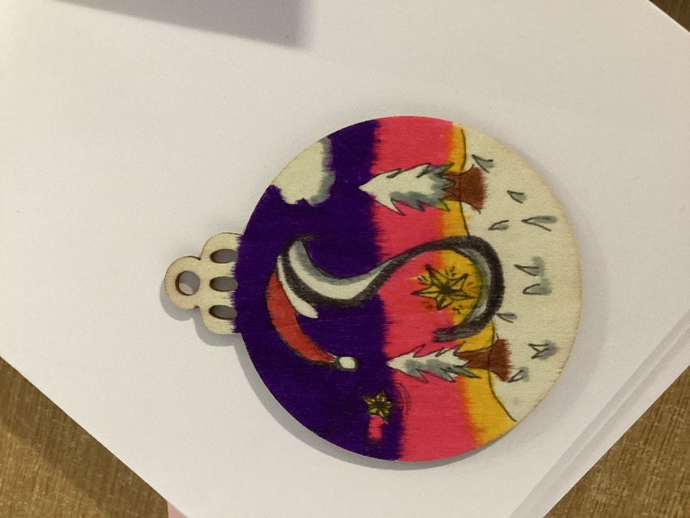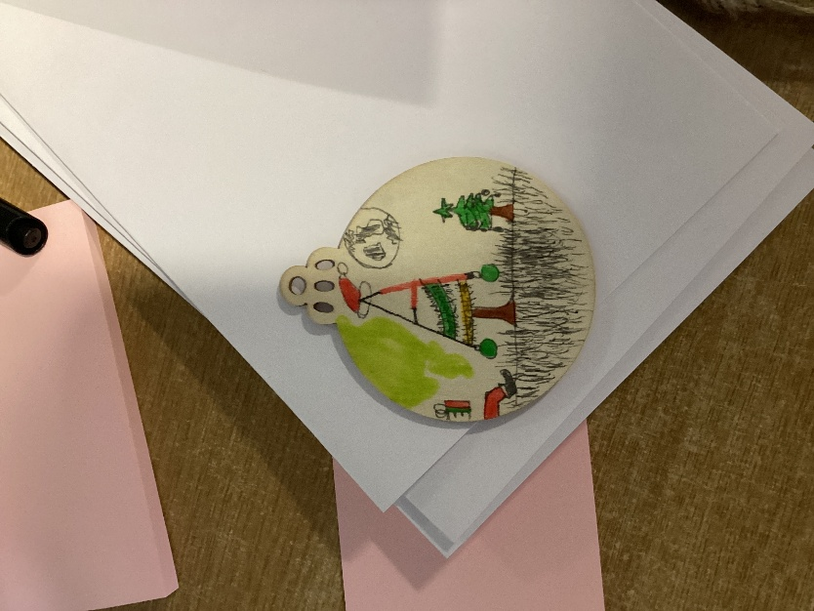
It was arts and crafts galore in Class 4 on Wednesday 3rd December. The timetable was abandoned for the day to make our classroom festive.
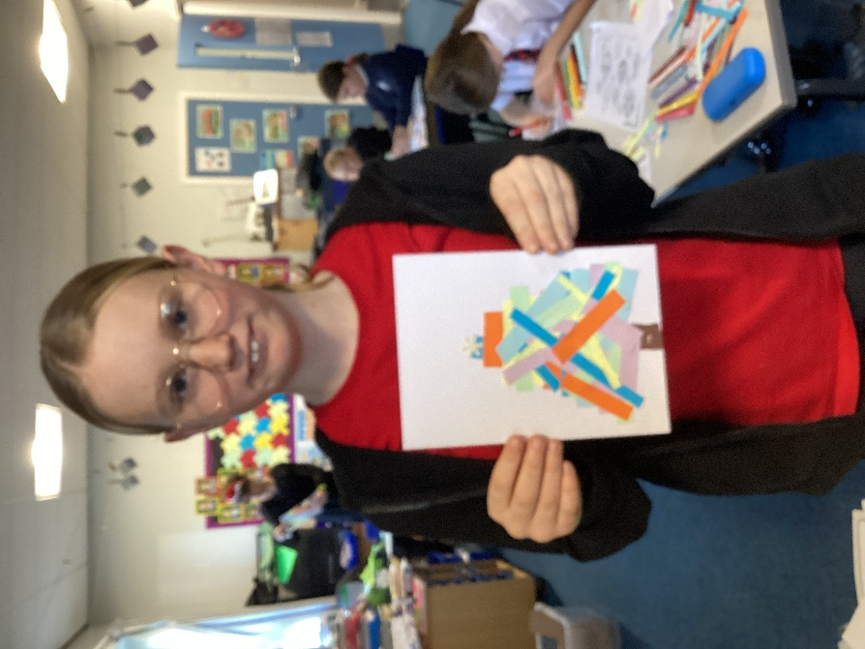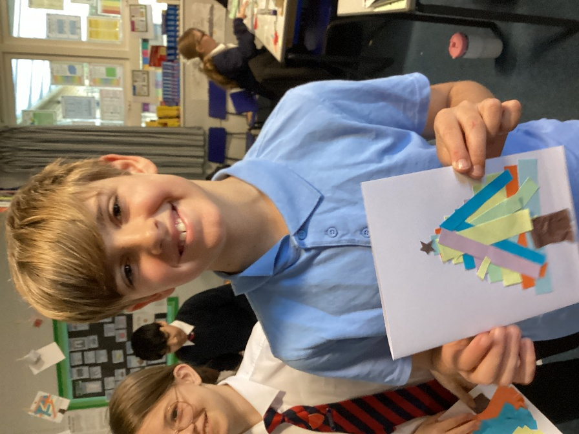
Activities throughout the day included making wooden decorative baubles for a community tree in support of the Friends, abstract art Christmas cards, wreaths with assorted media, reindeer, gonks and spiral snowmen. Filler activities included making hats for the forthcoming school Christmas lunch and mindfulness colouring while popular Christmas songs were playing in the background.
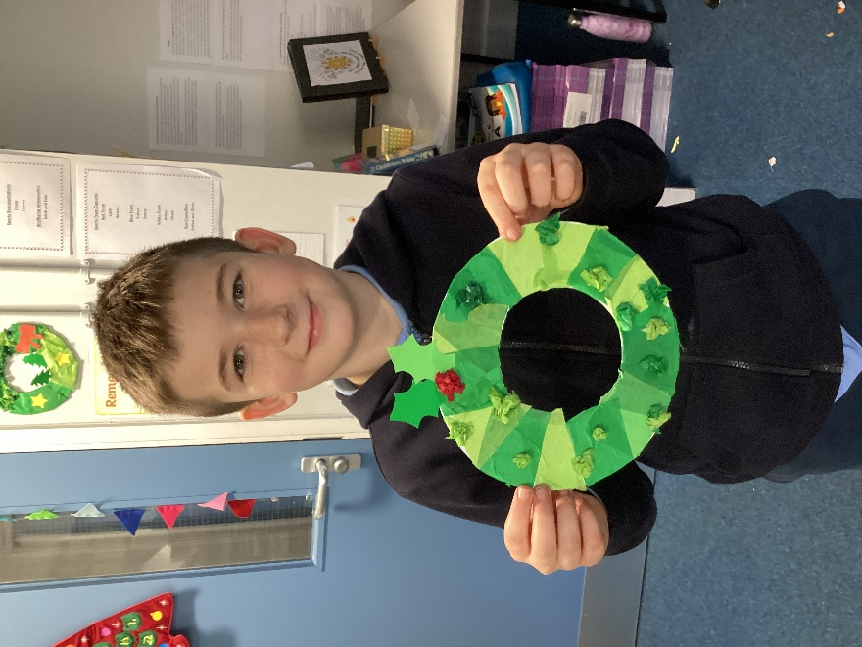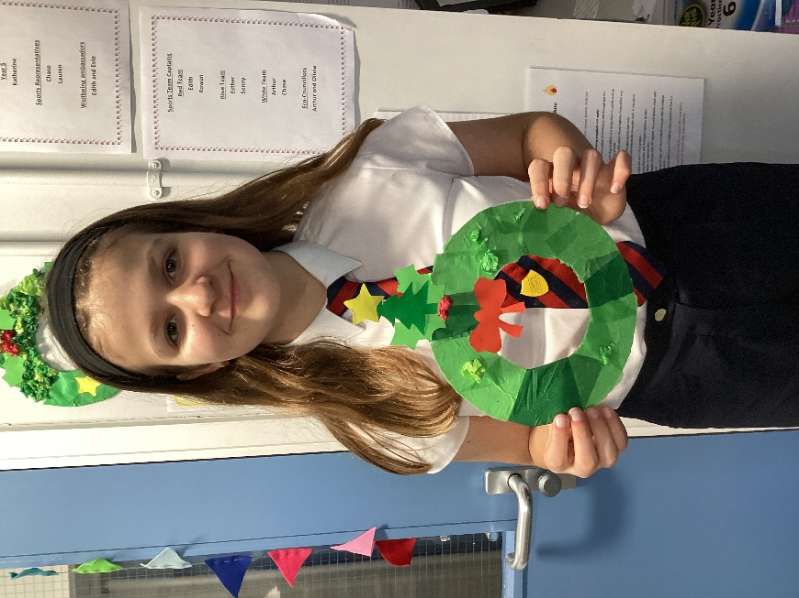
We are now well and truly decked out for the festive season. Thank you so much for Miss Boddy, Mrs Wright and Mrs Adams who spent the previous day preparing the activities and resources. They did a fantastic job!


