Christmas Fayre 2025
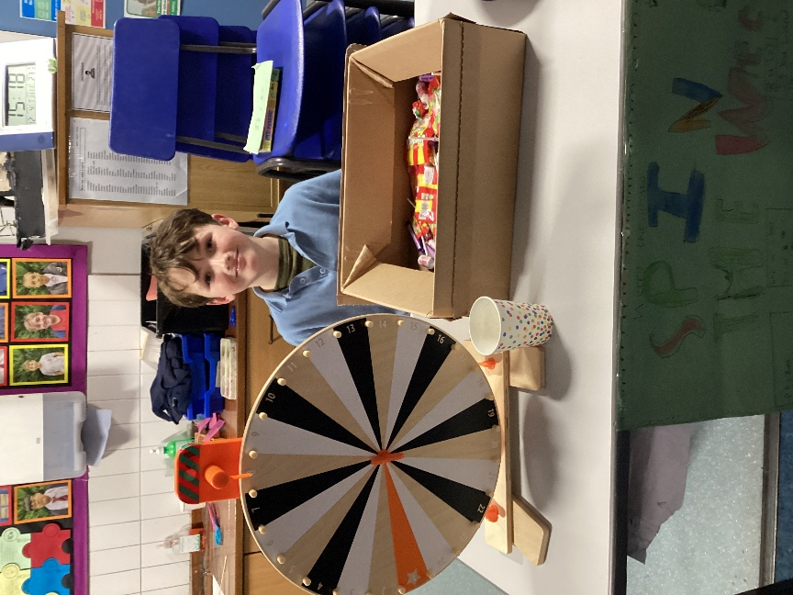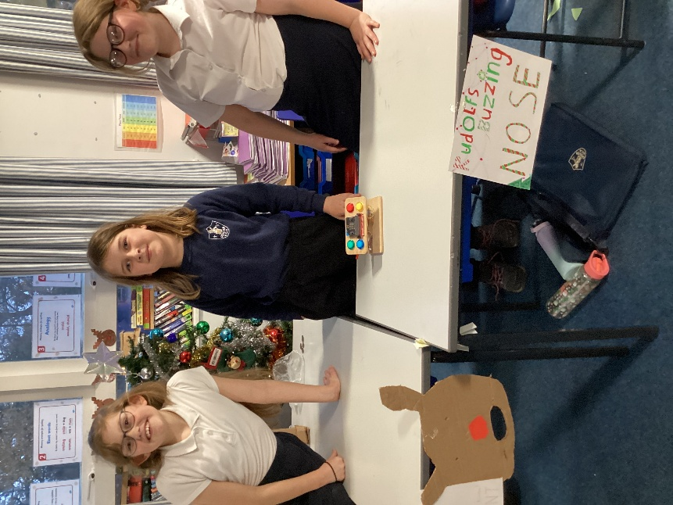
Each year in Class 4 we get fully involved with supporting the Friends of Denver School by making and then running a variety of stalls to raise funds for the Friends.
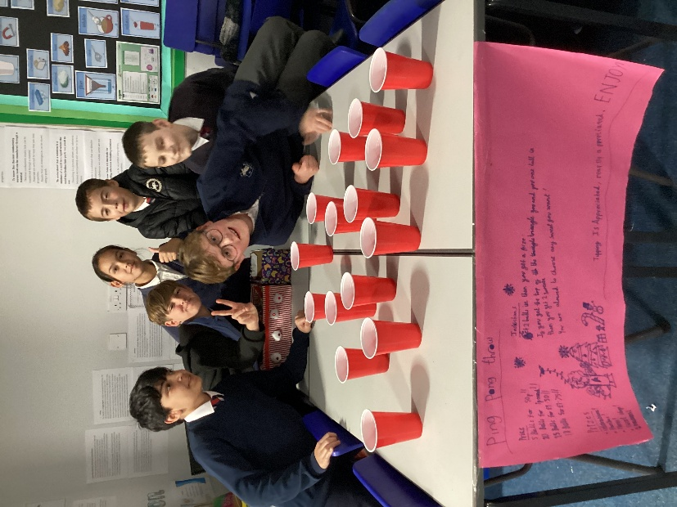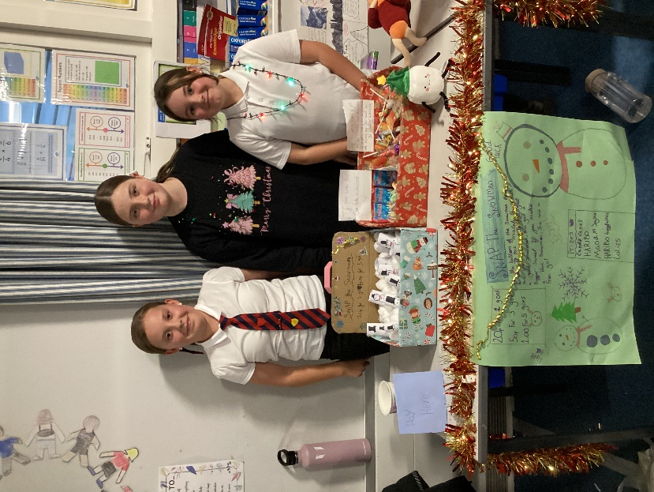

This year was no exception with a range of games to entertain our guests, an array of prizes and some entrepreneurial skills on show. The children have been fantastic!
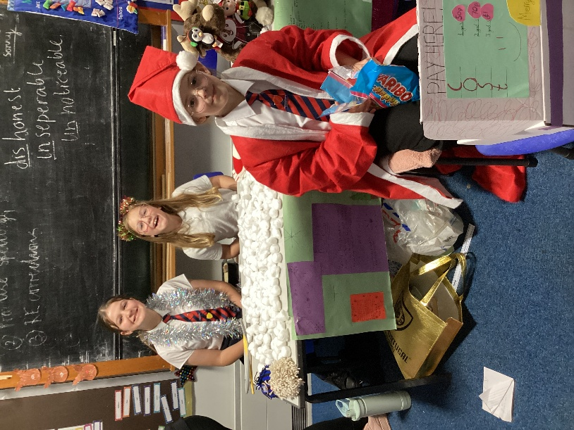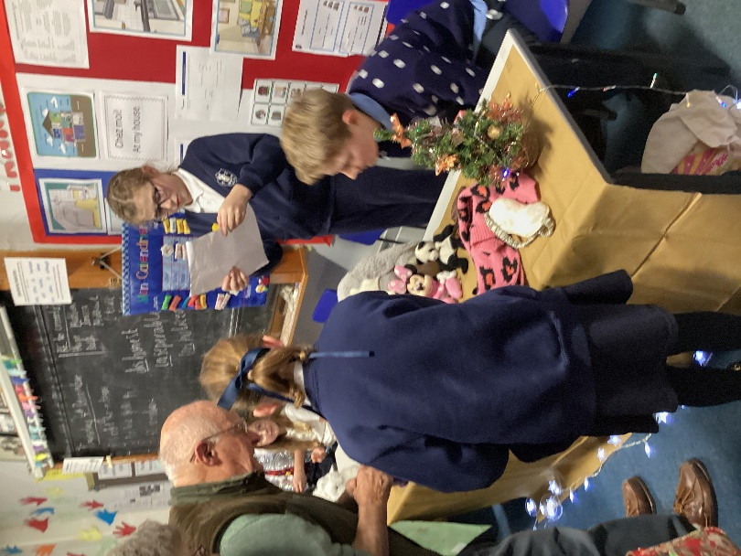
We would like to say a very big thank you to all the parents, carers, volunteers and the community for providing time and resources for the games, funding the prizes and for coming along to the fayre itself. Your generosity at such an expensive and busy time of the year is something we are very grateful for. These events showcase what a wonderful school community we are part of. Thank you!


