Christingle 2025
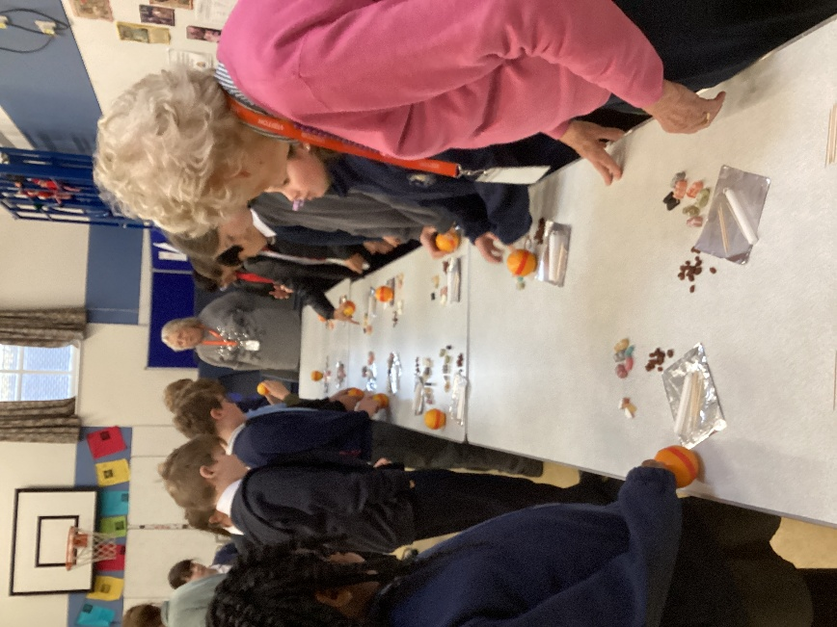
Our annual Christingle festivities rolled round again on Monday 1st December.
The Ladies of Denver Church came into school to teach us the meaning of each part of the Christingle and helped us to make them.
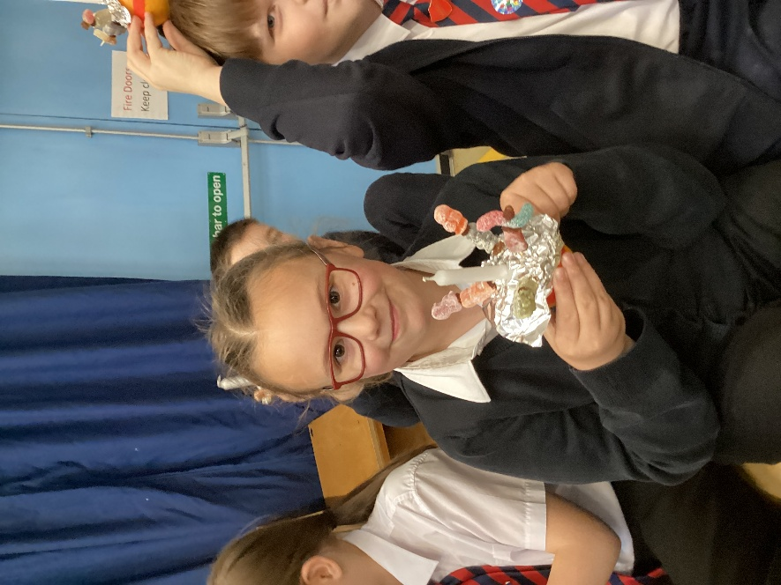
These were taken to the service at St. Mary’s Denver that afternoon. The children led a lovely service of readings, songs and prayer accompanied by Fraser Reich, Mr Lawrence and Chris Young.
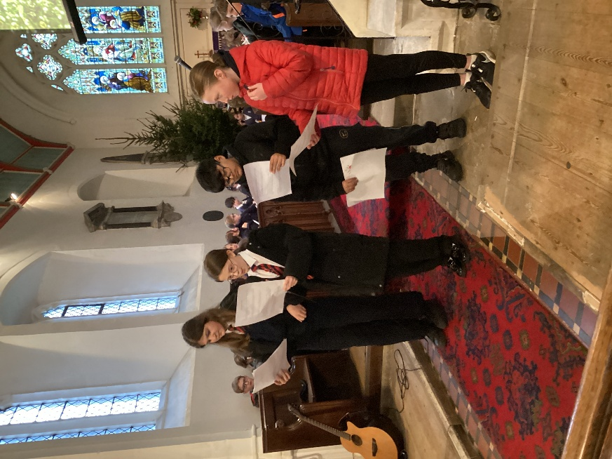
Reverend Nigel gave us an unforgettable sermon about the Christingle while wearing a woolly hat that had parts signifying each element of a Christingle.
Thank you to everyone who helped with this event and contributed to the Christingle charity boxes. Your generosity is much appreciated.


